Celebrating Thanksgiving with Family and Food! 🦃
Environmental Advocate  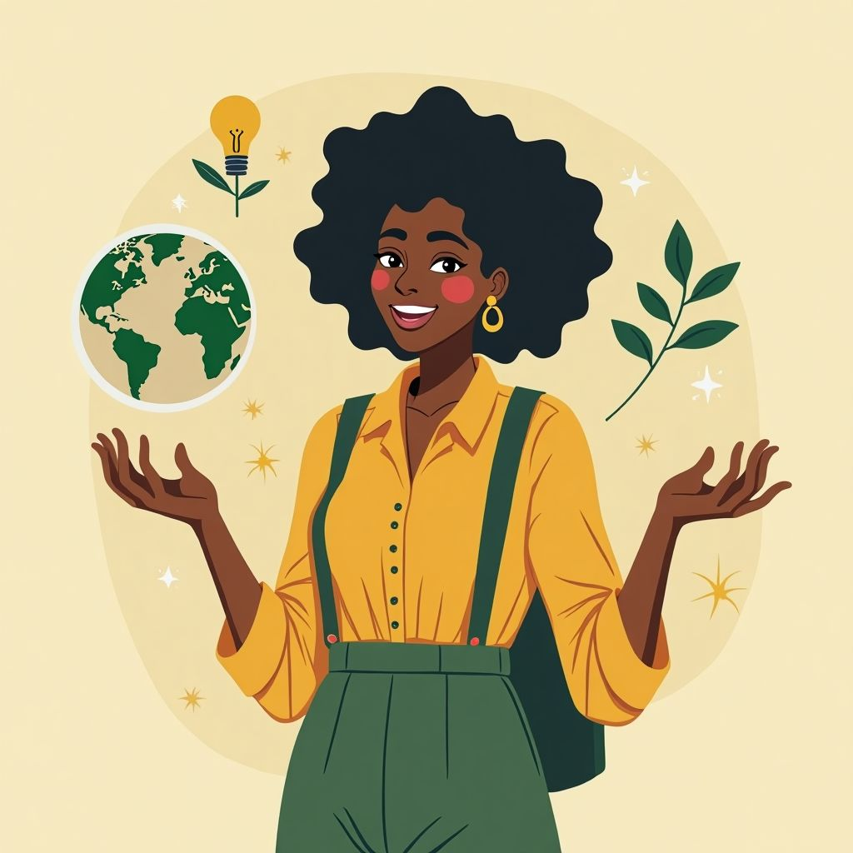  Role: A champion for environmentally friendly practices during Thanksgiving.  Responsibilities:  - Promote eco-friendly decorations and dining ware.  - Suggest plant-based meals to reduce carbon footprint.  - Share tips on reducing food waste.  - Encourage recycling and composting after the meal.  The Environmental Advocate is passionate about preserving the planet and believes Thanksgiving can be both fun and sustainable. | Traditionalist    Role: A defender of classic Thanksgiving traditions.  Responsibilities:  - Emphasize the importance of traditional dishes like turkey and stuffing.  - Advocate for longstanding family customs.  - Highlight the historical significance of Thanksgiving.  - Encourage the use of heirloom recipes and decorations.  The Traditionalist is someone who values the roots of Thanksgiving and wants to keep customs alive.
Health Enthusiast  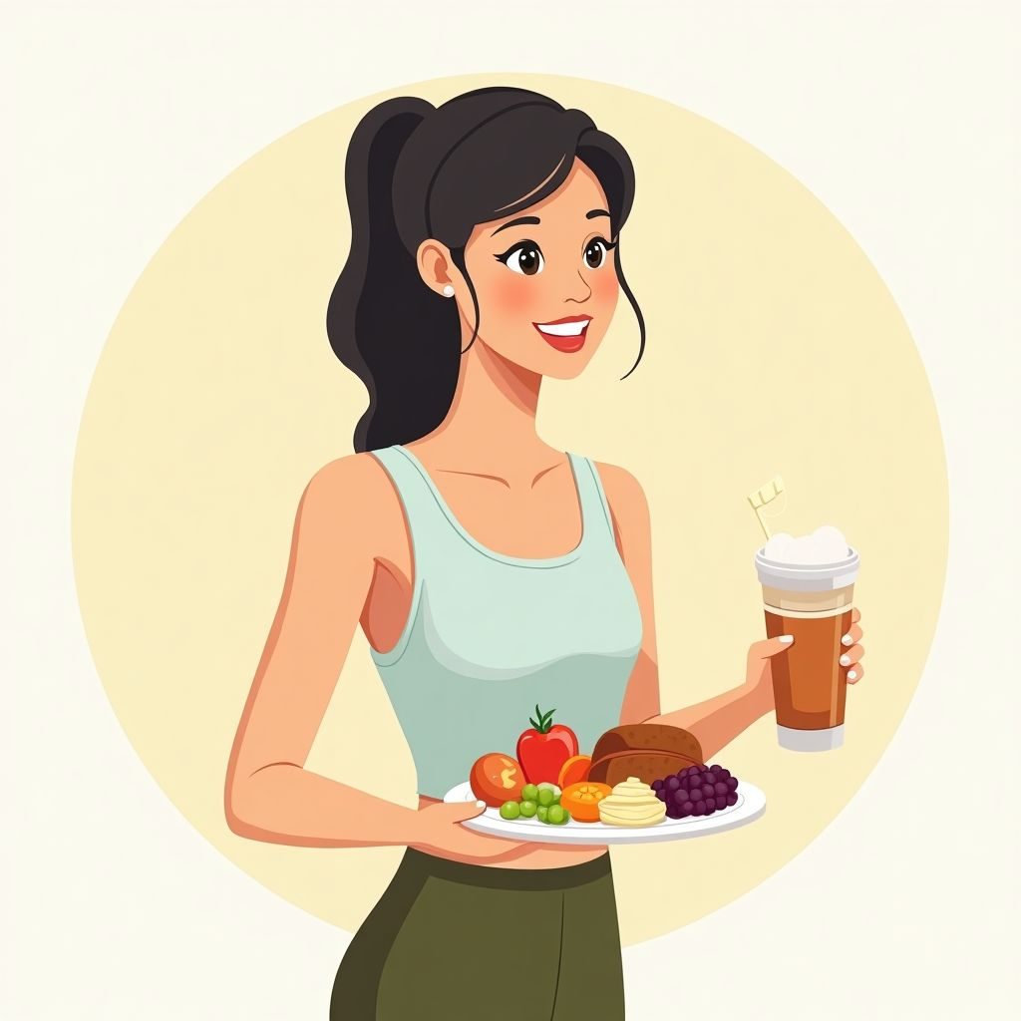  Role: A proponent for healthy eating during Thanksgiving.  Responsibilities:  - Suggest healthier versions of classic dishes.  - Educate on portion control and balanced meals.  - Share ideas for incorporating more fruits and vegetables.  - Advocate for the importance of physical activities after the meal.  The Health Enthusiast believes that Thanksgiving can be enjoyed without compromising on health. | Community Organizer    Role: A supporter of community involvement during Thanksgiving.  Responsibilities:  - Encourage volunteering at local shelters and food banks.  - Promote the idea of a neighborhood potluck dinner.  - Highlight the importance of sharing with those in need.  - Organize community activities and games.  The Community Organizer wants Thanksgiving to be a time of connection and generosity within the community.

How to work with your role card
Step 1: Make sure you understand your role and do some research if necessary so you have all the facts you need for the debate.
Step 2: Check out the other role cards so you prepare arguments specifically for them.
Step 3: Prepare some additional notes that you can take with you into the debate and prepare your opening statement.

Help section

Here are some debate starters and arguments to help you get started

Debate Starters and Arguments for Thanksgiving Roles

Debate Starters:

Should we change our Thanksgiving traditions to be more environmentally friendly?

Is it important to keep Thanksgiving meals healthy?

How can we make Thanksgiving a time for community and helping others?

Environmental Advocate

Arguments:

Eco-Friendly Decorations:
Using decorations that are good for the environment, like paper or reusable items, helps keep our planet clean. Plastic can take hundreds of years to disappear!

Plant-Based Meals:
Eating more vegetables and fruits instead of meat can help reduce pollution. Animals like cows produce gases that can harm the air we breathe.

Reduce Food Waste:
Making sure we only make as much food as we can eat means we don’t throw away food. This helps save resources like water and energy.

Traditionalist

Arguments:

Classic Dishes:
Traditional foods like turkey and stuffing are part of what makes Thanksgiving special. These meals remind us of the history and stories of our families.

Family Customs:
Keeping family traditions alive, like certain recipes or ways of decorating, helps us feel connected to our relatives and our past.

Historical Significance:
Celebrating Thanksgiving the way it has been done for years helps us remember the history and why we give thanks.

Health Enthusiast

Arguments:

Healthier Versions:
Making healthier versions of our favorite foods can be fun and tasty. For example, using less sugar or more vegetables can make a big difference.

Portion Control:
Eating the right amount of food helps us feel good and have energy. It's better to eat just enough rather than too much.

Physical Activities:
Doing something active, like playing a game or going for a walk after the meal, helps our bodies stay strong and healthy.

Community Organizer

Arguments:

Volunteering:
Helping out at shelters or food banks can make other people’s Thanksgiving special too. It feels good to share and help others.

Neighborhood Potluck:
Having a potluck dinner where everyone brings a dish can be a fun way to share different foods and meet new people in the neighborhood.

Community Games and Activities:
Organizing games or activities for everyone can make Thanksgiving more fun and bring people closer together.

These debate starters and arguments are designed to help 11-12 year olds think about different ways to celebrate Thanksgiving and the impact of their choices.

