Trump's 2024 Campaign: A Journey of Controversy and Promises

Donald Trump's 2024 presidential campaign has been a rollercoaster of bold promises and heated controversies. Starting in November 2022, Trump declared his intent to return to the White House, pledging to "Make America Great Again" with a twist of "retribution." As he rallies his supporters, slogans like "America First" and "Warrior for Justice" have echoed across the nation, capturing the essence of his campaign's core messages.

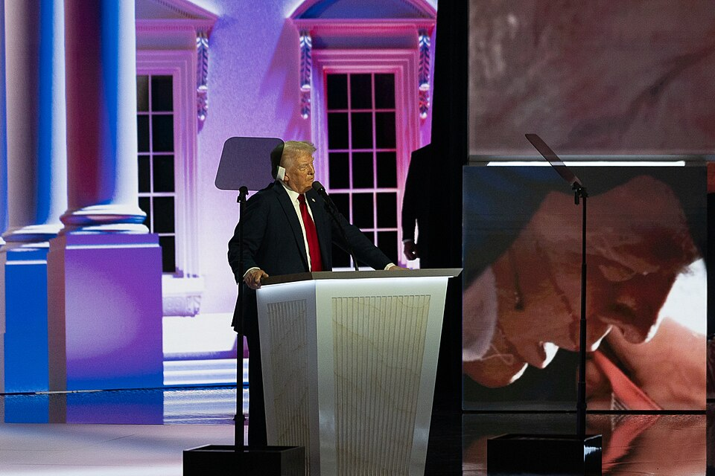

Trump delivering his acceptance speech at the 2024 Republican National Convention. Source: Tim Kennedy, CC BY 2.0

The campaign has been marked by Trump's unapologetic rhetoric, often targeting his main opponent, Kamala Harris, with personal jabs that critics deem misogynistic and racially charged. His strategy includes addressing national crises like immigration and the economy, promising sweeping changes such as expanding executive power and reforming immigration policies. Trump aims to dismantle the Affordable Care Act and replace it with a system he claims will be more efficient.

Despite facing legal challenges, including convictions and ongoing trials, Trump remains defiant. He dismisses these as politically motivated attacks, rallying his base by portraying himself as a victim of a "corrupt system." His campaign has also faced backlash for its authoritarian undertones, with promises to crack down on dissent and increase executive control, raising concerns about the future of American democracy.

As the election approaches, Trump's campaign continues to evolve, focusing on themes of strength and nationalism. He vows to restore what he views as America's lost greatness, appealing to voters who resonate with his vision of a powerful, self-reliant nation. The question remains whether his controversial style will lead him back to the presidency or alienate the broader electorate.

Analyzing Election Campaign Narratives
Election Campaign Narratives
why
vote for them
who
why
the best choice
five
often used narrative types
are stories that politicians use to explain people should . These stories help voters understand they are and they are . Here is a list of very important and :

1.

"hero" who will save the day
A hero story is when a politician presents themselves as the . They tell stories about the good things they've done or how they will help solve a big problem, like improving schools or making neighborhoods safer.

2.
problem
needs to be solved right away
A crisis narrative is used when the candidate talks about a big , or crisis, that . They explain how the crisis is affecting people and how they are the best person to fix it. It could be about a serious issue like bad roads or unsafe communities.

3.
problem
they are really good at solving
"own"
issue
best at handling it
In an issue ownership narrative, the candidate focuses on a specific or issue . For example, one candidate might focus on improving education, while another might be known for protecting the environment. They thatbecause they are seen as the .

4.
candidate talks about
opponent in a bad way
Negative campaigning is when a their . They might say their opponent did something wrong or isn't fit for the job.

5.
made a mistake
explain what happened
ry to fix their image
Image restoration strategies are used when a candidate has or done something people didn’t like. The candidate tells a story to and how they’ve learned from their mistakes. They tso people will trust them again.

📋 Task 1: Find out about the objectives that the five types of campaign narratives typically pursue by matching the five types to their objective description.
Hero Stories |  | Voters see the candidate as brave, strong, and capable of making their lives better—like a hero in a movie.
Crisis Narratives |  | Voters might forgive the candidate and believe that they have changed or learned from their errors, giving them a second chance to lead.
Issue Ownership |  | Voters associate the candidate with solving that specific problem and trust them to be the expert. For example, if you care about education, you’ll think of the candidate who "owns" that issue as the best choice.
Negative Campaigning |  | Voters see the candidate as someone who understands the problem and has the solutions to get things back to normal. They feel the candidate is the right person for the job in a tough situation.
Image Restoration Strategies |  | Voters may start to see the opponent in a negative light and believe the candidate speaking negatively is the better choice because they pointed out problems with the other person.

📋 Task 2: Match the statements extracted from the newspaper article to the five types of election campaign narratives.
Trump declared himself as the fighter and avenger for those wronged and betrayed. |  | Crisis Narratives
Trump emphasizes his unique ability to fix national issues like immigration and the economy. |  | Issue Ownership
Trump emphasizes his 'America First' approach, particularly on immigration reform and economic policies. |  | Negative Campaigning
Trump has made personal attacks against Kamala Harris, which critics see as sexist and racist. |  | Image Restoration Strategies
Trump portrays his legal challenges as politically motivated and presents himself as a victim of a corrupt system. |  | Hero Stories

📋 Task 3:
Search the newspaper article for another campaign narrative. Assign it to one of the five narrative types and make a hypothesis about the goal the narrative is pursuing.

___________________________________________________________________

___________________________________________________________________

___________________________________________________________________

___________________________________________________________________

