City Planner  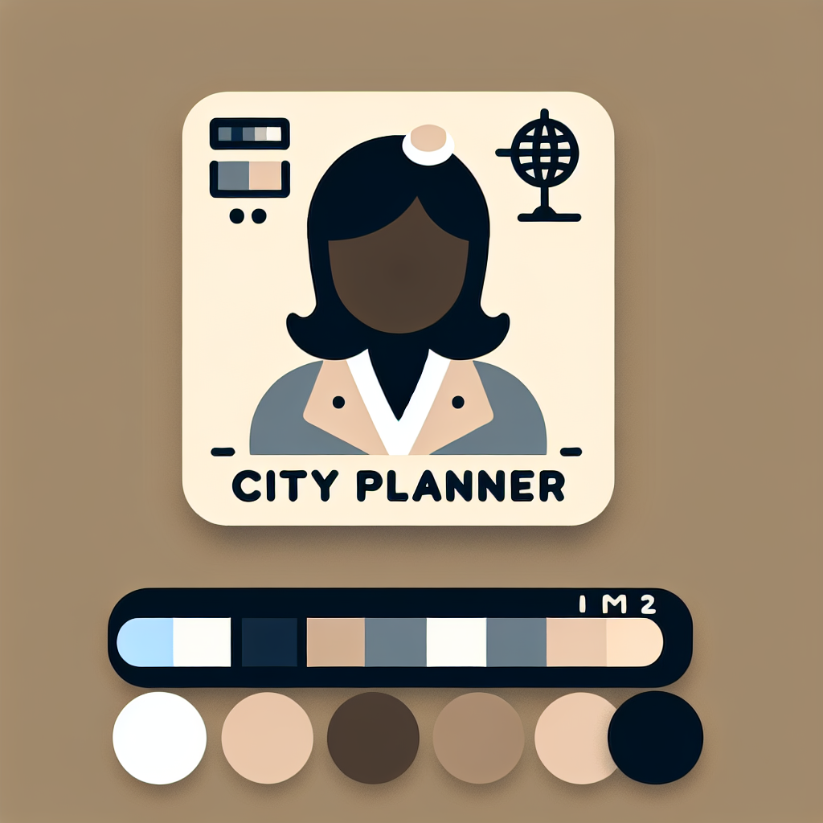  - Propose city design changes to reduce heat absorption.  - Advocate for increased green spaces and urban forests.  - Discuss the implementation of reflective materials in infrastructure.  - Highlight the importance of community cooling centers.  The city planner is passionate about transforming cities into green oases. | Climate Scientist    - Present data on the rising frequency and severity of heatwaves.  - Explain the long-term effects of heatwaves on health and ecosystems.  - Advocate for reducing greenhouse gas emissions.  - Provide projections and models for future heatwave scenarios.  The climate scientist is deeply concerned about the lack of global action on climate change.
Public Health Official    - Discuss the health risks associated with heatwaves, especially for vulnerable populations.  - Propose public health campaigns for heatwave preparedness.  - Advocate for policies to ensure access to cooling resources.  - Coordinate emergency response plans for extreme heat events.  The public health official is focused on immediate and practical solutions to protect lives. | Renewable Energy Advocate    - Highlight the role of renewable energy in mitigating climate change.  - Propose investments in solar, wind, and other renewable sources.  - Discuss energy-efficient technologies and their benefits.  - Advocate for policies supporting the transition to a green economy.  The renewable energy advocate believes that a sustainable energy transition is crucial to combat heatwaves.

How to work with your role card
Step 1: Make sure you understand your role and do some research if necessary so you have all the facts you need for the debate.
Step 2: Check out the other role cards so you prepare arguments specifically for them.
Step 3: Prepare some additional notes that you can take with you into the debate and prepare your opening statement.

Help section

Here are some debate starters and arguments to help you get started

Debate Starters and Arguments

Theses/Questions

What are the most effective strategies for cities to mitigate the impact of heatwaves?

How can urban planning and renewable energy initiatives complement each other to create resilient cities?

What immediate actions can be taken to protect vulnerable populations during extreme heat events?

Arguments

City Planner

Thesis 1: What are the most effective strategies for cities to mitigate the impact of heatwaves?

Green Spaces and Urban Forests
: Increasing the number of parks and urban forests can significantly reduce urban heat islands by providing shade and promoting evapotranspiration.

Reflective Materials
: Implementing reflective materials in building roofs and pavements can decrease heat absorption and lower surrounding temperatures.

Cool Roofs and Walls
: Encourage the use of cool roofs and walls in building designs to reflect more sunlight and absorb less heat, reducing cooling demands.

Thesis 2: How can urban planning and renewable energy initiatives complement each other to create resilient cities?

Integrated Design
: Urban planning can incorporate renewable energy systems like solar panels on buildings and in public spaces, creating a synergy between green infrastructure and energy efficiency.

Zoning for Sustainability
: Designate zones for renewable energy installations such as wind turbines and solar farms, ensuring these are integrated into the urban fabric.

Green Transit Systems
: Develop transit systems powered by renewable energy sources, reducing greenhouse gas emissions and heat generated by conventional vehicles.

Thesis 3: What immediate actions can be taken to protect vulnerable populations during extreme heat events?

Community Cooling Centers
: Establish and maintain community cooling centers in various parts of the city to provide relief during extreme heat events.

Heatwave Preparedness Campaigns
: Educate the public about heatwave risks and preparedness measures through city-wide campaigns.

Emergency Response Plans
: Develop and implement detailed emergency response plans that include specific protocols for assisting vulnerable populations.

Climate Scientist

Thesis 1: What are the most effective strategies for cities to mitigate the impact of heatwaves?

Data-Driven Planning
: Utilize climate data to inform urban planning decisions, ensuring that strategies are based on accurate projections and models.

Heat-Resilient Infrastructure
: Invest in infrastructure that can withstand extreme heat, such as heat-resistant materials and advanced cooling technologies.

Emission Reductions
: Advocate for policies that reduce greenhouse gas emissions to lessen the frequency and intensity of heatwaves in the long term.

Thesis 2: How can urban planning and renewable energy initiatives complement each other to create resilient cities?

Climate Models
: Use climate models to predict the benefits of integrating renewable energy into urban design, demonstrating potential reductions in heatwave impacts.

Synergistic Policies
: Promote policies that simultaneously address urban heat and renewable energy adoption, ensuring that both objectives are met efficiently.

Research and Development
: Support R&amp;D initiatives that explore innovative solutions combining urban planning and renewable energy technologies.

Thesis 3: What immediate actions can be taken to protect vulnerable populations during extreme heat events?

Health Impact Studies
: Conduct studies to identify the most at-risk populations and tailor interventions accordingly.

Early Warning Systems
: Implement early warning systems that provide timely alerts about upcoming heatwaves, allowing for proactive measures.

Community Engagement
: Work with local communities to develop resilience plans that are culturally and contextually appropriate.

Public Health Official

Thesis 1: What are the most effective strategies for cities to mitigate the impact of heatwaves?

Public Health Campaigns
: Launch campaigns to educate the public on how to stay safe during heatwaves, emphasizing hydration and cool environments.

Access to Healthcare
: Ensure that healthcare facilities are equipped to handle heat-related illnesses, especially during peak heat periods.

Cooling Resources
: Advocate for the distribution of cooling resources like fans, water, and portable air conditioners to those in need.

Thesis 2: How can urban planning and renewable energy initiatives complement each other to create resilient cities?

Health and Energy Efficiency
: Promote building designs that enhance energy efficiency and provide healthier living conditions by reducing indoor heat levels.

Resilient Healthcare Facilities
: Support the development of healthcare facilities powered by renewable energy, ensuring they remain operational during heatwaves.

Cross-Sector Collaboration
: Encourage collaboration between urban planners, energy experts, and public health officials to create holistic and sustainable solutions.

Thesis 3: What immediate actions can be taken to protect vulnerable populations during extreme heat events?

Cooling Centers and Shelters
: Set up and publicize cooling centers and shelters where vulnerable populations can find refuge from the heat.

Emergency Services
: Enhance emergency services to provide rapid response to heat-related health crises, including mobile units for on-site assistance.

Community Outreach
: Conduct outreach programs to inform and assist vulnerable populations, ensuring they know how to access cooling resources and emergency services.

Renewable Energy Advocate

Thesis 1: What are the most effective strategies for cities to mitigate the impact of heatwaves?

Renewable Energy Adoption
: Increase the adoption of renewable energy sources such as solar and wind to reduce the urban heat generated by fossil fuel-based power plants.

Energy-Efficient Technologies
: Promote the use of energy-efficient technologies that reduce the need for air conditioning and other cooling methods that contribute to heat.

Sustainable Building Practices
: Advocate for building practices that incorporate renewable energy and energy efficiency from the ground up, reducing overall heat absorption.

Thesis 2: How can urban planning and renewable energy initiatives complement each other to create resilient cities?

Solar-Powered Infrastructure
: Integrate solar panels into urban infrastructure such as rooftops, parking lots, and public buildings to provide clean energy and reduce heat absorption.

Energy Storage Solutions
: Develop energy storage solutions that can be integrated into urban planning, ensuring a reliable supply of renewable energy during peak heat times.

Incentives for Green Buildings
: Advocate for incentives and regulations that promote the construction and retrofitting of buildings to be energy-efficient and powered by renewable sources.

Thesis 3: What immediate actions can be taken to protect vulnerable populations during extreme heat events?

Renewable-Powered Cooling Centers
: Establish cooling centers powered by renewable energy, ensuring they remain operational even during power outages.

Distributed Energy Systems
: Promote the installation of distributed renewable energy systems that provide reliable power to vulnerable communities during heatwaves.

Public Education on Renewable Energy
: Launch public education campaigns to inform communities about the benefits of renewable energy and how it can help mitigate the effects of heatwaves.

