Principle of the American Dream

The American Dream is the belief that anyone, regardless of background, can achieve success and prosperity through hard work and determination.

Example:
A person from a humble background becoming a successful entrepreneur.

Listen to the story of this immigrant
 | Audio Content  To listen to audio content just scan the QR code and listen to it on the digital worksheet.  https://to-teach.ai/worksheet/dEsRgE49PnBeePkgNuMu

Answer the questions about the monologue.
Why did Sean O'Reilly decide to leave Ireland?
___________________________________________________________________
What did Sean O'Reilly hope to achieve in America?
___________________________________________________________________
What was life like for Sean O'Reilly in New York City?
___________________________________________________________________
What kind of job did Sean O'Reilly find in America?
___________________________________________________________________
What future did Sean O'Reilly hope for in the United States?
___________________________________________________________________

The American Dream: Reality or Illusion?

The American Dream, a concept rooted in the ethos of the United States, has evolved significantly since its inception. Popularized by James Truslow Adams in 1931, it originally emphasized democracy, liberty, and equality. Over time, this vision shifted towards material wealth and upward mobility. Despite the enduring allure of this dream, evidence suggests that social mobility in the U.S. has declined. Statistics reveal that the U.S. ranked 27th in the 2020 Global Social Mobility Index. A 2020 poll found that only 54% of American adults believed the American Dream was attainable, highlighting a growing skepticism, particularly among Black and Asian Americans and younger generations.

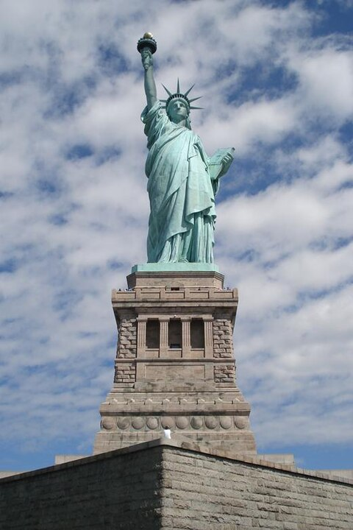

Liberty Enlightening the World (the Statue of Liberty) in New York Harbor was the first view of the United States for many immigrants during the mid-19th to the early 20th century. In this role, it signified new opportunities for becoming American, and evolved into a symbol of the American Dream. Source:
GaMeRuInEr
at
English Wikipedia

Despite the challenges, the idea of the American Dream has persisted for centuries. This resilience can be attributed to its deep roots in the U.S. Declaration of Independence, which proclaims that "all men are created equal" with rights to "life, liberty, and the pursuit of happiness." The dream encapsulates the promise of individual prosperity and success through hard work and determination in a capitalist society. However, rising income inequality and declining social mobility challenge this ideal. In 2024, only 10% of American workers were union members, down from 20% in 1983, reflecting a shift away from collective bargaining power that once supported the middle class.

Critics argue that the dream has been co-opted by materialism and consumerism, placing undue blame on individuals for their lack of success. Despite these critiques, the American Dream remains a powerful narrative, symbolizing hope and opportunity for many. It continues to inspire immigrants and citizens alike, even as they navigate the complexities of modern American society. The dream's endurance is a testament to its foundational role in American identity, even as its attainability becomes increasingly scrutinized.

As the U.S. grapples with these issues, the American Dream's future remains uncertain. While belief in the dream may waver, its core ideals of freedom, opportunity, and equality continue to resonate. The challenge lies in addressing the structural barriers that hinder its realization, ensuring that the dream remains within reach for all Americans. The American Dream's evolution reflects the nation's ongoing struggle to balance ideals with reality, a dynamic that will undoubtedly shape its narrative for generations to come.

Based on the base text, do you think Sean O'Reilly achieved his dream? Explain why the idea of the American Dream is still such a strong concept.

___________________________________________________________________

___________________________________________________________________

___________________________________________________________________

___________________________________________________________________

