Introduction
Today we are taking a closer look at a very special day. We look at the day in particular in relation to its economic context.
Alex
Hey Alex! Are you already in the mood for Valentine's Day? 😊
Hey Chris! Kind of, I'm thinking about what to get for my partner. You?
Same here! I'm planning to buy some flowers and maybe some chocolates. Have you seen any good deals? 💐🍫
Yeah, there are some great offers online. But honestly, don't you think we spend too much money this time of year? 🤔
Totally agree. It feels like there's a lot of pressure to spend a lot. Sometimes I feel like it's too much. 😅
Exactly! I think homemade gifts or saving for experiences together can be just as special. 🎁✨
Absolutely! It’s the thought that counts. Let's do something fun together instead. 😃
Sounds perfect! Looking forward to it. 😊

📝 Task: Reflect on the significance of this special day for you
What does this day mean in your life? Think about whether and how you spend money on this day.

___________________________________________________________________

___________________________________________________________________

___________________________________________________________________

___________________________________________________________________

Different perspectives
Now see what this special day looks like from different perspectives. What do a retail entrepreneur, a parcel carrier, a consumer and an environmental activist have to say?
Retail Business Owner    Valentine's Day is a crucial time for my business. The weeks leading up to February 14th are some of the busiest of the year, with customers flocking to buy flowers, chocolates, and gifts. It's a period that significantly boosts our sales and can make a huge difference in our annual revenue. The economic activity generated during this time benefits not just my store, but also the local suppliers and employees who work extra hours to meet the demand. The festive atmosphere and the focus on love and affection bring people together, creating a positive social impact on our community.  Valentine's Day is a crucial period that boosts sales and positively impacts the community. | Delivery Driver    Valentine's Day means an overwhelming increase in workload for me. The sheer volume of packages, especially last-minute orders, can be daunting. We work long hours to ensure that everyone's gifts arrive on time, which can be physically exhausting. Moreover, the environmental impact of all these deliveries is significant. The increased use of delivery vehicles leads to higher CO2 emissions, and the amount of packaging waste is staggering. While it's heartwarming to see people express their love, I often wonder about the ecological price we're paying for this celebration.  Valentine's Day brings an overwhelming increase in workload and significant environmental impact.
Consumer    I absolutely love Valentine's Day. The excitement of finding the perfect gift for my partner and the joy of receiving one in return is unparalleled. The decorated stores, special offers, and the overall festive spirit make the experience delightful. Shopping for Valentine's Day gifts brings a sense of happiness and anticipation, and it's a wonderful opportunity to show my loved ones how much they mean to me. The holiday encourages us to take a break from our busy lives and focus on celebrating love and affection, which I find deeply fulfilling.  Valentine's Day brings joy, excitement, and a festive spirit that encourages celebrating love. | Environmental Activist  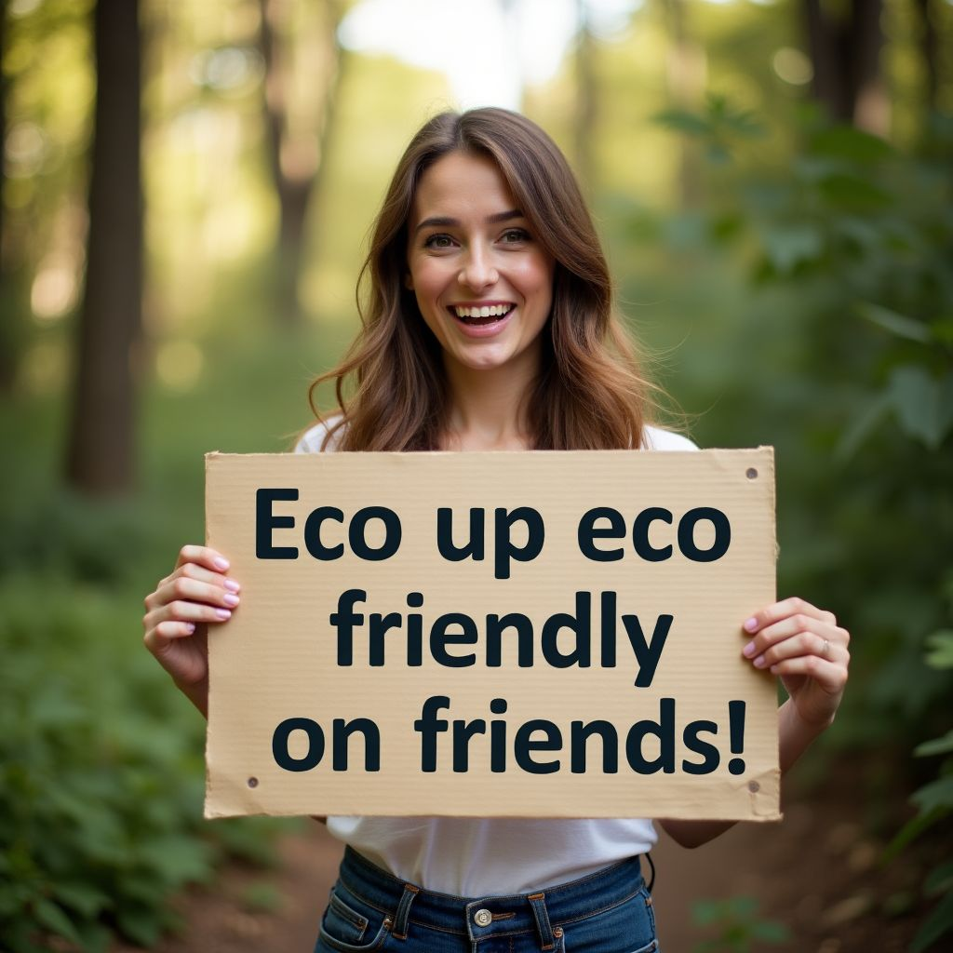  Valentine's Day represents a challenging time from an ecological standpoint. The surge in consumerism leads to overproduction, excessive waste, and increased carbon footprints. The packaging materials, many of which are non-recyclable, contribute to significant environmental degradation. It's crucial that society reconsiders how we celebrate this day. We should focus on sustainable practices, such as choosing eco-friendly gifts and reducing waste. Promoting awareness about the environmental impact of our consumption habits is essential to ensuring that our expressions of love do not come at the expense of our planet's health.  Valentine's Day presents ecological challenges due to overproduction, waste, and increased carbon footprints.

📝 What problem does the different perspectives reveal with regard to consumption on/for this day?
___________________________________________________________________
___________________________________________________________________
___________________________________________________________________

An opportunity for the economy or a threat to the environment?
As you have already recognized, consumption on or for this day can be a problem, as it brings both advantages and disadvantages. To answer the question of whether this consumption is more of an opportunity for the economy or a threat to the environment, you should take a closer look at the individual arguments. Analyze the problems and opportunities in order to arrive at a well-founded assessment.

📝Task

Note down the strengths, weaknesses, opportunities and risks that the different people mention in relation to consumption on this special day. Use the table for this.
Strengths | Weaknesses
Opportunities | Threats

Promoting sustainable practices · Enhancing community engagement through celebrations · Increasing awareness of environmental impact · Overwhelming workload for delivery drivers · Increased CO2 emissions from delivery vehicles · Generates economic benefits for local suppliers and employees · Encourages people to express love and affection · Physical exhaustion for workers · Boosts sales for retail businesses · Potential negative ecological impact · Creates a festive atmosphere · Encouraging eco-friendly gift choices · Excessive packaging waste · Environmental degradation from non-recyclable materials · Significant environmental impact · Overproduction and consumerism leading to waste

📝Task

Can you think of any other strengths, weaknesses, opportunities or risks? Complete the table.

📝Task
What do you think, is consumption on this day an opportunity for the economy or a threat to the environment? Take a differentiated stance and explain your arguments.

___________________________________________________________________

___________________________________________________________________

___________________________________________________________________

___________________________________________________________________

