The planets in our solar system

Look at the following picture and try to put the planets in the correct order.
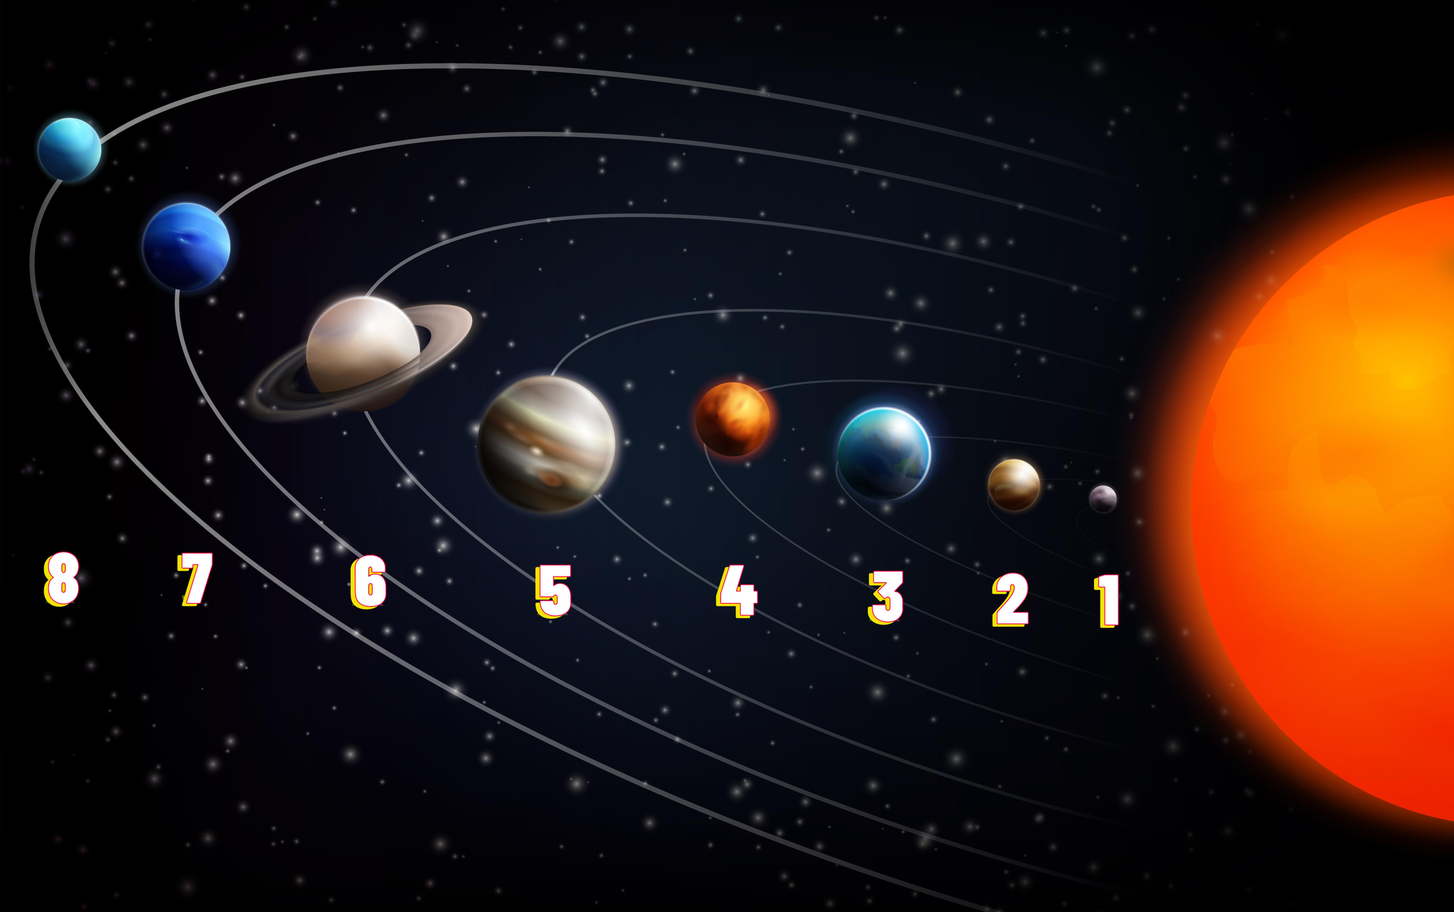

Sort the planets from smallest to furthest distance to the Sun.
1 |  | Venus
2 |  | Jupiter
3 |  | Neptune
4 |  | Earth
5 |  | Mars
6 |  | Uranus
7 |  | Mercury
8 |  | Saturn

A closer look at a planet
Now learn more about a planet in our solar system. Read the text, then fill out the profile on the following page.

Earth

Earth
Sun
solar system
life
is the third planet from the and the fifth largest in our . It has a diameter of about 12,742 kilometers, making it the largest of the terrestrial planets, which include Mercury, Venus, and Mars. Earth is unique because it is the only planet known to support .

crust
mantle
core
Earth is made up of different layers. The outer layer is called the , which is mostly made of rocks and minerals. Below the crust is the , which is made of hot, semi-solid rock. At the center is the , which is divided into the outer and inner core, composed mostly of iron and nickel. The movement of the liquid outer core creates Earth's magnetic field.

atmosphere
Earth's is vital for life. It is composed mainly of nitrogen (about 78%) and oxygen (about 21%), with small amounts of other gases like carbon dioxide and argon. This atmosphere protects us from the Sun's harmful rays and helps keep the planet warm enough to sustain life.

In the solar system, Earth is the third planet from the Sun, positioned between Venus and Mars. It takes about 365.25 days to orbit the Sun, which is why we have a leap year every four years to keep our calendar in sync.

moon
Earth has one that is large compared to other moons in the solar system. This moon affects the planet's tides and stabilizes its rotation, which helps maintain a stable climate. Earth does not have rings like Saturn or Jupiter.

habitable
Earth is the only planet known to be . It has water in liquid form, a stable climate, and the right conditions for plants and animals to thrive. Scientists are always looking for other planets where life might be possible, but for now, Earth is our home and the only place where life is confirmed to exist.

In summary, Earth is a large, rocky planet with a life-supporting atmosphere, one moon, and no rings. It is a special place in our solar system, providing a home for countless living organisms, including humans.

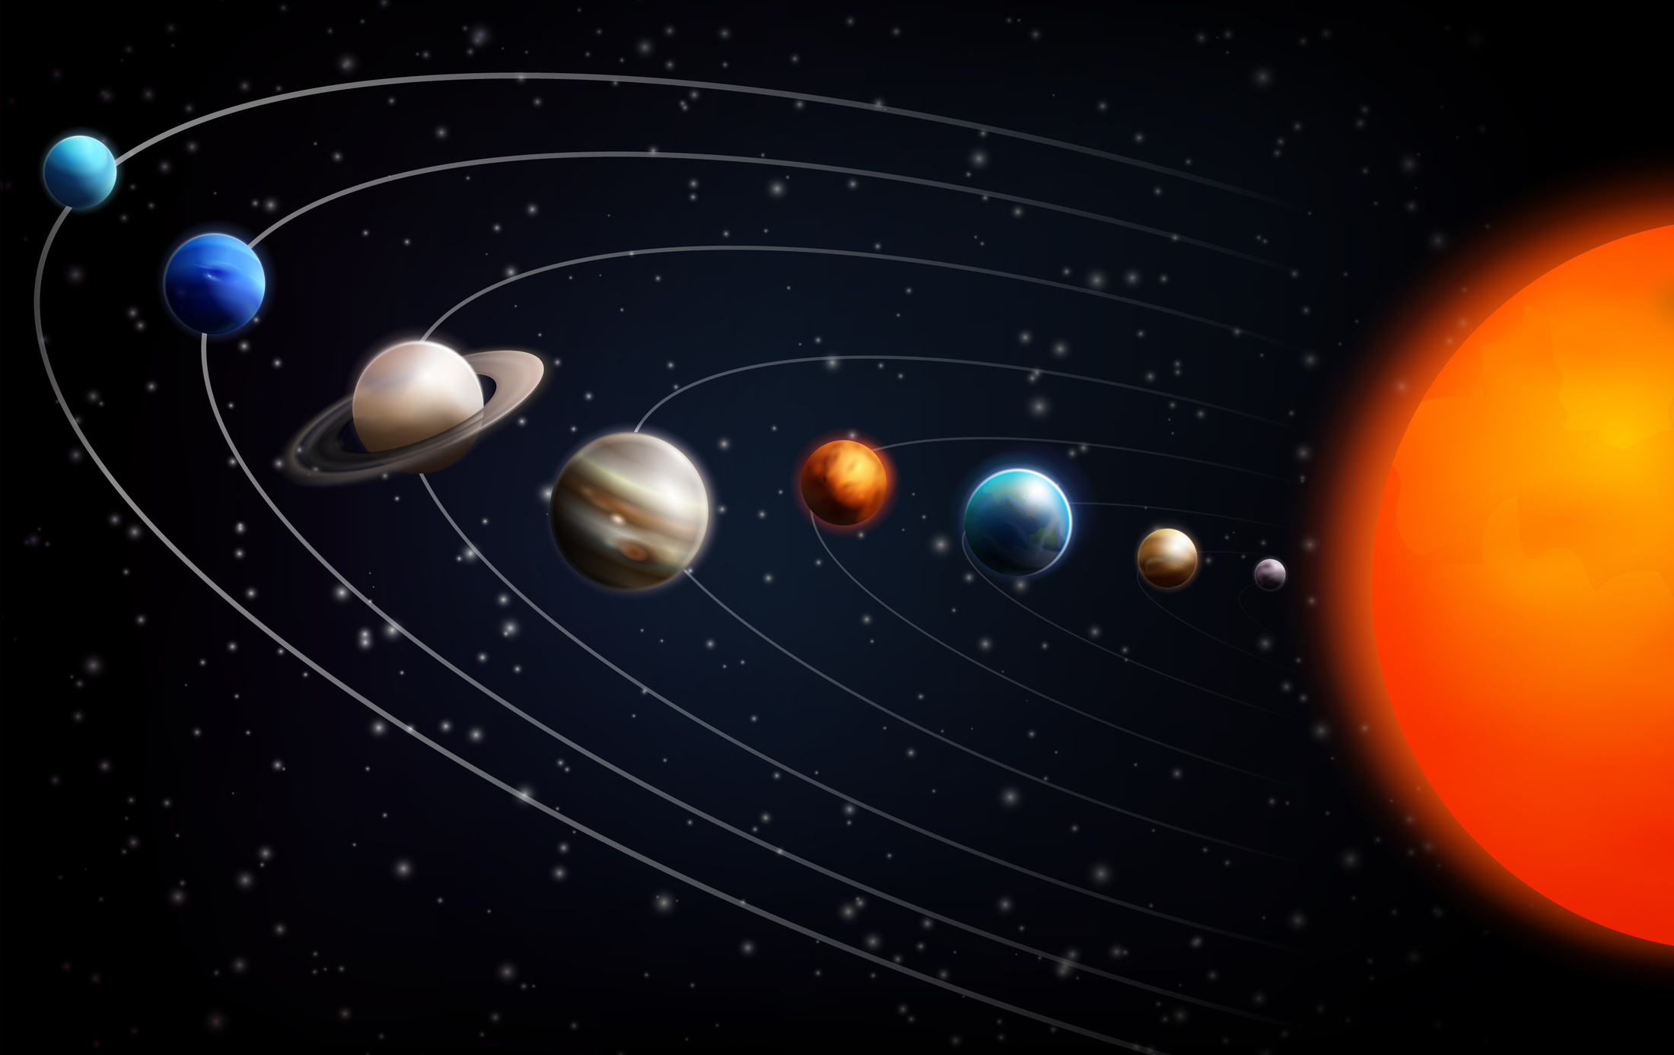 | Name
 | Size of the planet
 | Composition of the planet
Atmosphere

Position in the solar system

Satellites and rings

Habitability

Mnemonic to remember the order of planets
Here is a tip how you can remember the order of planets: in the following mnemonic each word starts with the same letter as one of the planets:

m
v
e
m
j
s
u
n
y ery ducated other ust erved s oodles

M
V
E
M
J
S
U
N
ercury enus arth ars upiter aturn ranus eptune

