Meteoroid

Prior knowledge
What do you already know about the topic? Collect your knowledge together as a class and create a mindmap.


Meteoroid

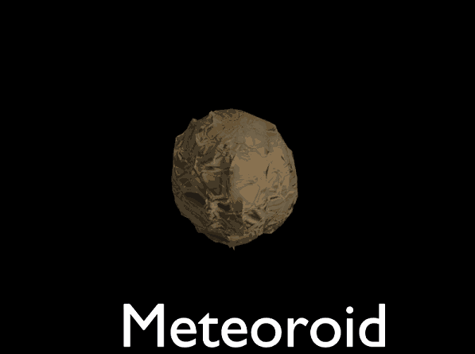

Source: Wikipedia

A meteoroid is a fascinating object in outer space, much smaller than asteroids, ranging from tiny grains to rocks about three feet wide. These space travelers become visible as meteors when they enter Earth's atmosphere, creating streaks of light known as shooting stars. If they survive their fiery journey and land on Earth, they're called meteorites.

Meteoroids have interesting origins. Many are fragments from comets or asteroids, while others are bits of debris from collisions on planets like the Moon or Mars. Each day, around 25 million meteoroids, micrometeoroids, and space debris enter Earth's atmosphere, adding up to about 15,000 tonnes of material each year!

These objects are made from stony or metallic material, often containing nickel and iron. Scientists use light spectra and trajectory measurements to study their compositions as they zoom through the sky. Meteoroids can have different orbits, sometimes forming streams linked to a parent comet, which creates meteor showers.

In our solar system, meteoroids usually come from the asteroid belt, moved by the gravity of planets. They travel at varying speeds, with the fastest reaching 42 km/s near Earth's orbit. When they collide with Earth's atmosphere, they can reach speeds of up to 71 km/s, especially if they're in a retrograde orbit.

If a meteoroid survives its journey and impacts Earth, it might leave behind an impact crater. These craters are common on planets or moons with little atmosphere, like the Moon or Mars. On Earth, the meteoroid's collision transforms its structure and chemistry, sometimes leaving visible impact craters or even vaporizing entirely.

Meteoroids are small yet mighty, traveling through space and occasionally visiting Earth as meteors or meteorites. These cosmic wanderers offer us a glimpse into the universe's mysteries, helping scientists understand more about space and the solar system's formation.

For each statement, choose if it's true or false.

Meteoroids are much larger than asteroids.
True False

When meteoroids enter Earth's atmosphere, they become meteors.
True False

Meteorites are meteoroids that have survived their journey to Earth.
True False

Meteoroids are mostly made of water and ice.
True False

The fastest meteoroids near Earth's orbit can travel at 42 km/s.
True False

Meteoroids often come from the asteroid belt in our solar system.
True False

Each day, around 25 million meteoroids enter Earth's atmosphere.
True False

Impact craters are rare on planets with thick atmospheres.
True False

The interview
Read an interview with a physicist who is talking about the current state of research. Then answer the questions.

Please note: This interview was generated by AI and does not feature a real conversation with the expert.
Neil deGrasse Tyson:
Hi everyone, I'm Neil deGrasse Tyson. I study the stars and planets, and I love to learn about the universe. I've been doing this for a long time, since I was a kid, and I even work at a big place called the Hayden Planetarium in New York City.

Interviewer:
When did people start studying meteoroids?

Neil deGrasse Tyson:
People have been curious about meteoroids for a long time! Meteoroids are space rocks that range from tiny dust grains to larger rocks. Scientists have been studying them closely for about a hundred years, trying to understand where they come from and what they're made of.

Interviewer:
What is the current state of meteoroid research?

Neil deGrasse Tyson:
Right now, researchers are using telescopes and radar to track meteoroids. They want to know how fast they travel and how they can affect things like spacecraft. NASA and other organizations are working hard to learn more about these space rocks.

Interviewer:
What questions have scientists answered about meteoroids?

Neil deGrasse Tyson:
Scientists have discovered that most meteoroids come from asteroids, which are large rocks in space. They've also figured out that meteoroids travel really fast, sometimes faster than 100,000 kilometers per hour! And some meteoroids even come from the Moon and Mars.

Interviewer:
Are there questions we still need to answer?

Neil deGrasse Tyson:
Absolutely! Researchers are still trying to understand how meteoroids form and why they explode before reaching Earth. They're also curious about the effects meteoroids can have on our planet's atmosphere. There's always more to learn!

Interviewer:
Wow! Thank you, Mr. Tyson, for sharing your knowledge with us!

Neil deGrasse Tyson:
You're welcome! Keep looking up at the stars and asking questions. That's what makes science fun!

What are meteoroids and where do most of them come from?
___________________________________________________________________
___________________________________________________________________
___________________________________________________________________
How do scientists study meteoroids and what have they discovered?
___________________________________________________________________
___________________________________________________________________
___________________________________________________________________

