Harris 2024: "Let's WIN this."

Kamala Harris, the first female Vice President of the United States, launched her 2024 presidential campaign with a powerful message of resilience and hope. Following President Biden's withdrawal, Harris became the Democratic nominee, promising to address key crises such as economic inequality, healthcare access, and climate change. Her campaign slogans, "Let's WIN this," "When we fight, we win," and "We're not going back," resonated with many Americans seeking stability and progress.

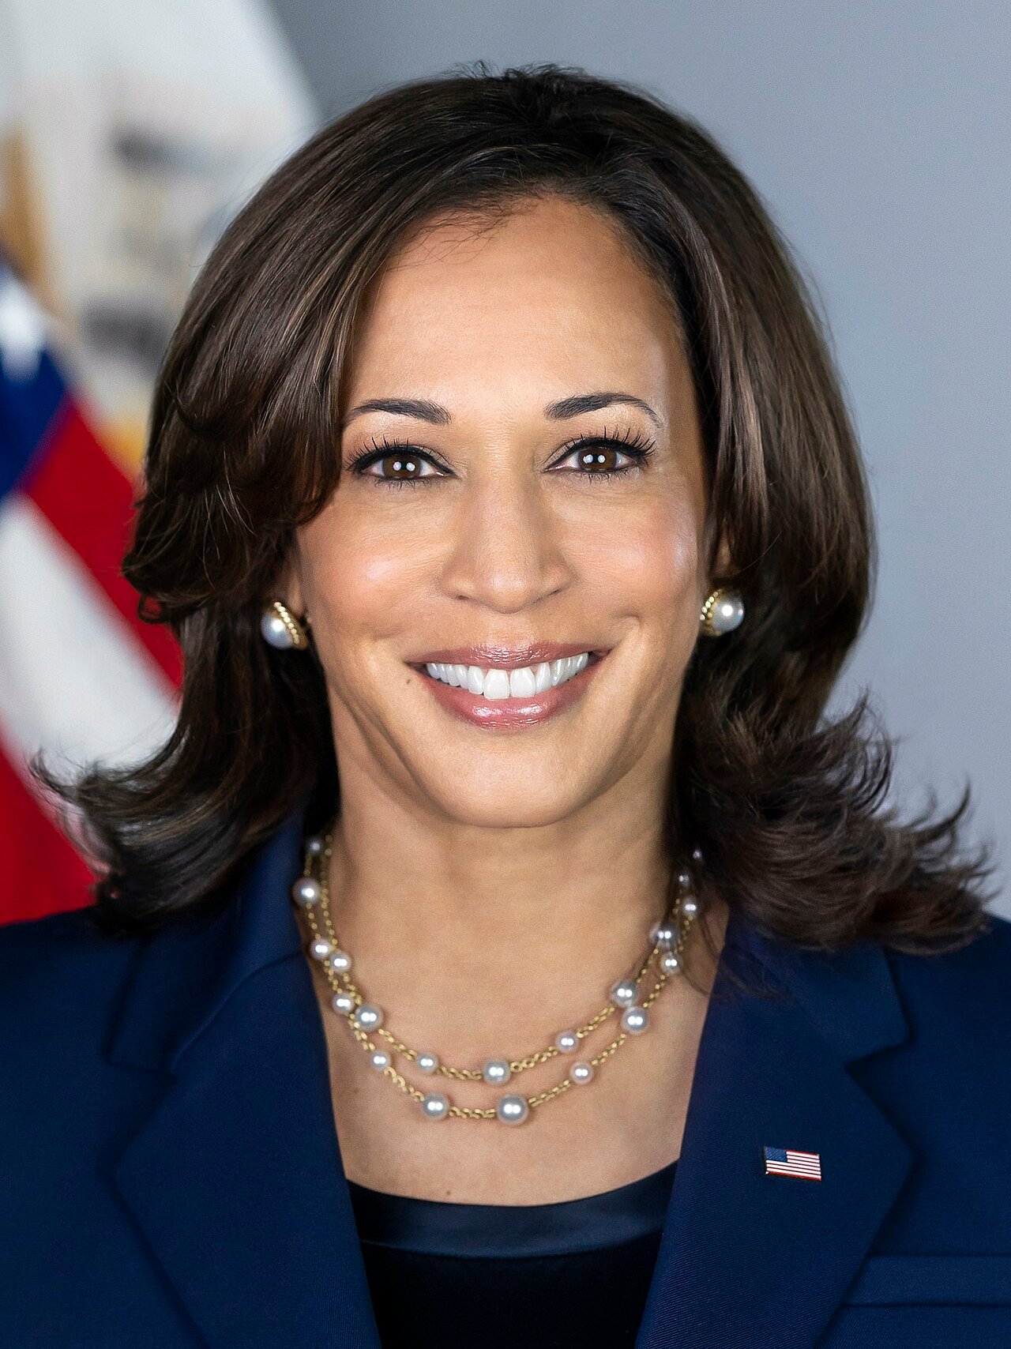

Kamala Harris at a rally in 2024 (Source: Wikipedia)

Throughout her campaign, Harris emphasized her expertise in law and policy, gained from her tenure as California's Attorney General and U.S. Senator. She addressed the need for national abortion protections, gun control, and federal cannabis legalization. Harris's economic platform, described as populist, included capping prescription drug costs and expanding the child tax credit.

Harris faced allegations about her past decisions as Attorney General, but she met these challenges head-on, highlighting her commitment to reform and justice. She remained focused on her vision for America's future, often contrasting her plans with those of her main opponent, Donald Trump. Harris criticized Trump's policies sharply, branding them as chaotic and divisive.

In campaign events filled with optimism, Harris promised to fight for a better America, advocating for strong border security coupled with immigration reform. She reassured her supporters that her administration would bring positive change, focusing on freedom and the future. As the election nears, Harris's message of resilience and progress continues to inspire many across the nation.

Analyzing Election Campaign Narratives
Election Campaign Narratives
why
vote for them
who
why
the best choice
five
often used narrative types
are stories that politicians use to explain people should . These stories help voters understand they are and they are . Here is a list of very important and :

1.

"hero" who will save the day
A hero story is when a politician presents themselves as the . They tell stories about the good things they've done or how they will help solve a big problem, like improving schools or making neighborhoods safer.

2.
problem
needs to be solved right away
A crisis narrative is used when the candidate talks about a big , or crisis, that . They explain how the crisis is affecting people and how they are the best person to fix it. It could be about a serious issue like bad roads or unsafe communities.

3.
problem
they are really good at solving
"own"
issue
best at handling it
In an issue ownership narrative, the candidate focuses on a specific or issue . For example, one candidate might focus on improving education, while another might be known for protecting the environment. They thatbecause they are seen as the .

4.
candidate talks about
opponent in a bad way
Negative campaigning is when a their . They might say their opponent did something wrong or isn't fit for the job.

5.
made a mistake
explain what happened
ry to fix their image
Image restoration strategies are used when a candidate has or done something people didn’t like. The candidate tells a story to and how they’ve learned from their mistakes. They tso people will trust them again.

📋 Task 1: Find out about the objectives that the five types of campaign narratives typically pursue by matching the five types to their objective description.
Hero Stories |  | Voters might forgive the candidate and believe that they have changed or learned from their errors, giving them a second chance to lead.
Crisis Narratives |  | Voters see the candidate as someone who understands the problem and has the solutions to get things back to normal. They feel the candidate is the right person for the job in a tough situation.
Issue Ownership |  | Voters associate the candidate with solving that specific problem and trust them to be the expert. For example, if you care about education, you’ll think of the candidate who 'owns' that issue as the best choice.
Negative Campaigning |  | Voters may start to see the opponent in a negative light and believe the candidate speaking negatively is the better choice because they pointed out problems with the other person.
Image Restoration Strategies |  | Voters see the candidate as brave, strong, and capable of making their lives better—like a hero in a movie.

📋 Task 2: Match the statements extracted from the newspaper article to the five types of election campaign narratives.
Harris frames her campaign as 'a choice between freedom and chaos,' 'advocating for positive change and progress.' |  | Image Restoration Strategies
Harris promises to address issues like 'economic inequality, healthcare access, and climate change.' |  | Crisis Narratives
Harris emphasizes her stances on 'national abortion protections, gun control, and federal cannabis legalization.' |  | Issue Ownership
Harris contrasts her vision with Donald Trump’s, branding his policies as 'chaotic and divisive.' |  | Negative Campaigning
Harris faced allegations about her past decisions as Attorney General but highlighted her 'commitment to reform and justice.' |  | Hero Stories

📋 Task 3:
Search the newspaper article for another campaign narrative. Assign it to one of the five narrative types and make a hypothesis about the goal the narrative is pursuing.

___________________________________________________________________

___________________________________________________________________

___________________________________________________________________

___________________________________________________________________

