Austrian Legislative Election 2024: A Historic Shift

On September 29, 2024, Austrians cast their votes in a landmark legislative election to elect the 28th National Council. The election witnessed the far-right Freedom Party of Austria (FPÖ) clinch 28.8% of the vote, marking a historic first as they emerged as the largest party in the National Council. This unprecedented victory underscores a significant shift in Austria's political landscape, as it is the first time a far-right party has led since World War II.

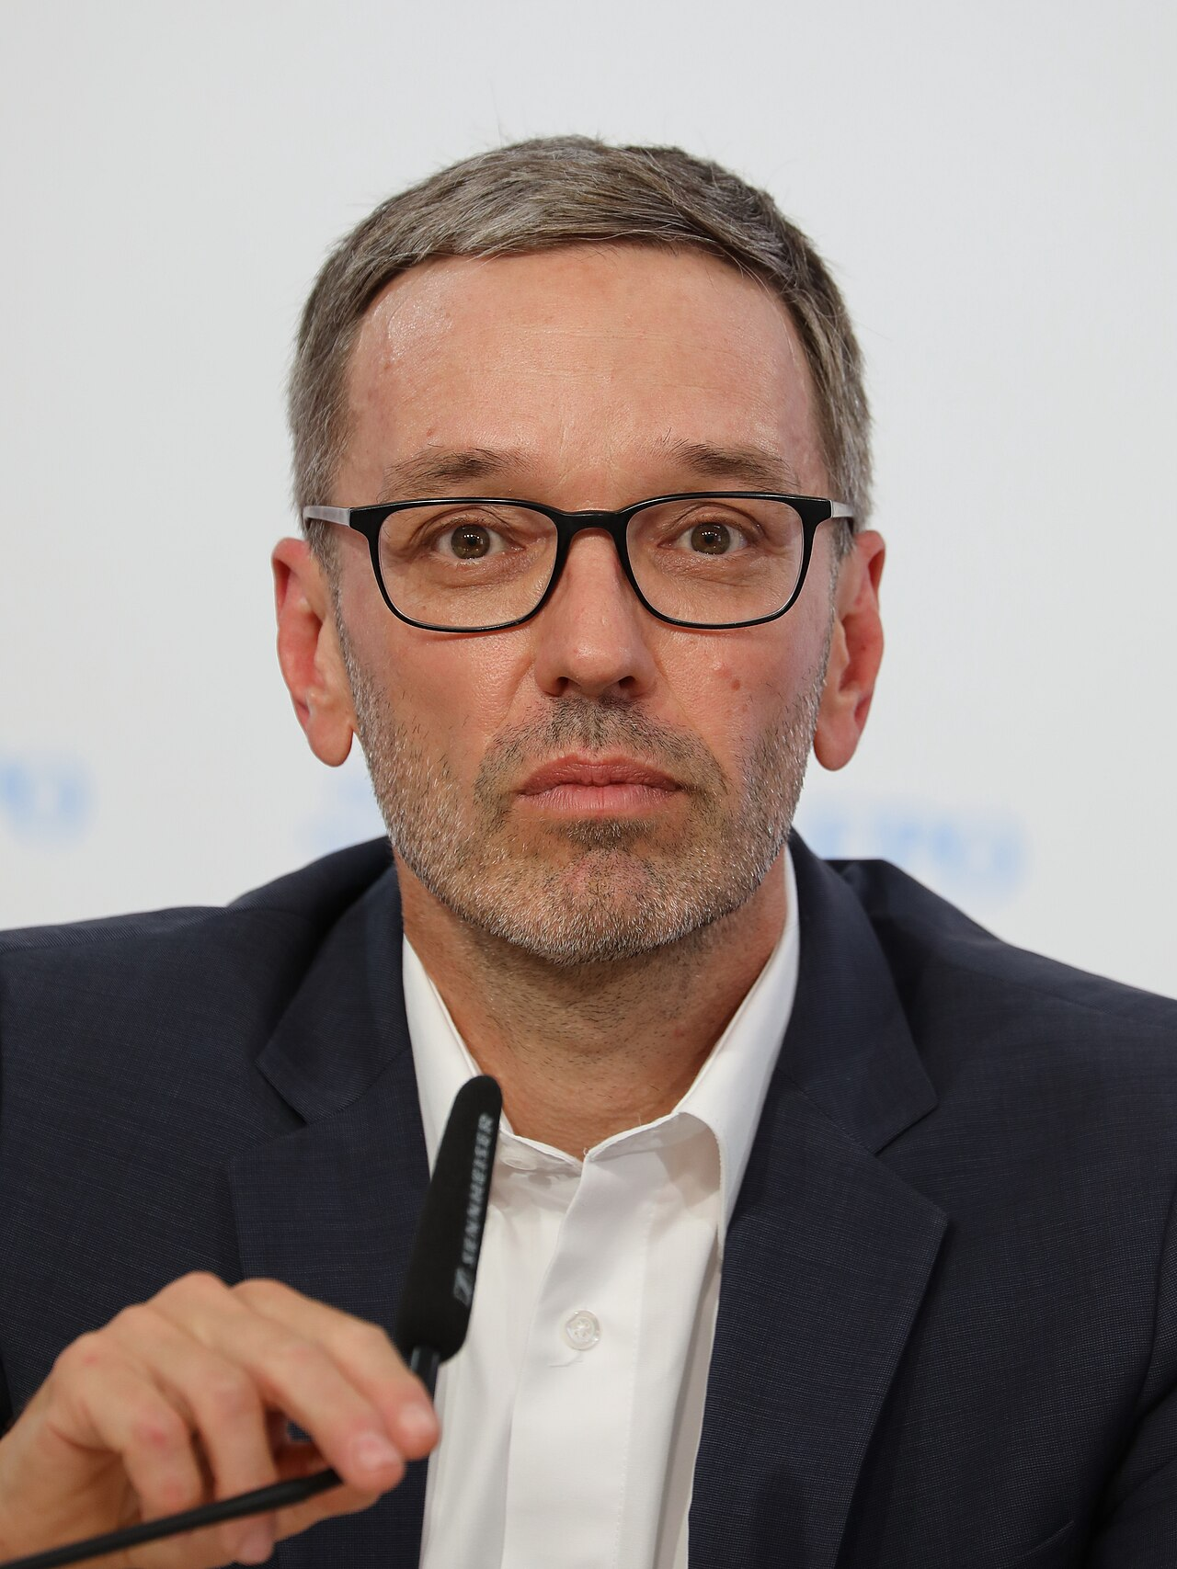

Herbert Kickl, leader of the FPÖ.
Source

The ruling Austrian People's Party (ÖVP) suffered a significant setback, losing 20 seats, while their coalition partners, the Greens, lost 10 seats. The Social Democratic Party (SPÖ) also faced a disappointing outcome, securing just 21.1% of the vote, their worst result in history, though they gained one seat. NEOS, another contender, improved slightly from the previous election, increasing their seats from 15 to 18.

The election was marked by a high voter turnout and a series of contentious issues, including rising inflation, housing affordability, and immigration. The FPÖ capitalized on public discontent, promising stricter immigration laws and a crackdown on political Islam. Their campaign rhetoric drew comparisons to historical far-right movements, raising concerns among many Austrians.

Polling stations were open from 07:00 to 17:00, with a record number of absentee ballots issued. The electoral process was streamlined following recent reforms, leading to most votes being counted on election day. With the FPÖ's victory, Austria now faces the prospect of a coalition government led by Herbert Kickl, a scenario that remains fraught with political and societal implications.

Select the correct answer

What percentage of the vote did the Freedom Party of Austria (FPÖ) secure in the 2024 legislative election?
28.8% 27.4% 25.3% 30.5%

Which party suffered a significant setback by losing 20 seats in the 2024 Austrian legislative election?
Social Democratic Party (SPÖ) NEOS The Greens Austrian People's Party (ÖVP)

How did the Social Democratic Party (SPÖ) fare in the 2024 Austrian legislative election?
They secured their worst result in history while gaining 1 seat. They remained static with no change in seats. They gained 5 seats. They lost 10 seats.

What main issues did the FPÖ capitalize on during their campaign leading up to the 2024 election?
Technological innovation and defense Environmental policies and education reform Healthcare and foreign policy Rising inflation, housing affordability, and immigration

What unique aspect did the 2024 Austrian legislative election have in terms of voter participation?
Compulsory voting for all citizens. Introduction of electronic voting for the first time. The lowest voter turnout in history. A record number of absentee ballots issued.

What time were polling stations open during the 2024 Austrian legislative election?
07:00 to 17:00 08:00 to 20:00 06:00 to 18:00 07:00 to 19:00

What are some potential societal concerns associated with FPÖ's victory?
Increased environmental degradation Decline in technological advancements Higher taxes and reduced government spending Rising nationalism and comparisons to historical far-right movements

Who is the leader of the FPÖ, the party that won the most votes in the 2024 Austrian legislative election?
Pamela Rendi-Wagner Sebastian Kurz Norbert Hofer Herbert Kickl

Some background information

Drag the words into the correct panels.
Austria operates under a ______________________________________________________ electoral system, ensuring that the composition of the National Council reflects the vote share of each party. This system allocates seats in a way that smaller parties also have a chance to be represented, avoiding dominance by any single entity. The National Council consists of 183 members who are elected to serve a five-year term. Voting is open to Austrian citizens aged 16 and over, making ______________________________________________________ one of the few countries that allow adolescents to participate in national elections. The country is divided into nine regional constituencies, which are further segmented into 39 electoral districts. Each party submits a list of candidates for each district, with seats being allocated based on the proportion of votes received. An important aspect of this system is the issuance of absentee ballots, which facilitates higher voter ______________________________________________________. This method ensures a more inclusive electoral process, reflecting the diverse political landscape of the country.
proportional representation, Austria, turnout,

Meet the candidates
Herbert Kickl  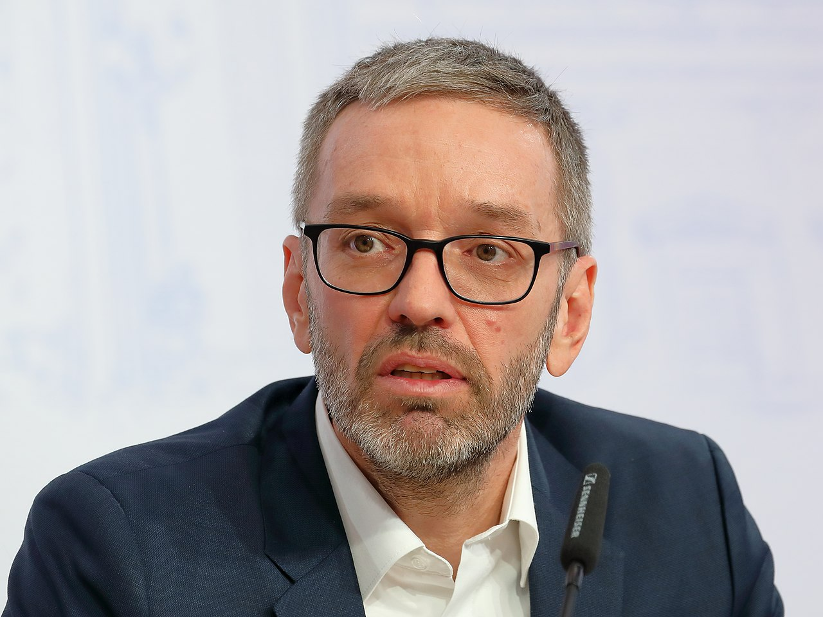  Herbert Kickl (born 19 October 1968) is an Austrian politician who has been the leader of the Freedom Party of Austria (FPÖ) since June 2021. He previously served as Minister for the Interior from 2017 to 2019 and has been described as a far-right politician. Kickl is known for his hardline stance on immigration and political Islam, advocating for a 'Fortress Austria' and remigration policies.  Kickl's political agenda is rooted in strong anti-immigration policies, advocating for stricter immigration laws and a crackdown on political Islam. He has often been compared to historical far-right movements due to his rhetoric. | Karl Nehammer  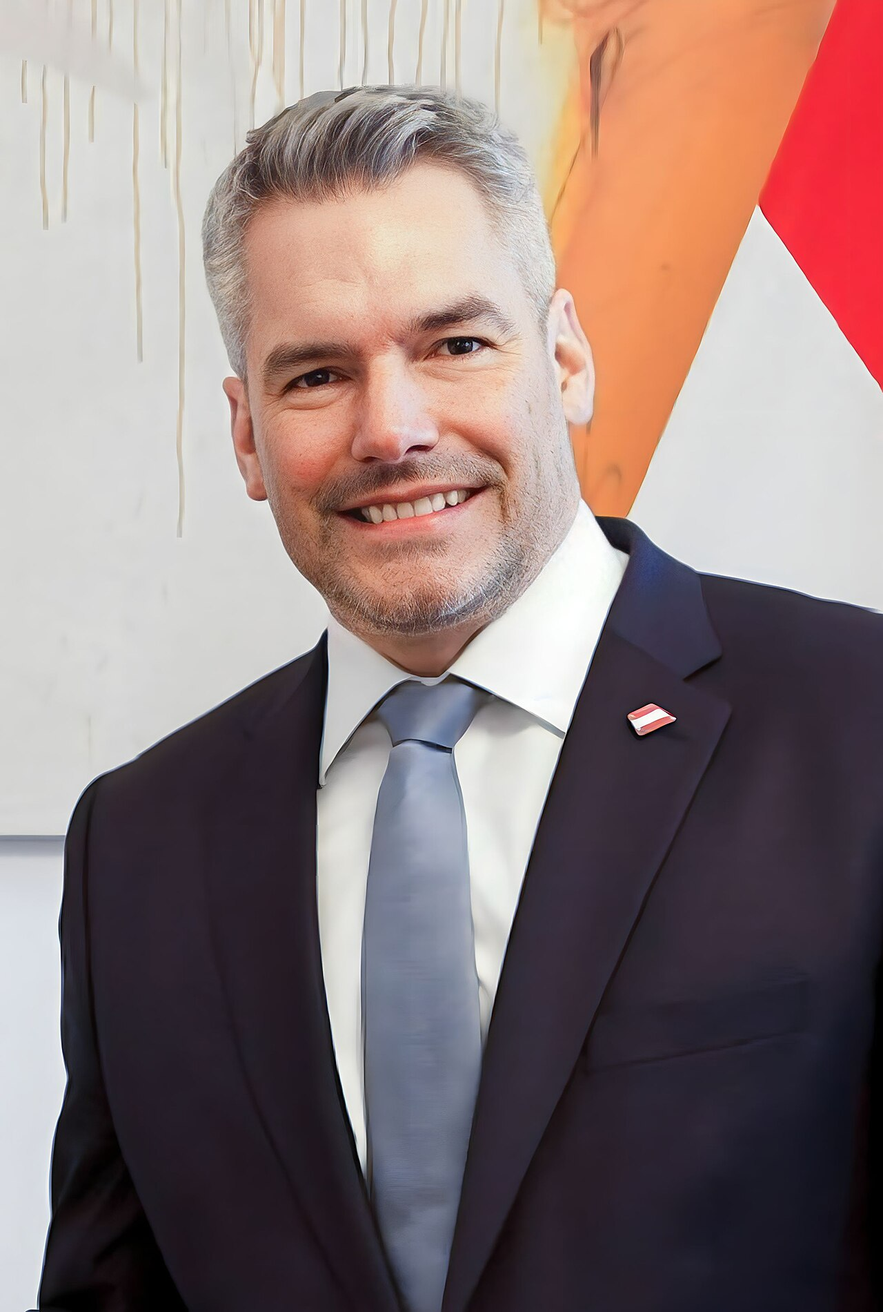  Karl Nehammer (born 18 October 1972) is an Austrian politician who has been the 29th Chancellor of Austria since 2021. A member of the Austrian People's Party (ÖVP), he previously served as Minister of the Interior from 2020 to 2021. Nehammer is known for his strong stance on security and migration issues, and his leadership during the COVID-19 pandemic.  Nehammer's political agenda focuses on maintaining strict security measures, managing migration effectively, and supporting strong international relations. His tenure has emphasized Austria's firm stance on security and economic stability.
Pamela Rendi-Wagner  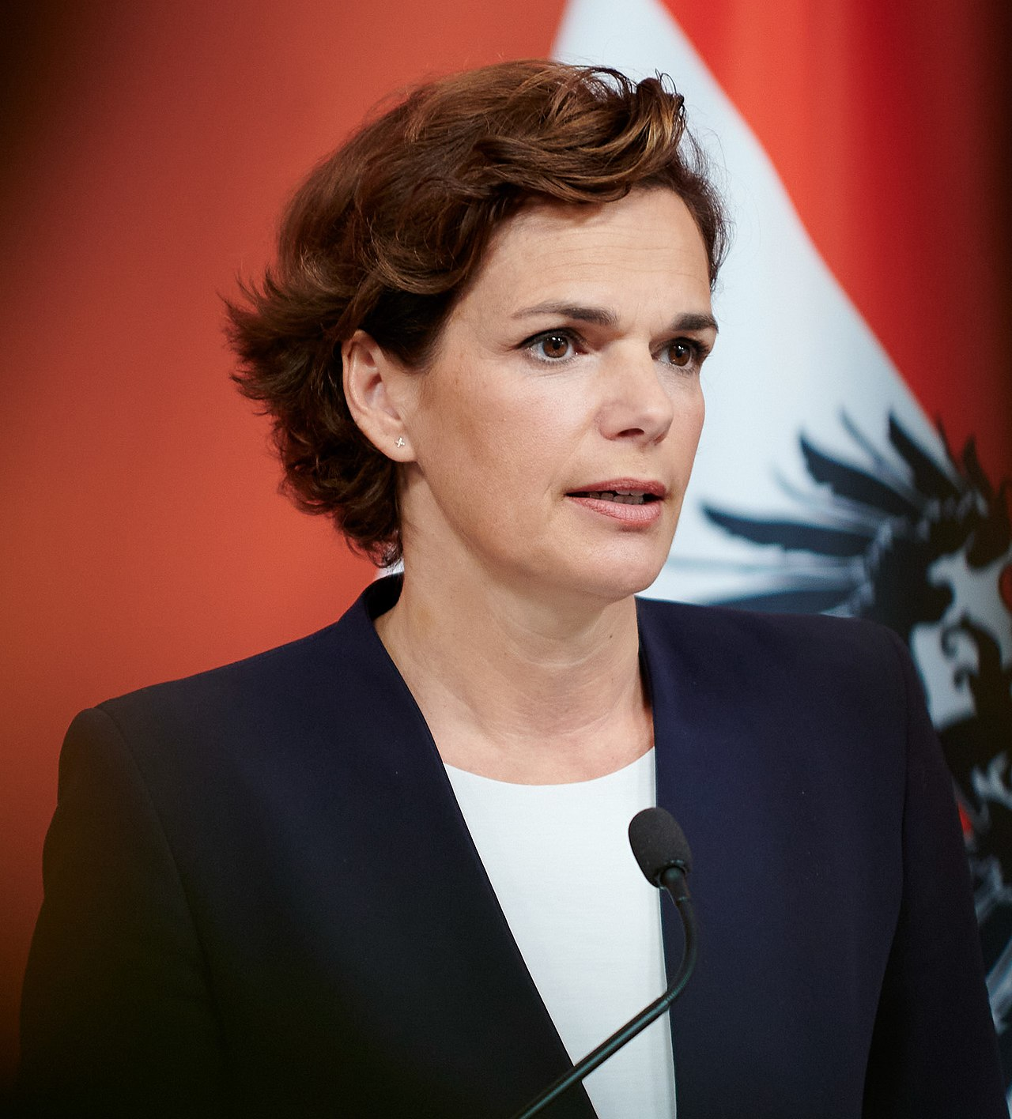  Pamela Rendi-Wagner (born 7 May 1971) is an Austrian physician and politician who is the current director of the European Centre for Disease Prevention and Control. She previously served as chairwoman of the Social Democratic Party (SPÖ) and was the first woman to lead the SPÖ. Rendi-Wagner has a strong background in public health and has been an advocate for social justice and equal opportunities.  Rendi-Wagner's political agenda emphasizes modern, progressive policies focusing on health, social justice, and equal opportunities. She aims to provide a sharp contrast to conservative policies, advocating for a strong welfare state and public health system. | Werner Kogler  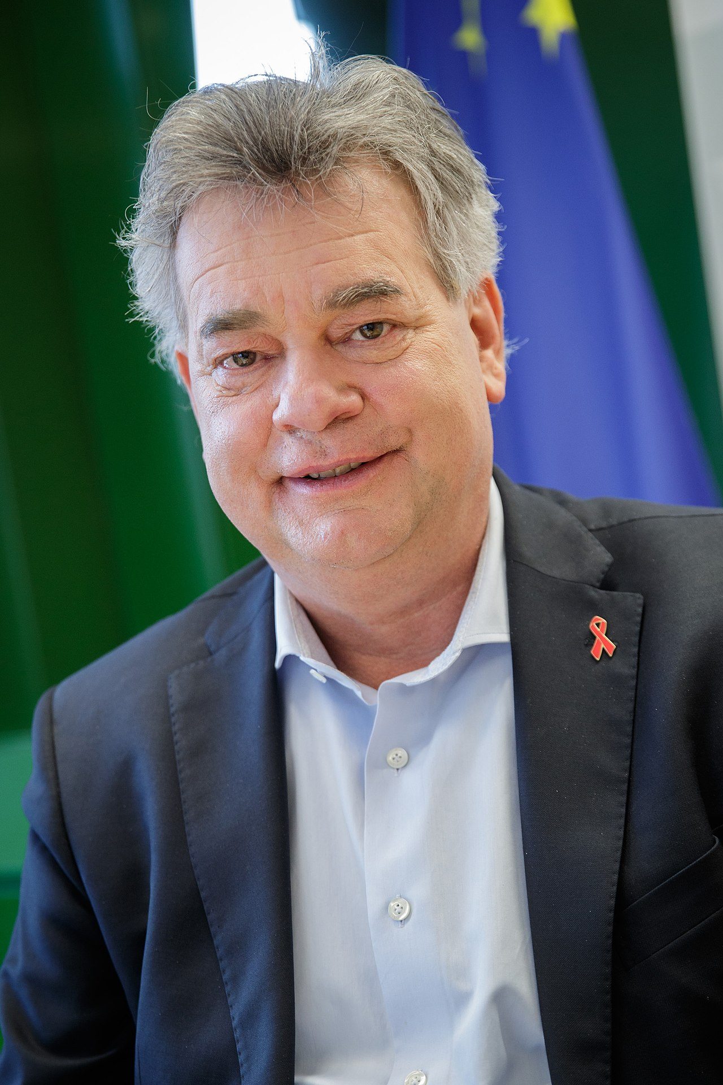  Werner Kogler (born 20 November 1961) is an Austrian politician of the Green Party who has been serving as Vice-Chancellor of Austria and Minister for Arts, Culture, the Civil Service, and Sport since 2020. Kogler is known for his dedication to environmental issues and his role in coalition negotiations that brought the Greens into government.  Kogler's political agenda is centered around environmental sustainability, aiming to make Austria carbon neutral by 2030. He supports investments in renewable energy, public transport, and cultural initiatives, while advocating for social equality and civil rights.

