Different traditions
Lucas
Hi Lucas! Are you excited for Halloween?
Hey Sophia! Yeah, I can't wait! How do you celebrate it in Spain?
We usually have costume parties and go trick-or-treating, but it's more common to honor the dead on All Saints' Day. How about in the US?
We do a lot of trick-or-treating, haunted houses, and Halloween parties. My parents told me Halloween used to be more about spooky ghost stories and less about candy.
That's interesting! My grandparents said that in Spain, they used to carve turnips instead of pumpkins. Have you heard of anything like that?
Not really. Here it's always been pumpkins as far as I know. Carving turnips sounds cool but hard! Do you still do any old traditions?
We still light candles for our loved ones on All Saints' Day, but most kids are more into the Halloween costumes and parties now. Do you still tell ghost stories?
Sometimes, but mostly we just watch scary movies. I think ghost stories are making a comeback though. Do you have a favorite Halloween costume?
I love dressing up as characters from my favorite books. This year I'm going as Hermione from Harry Potter. What about you?
Cool! I'm going as a zombie. I think it's fun to do the makeup. Do you decorate your house for Halloween?
A little bit. We put up some spooky lights and fake cobwebs. How about you?
We go all out with decorations, like fake tombstones and skeletons. It's a big event in our neighborhood. Do you get a lot of trick-or-treaters?
Not as many as you probably do. It's getting more popular here, but still not like in the US. Do you have a favorite Halloween candy?
Definitely Reese's Peanut Butter Cups. What’s yours?
I love gummies, especially the spooky-shaped ones. How late do you stay out on Halloween?
Usually until 9 or 10. How late do you stay out?
About the same. It's fun to see everyone in their costumes. Have a great Halloween, Lucas!
You too, Sophia! Happy Halloween!

How do you celebrate?
Read the chat conversation and talk about it in class: Do you celebrate this traditional holiday, and if so, how? Do you know of any other customs associated with this day?

Traditional holidays in different countries

The traditional holiday is celebrated differently in various countries. Can you correctly match the traditions?

Match the country with the tradition.
USA |  | Parties with scary costumes are held in homes.
Mexico |  | People walk through haunted houses.
Ireland |  | Pumpkin carving contests are popular.
Japan |  | Eating 'Ossa dei Morti' cookies on this day is common.
Canada |  | Parades with elaborate costumes take place in cities.
Germany |  | Kids dress up and go door-to-door for candy.
Italy |  | Families create altars to honor deceased loved ones.
France |  | People light bonfires and enjoy traditional games.

Traditional holidays in transition

Have a look at how traditions associated with the traditional holiday have changed over the course of several centuries.

Elizabeth, 1750  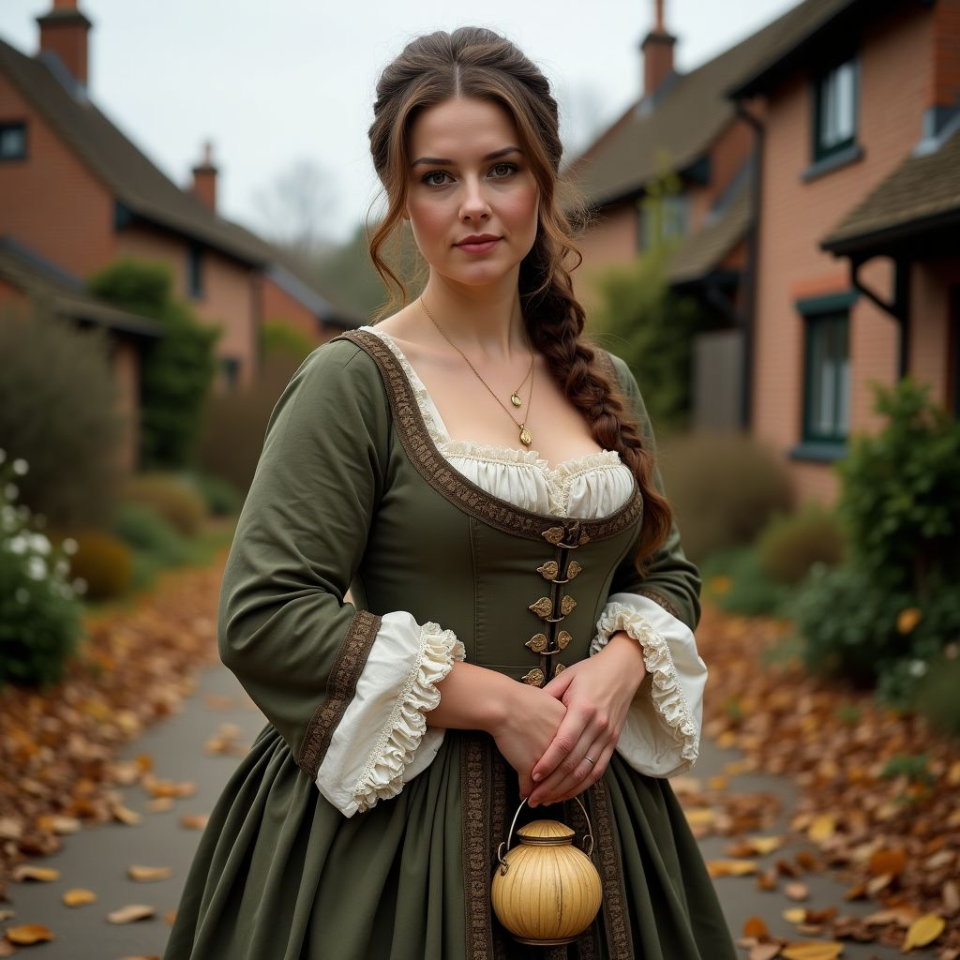  Greetings, I am Elizabeth, and the year is 1750. In England, we celebrate Halloween with simple but meaningful traditions. We carve faces into turnips and place candles inside to ward off evil spirits. Children go from house to house, reciting verses or singing songs in exchange for soul cakes. It's a night filled with a bit of mischief and a lot of community spirit.  Elizabeth describes Halloween in 1750 England, focusing on turnip lanterns, soul cakes, and communal activities. | William, 1900  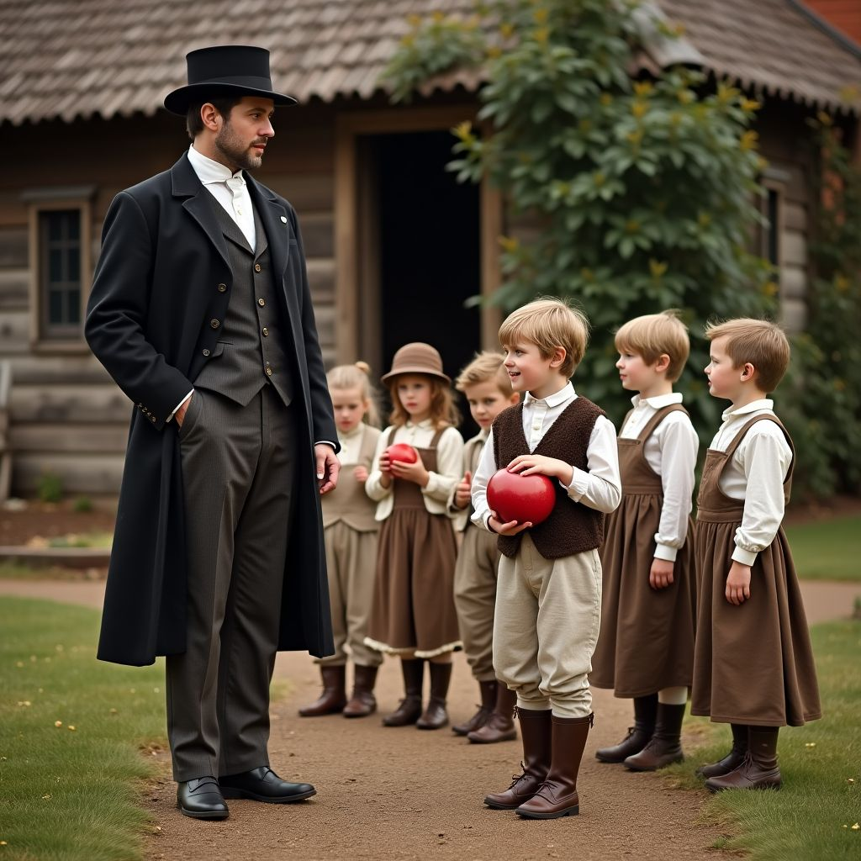  Hello, my name is William, and it is the year 1900 in England. Halloween has evolved quite a bit since my grandmother's time. Now, children enjoy dressing up in homemade costumes and playing games like bobbing for apples. We also carve pumpkins instead of turnips, and the night is filled with laughter and fun, rather than fear of spirits.  William describes Halloween in 1900 England, noting the shift to pumpkins, costumes, and playful activities. | Sophie, 2023  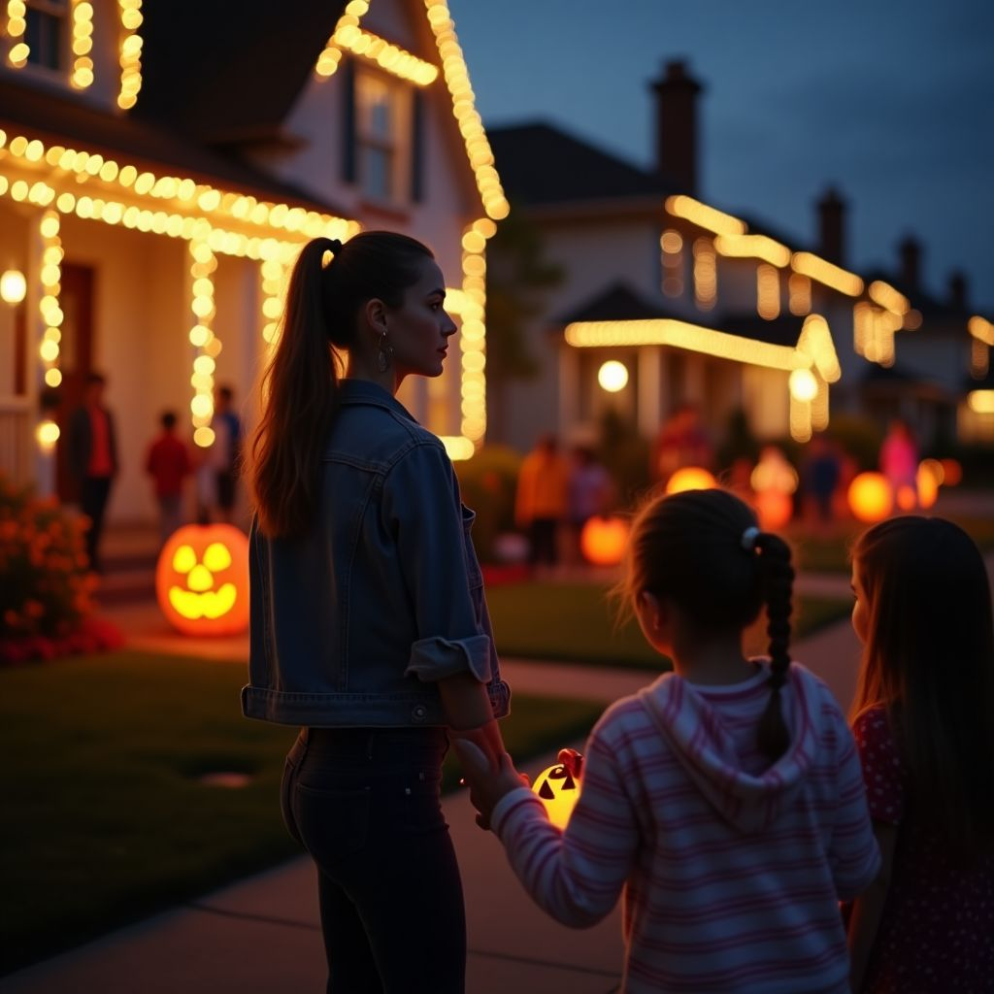  Hi, I'm Sophie, and it's the year 2023 here in England. Halloween has become a major celebration with elaborate decorations and themed parties. Children and even adults dress up in a wide range of costumes, from spooky to funny. Trick-or-treating is a huge event, and people go all out with their decor. It's fun to see how this tradition has grown and changed over the centuries.  Sophie describes modern Halloween in 2023 England, highlighting decorations, costumes, and the popularity of trick-or-treating.

What important differences can you identify in the way the traditional holiday was celebrated in the past compared to today? Note them down.
___________________________________________________________________
___________________________________________________________________
___________________________________________________________________
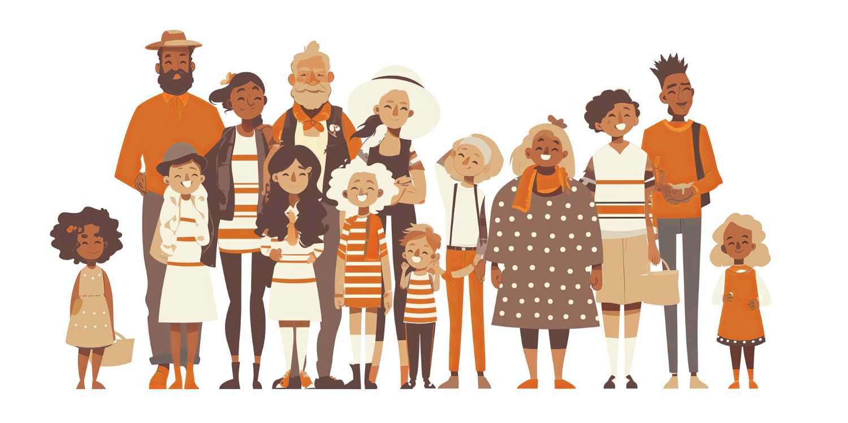

A different side of the tradition

Now read the newspaper article on the following page. What problem is being addressed here?

Haunting Pollution: The Environmental Cost of Halloween

Each year, Halloween enthusiasts eagerly await October 31st to don their spookiest costumes and revel in festive fun. However, behind the vibrant masks and eerie decorations lies a haunting reality: the environmental toll of this beloved holiday. From excessive plastic waste to chemical-laden makeup, Halloween's environmental impact is frighteningly significant.

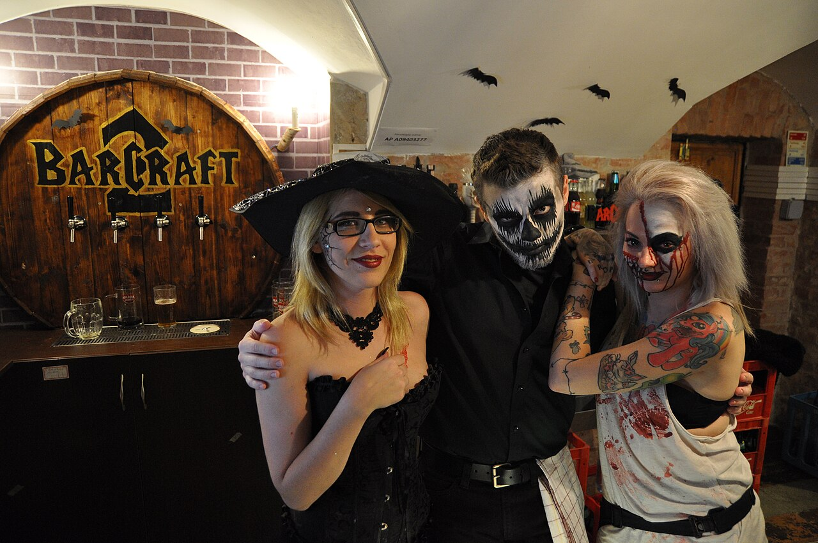

Bartenders dressed as Ghouls during Halloween in Budapest. Source: Christo,
File:Budapest, BarCraft 2, Halloween, 23.jpg
, CC BY-SA 4.0

With Americans spending an estimated $9.1 billion on Halloween merchandise in 2017, the holiday has turned into a massive consumer event. This surge in spending leads to an increase in single-use plastics, from candy wrappers to costume accessories, contributing to landfills and ocean pollution. Additionally, the rise in demand for fast fashion costumes exacerbates the already critical issue of textile waste.

Moreover, the environmental cost extends to Halloween makeup. Many products contain harmful chemicals that can seep into the skin and waterways, posing risks to both human health and aquatic life. As Halloween continues to grow in popularity, it is crucial to address these environmental concerns. Sustainable alternatives, such as homemade costumes and eco-friendly decorations, can help mitigate the negative impact of this festive tradition.

The haunting reality is clear: while Halloween brings joy and excitement, it also leaves behind a trail of environmental damage. By making conscious choices, we can ensure that our celebrations are not only fun but also eco-friendly, allowing future generations to enjoy the magic of Halloween without the ghastly environmental repercussions.

Criticism of traditional holidays
Although traditional holidays are celebrated often and with enthusiasm, there are also frequently negative aspects associated with them. Can you imagine what points might generally be criticized about traditional holidays?

Collect your ideas together in the class.

Discussion - Partner Work

Now prepare a discussion with role cards in partner work. One of you will take the pro position, and the other person will take the contra position. In addition to the arguments on the role cards, try to find other arguments for your position.

Emma (pro)  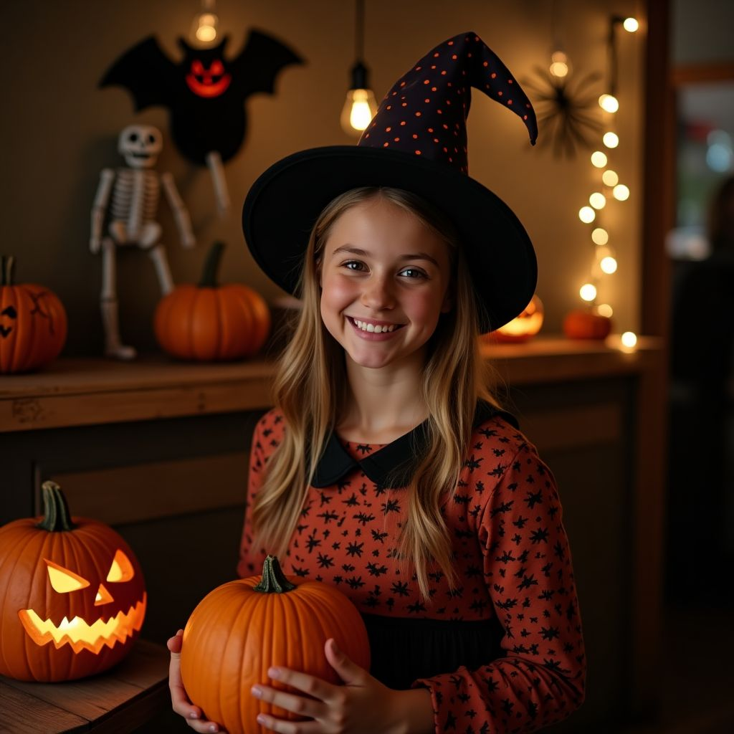  Halloween is a fantastic tradition that brings communities together in a fun and creative way. It's a day where people of all ages can express themselves through costumes, enjoy festive activities like trick-or-treating, and experience the joy of imaginative play. Halloween also has economic benefits, boosting sales for local businesses and providing job opportunities. Additionally, it encourages cultural exchange as people explore different myths, legends, and traditions from around the world.  Emma highlights the positive aspects of Halloween, including community building, creativity, economic benefits, and cultural exchange. | Liam (contra)    While Halloween is celebrated by many, it has several problematic aspects. Politically, it can perpetuate stereotypes and cultural appropriation through insensitive costumes. Culturally, it often commercializes and trivializes important traditions and beliefs from various cultures. From an environmental perspective, the waste generated by single-use decorations, costumes, and candy wrappers is significant and unsustainable. It's important to rethink how we celebrate Halloween to make it more inclusive and environmentally friendly.  Liam critiques Halloween for its potential to perpetuate stereotypes, cultural appropriation, commercialization of traditions, and environmental unsustainability, emphasizing the need for a more thoughtful approach.

Further arguments
Use this space to note down further arguments that support your position.

___________________________________________________________________

___________________________________________________________________

___________________________________________________________________

___________________________________________________________________

Discussion

Now have a discussion with your partner and try to convince them of your opinion.

Discussion in class
Discuss the results of your discussion rounds in class: Which position was more convincing?

Now also ask yourselves the question of what relevance such traditional holidays still have today and discuss this together as a class.

While Halloween is a popular and much-loved celebration, it has its drawbacks such as safety concerns, environmental impact from disposable costumes and decorations, and cultural appropriation issues. How can communities and individuals improve the way Halloween is celebrated to mitigate these negative aspects while still preserving the fun and spirit of the holiday?
___________________________________________________________________
___________________________________________________________________
___________________________________________________________________

Further questions

Choose one of the following three questions, and answer them in a short text.

Evaluate the historical origins of Halloween and discuss how its meaning and practices have evolved over time.
___________________________________________________________________
___________________________________________________________________
___________________________________________________________________
Discuss the cultural significance of Halloween in contemporary society and how it varies across different regions and communities.
___________________________________________________________________
___________________________________________________________________
___________________________________________________________________
Give your opinion on the commercialization of Halloween and its impact on traditional practices and cultural values.
___________________________________________________________________
___________________________________________________________________
___________________________________________________________________

