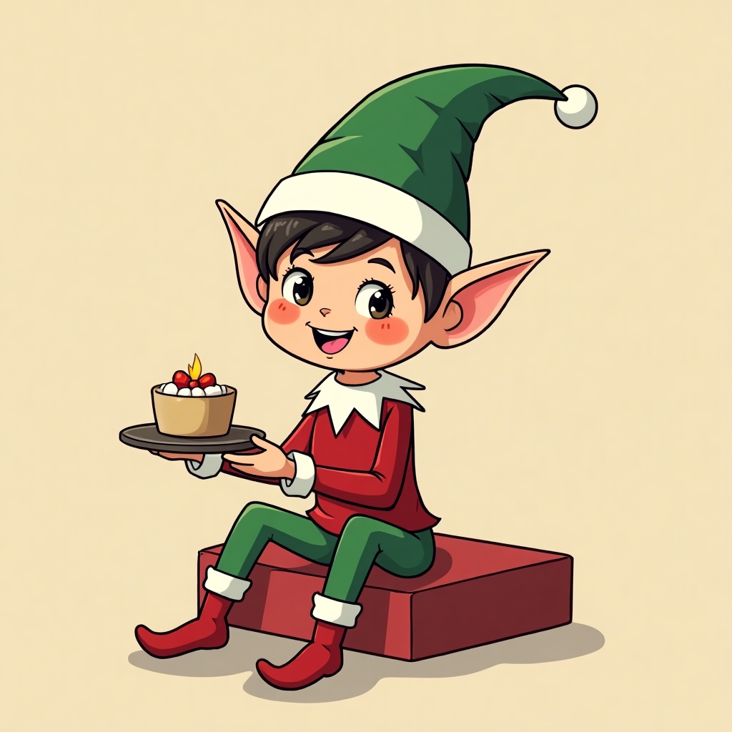

Elf on the Shelf: A Beloved Christmas Tradition

Elf on the Shelf
The is a 2005 American children's picture book written by Carol Aebersold and her daughter Chanda Bell. Illustrated by Coë Steinwart, it tells the story of how Santa knows who is naughty or nice, with the help of scout elves who visit children from Thanksgiving to Christmas Eve.

Originating from a family tradition in Georgia, the elf hides in different spots around the house each morning, creating an interactive hide-and-seek game. Children love it because it adds a sense of magic and excitement to the holiday season.

Some Elf on the Shelf Ideas for your class!
Idea Number | Elf on the Shelf Idea | Explanation and Required Materials
1 | Elf Playing with Toys | Place elf in a toy corner playing with toys. Required materials: small toys, note saying "Play is essential!"
2 | Elf in a Tissue Box House | Elf builds a house out of tissues. Required materials: tissue box, small furniture items, note saying "Home sweet home."
3 | Elf Drawing on the Board | Elf holding a marker, drawing funny faces on the whiteboard. Required materials: dry erase markers, note saying "Art time!"
4 | Elf Reading a Book | Elf sitting with a book open in front of him. Required materials: a children's book, note saying "Reading is magical!"
5 | Elf Playing Hide and Seek | Elf hiding in a corner or behind objects. Required materials: place elf in a hidden spot, note saying "Can you find me?"
6 | Elf Hanging from the Ceiling | Elf attached to a string hanging from the ceiling. Required materials: string, tape, note saying "I'm on top of things!"
7 | Elf Making a Mess with Craft Supplies | Elf surrounded by glue, glitter, and paper cutouts. Required materials: craft supplies, note saying "Oops, my bad!"
8 | Elf Writing on the Student's Desks | Elf with a small notebook and pencil writing notes to students. Required materials: small notebook, pencil, notes personalized for students
9 | Elf Trying to Open Presents | Elf caught trying to unwrap a present. Required materials: wrapped gift box, note saying "I couldn't wait!"
10 | Elf Spelling Out Words with Blocks | Elf forming words with letter blocks. Required materials: letter blocks, note saying "I love learning!"
11 | Elf Sending Secret Messages | Elf with an envelope and notes for students. Required materials: envelopes, small notes, note saying "You've got mail!"
12 | Elf Drinking Hot Cocoa | Elf with a toy mug, pretending to drink cocoa. Required materials: toy mug, cocoa powder, note saying "Stay warm!"

