## The History of Thanksgiving: A Harvest of Gratitude

Thanksgiving is a cherished national holiday celebrated in various countries, including the United States, Canada, and Liberia. It originated as a day to give thanks for the harvest and the blessings of the past year. The holiday has deep historical roots, with its traditions stemming from English religious practices dating back to the Protestant Reformation. Despite its origins in religious observance, Thanksgiving is now largely celebrated as a secular event, characterized by feasting and family gatherings.

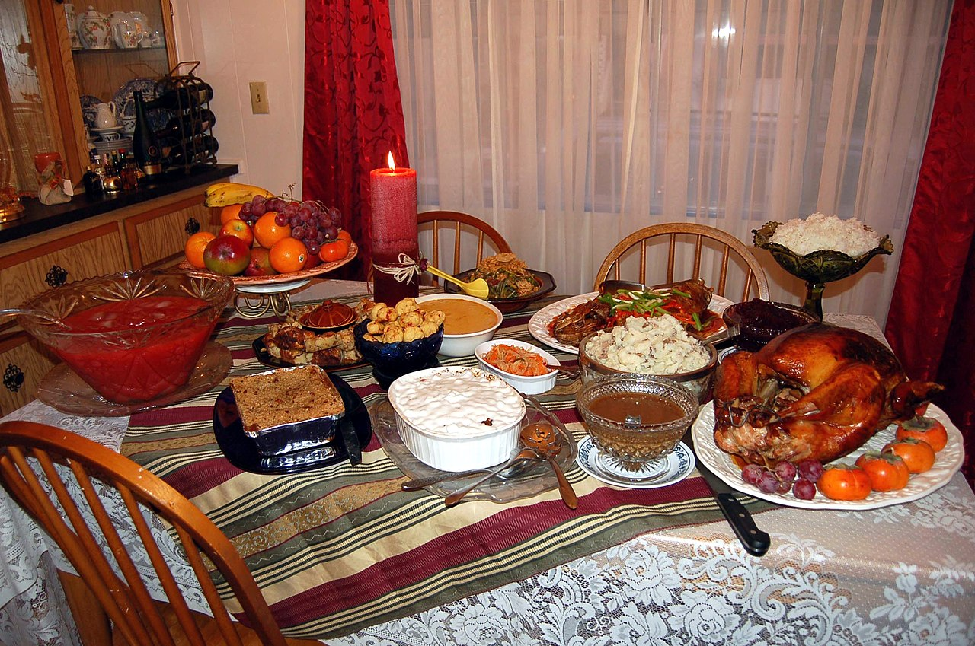

Photo by Ms Jones from California, USA, via Wikimedia Commons

The first Thanksgiving in North America is often attributed to the Pilgrims and the Wampanoag tribe in 1621 in Plymouth, Massachusetts, following a successful harvest. This celebratory feast marked a significant moment of cooperation and gratitude. However, Thanksgiving traditions can also be traced to English settlers in Virginia in 1619 and Martin Frobisher’s expedition in Canada in 1578. Each of these celebrations reflected a moment of giving thanks for survival and prosperity.

Over time, Thanksgiving evolved into a formalized holiday. In the United States, President Abraham Lincoln proclaimed Thanksgiving a national holiday in 1863, setting the precedent for its annual celebration on the fourth Thursday of November. Canada, on the other hand, observes Thanksgiving on the second Monday of October, a date fixed by Parliament in 1957. These dates allow each country to celebrate the holiday in alignment with their own harvest seasons and historical contexts.

Thanksgiving has become a symbol of unity and gratitude, transcending its religious roots to encompass a broader cultural significance. It serves as a reminder of the importance of community, reflection, and appreciation for the abundance in our lives. Whether through historical reenactments, parades, or the simple act of sharing a meal with loved ones, Thanksgiving continues to be a time-honored tradition that brings people together in a spirit of thankfulness.

## Complete the timeline

Add the main events and key figures to the timeline

