# Jack's Problem

Read the following conversation between Jack and Olivia where Jack describes a problem he's been dealing with.

Jack

Hey Jack! What's going on?

Hey Olivia! I need your advice on something.

Sure, what's up?

So, my friend Mike cheated on the math test, and the teacher thinks I did too because we sit next to each other. Should I tell the teacher the truth?

Wow, that's tough. But if you tell, Mike could get in serious trouble. Are you sure you want to do that to a friend?

I know, but if I don't, I might get blamed, and it's not fair to me. Plus, isn't honesty important?

True, honesty is important, but so is loyalty to your friends. Maybe you can talk to Mike first and see if he'll come clean on his own.

I thought about that, but what if he doesn’t? I don't want to get punished for something I didn't do.

I get your point, but friendships can be fragile. Would you want to risk losing Mike as a friend over this?

I don't want to lose him as a friend, but I also don't want to lie. It's a really difficult position to be in.

Yeah, it's definitely a tough call. Maybe there's a way to support Mike without lying.

Possibly. I guess I need to think this through a bit more.

Describe Jack's problem.

___________________________________________________________________

___________________________________________________________________

___________________________________________________________________

What would you do if you were in Jack's situation?

___________________________________________________________________

___________________________________________________________________

___________________________________________________________________

# Discussion

Share your thoughts with the rest of the class.

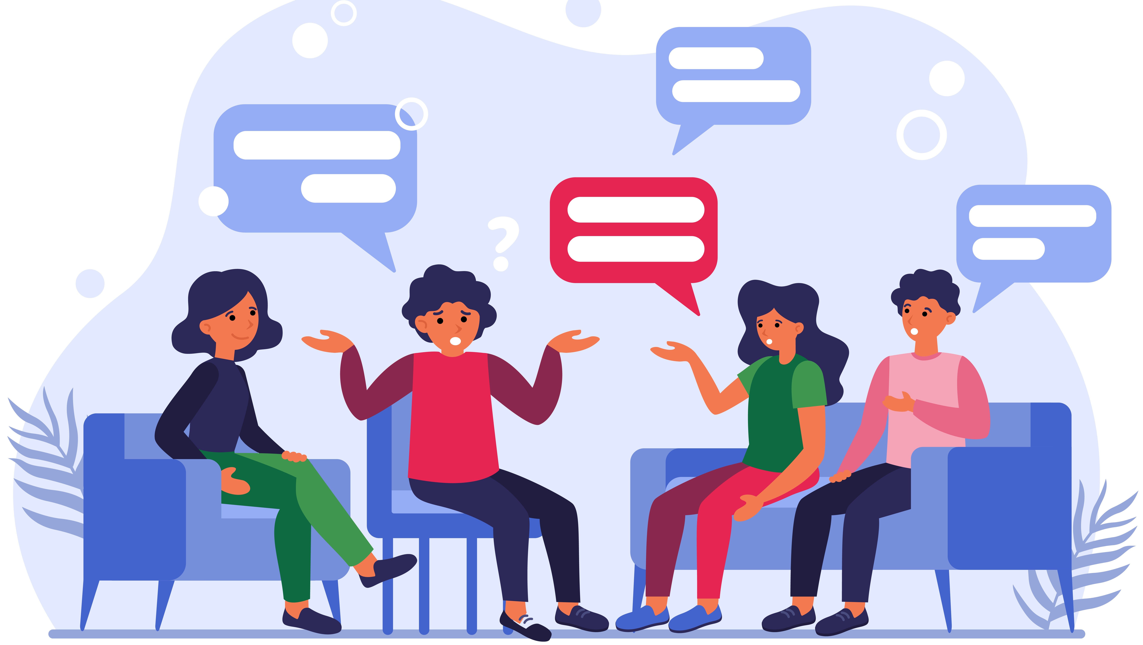

# Ethical behavior

Jack's problem is such a difficult one because it is related to ethical principals. Read the following infobox to find out more about ethical behavior.

|  |
| --- |
| Ethical behavior Ethical behavior is a term you might hear a lot, especially in your ethics class. But what does it really mean, and why is it important?    Greek word "ethos"  character  customs  doing the right thing  having good character  fair  honest  respectful  The word "ethical" comes from the , which means or . So, ethical behavior is all about and . It means making choices that are , , and to others.    "Is it fair?" "Is it honest?" "Will it hurt anyone?"  When we talk about ethical behavior, we often ask some important questions. For example, These questions help us think about whether our actions are right or wrong.    build trust and respect  Why is ethical behavior important? Imagine a world where people lie, cheat, or treat others unfairly. It wouldn’t be a very nice place to live, would it? Ethical behavior helps us with others. It makes our communities better and more pleasant places to be.    So, the next time you face a choice, remember to think about what is ethical. Ask yourself those important questions and try to do what is right. By practicing ethical behavior, you can help make the world a better place for everyone. |

Read through the chat again and then answer the following question: What would be ethical behavior in the described situation?

___________________________________________________________________

___________________________________________________________________

___________________________________________________________________

Can you think of other ethical problems that are similar to the one described in the chat?

___________________________________________________________________

___________________________________________________________________

___________________________________________________________________

# Work in pairs

Together with your neighbor, look at the conversation from the chat again and think about what Jack will decide to do in the end and how he will justify his decision.

Then practice the conversation so that you can present it to the class. You don't need to memorize the conversation word for word; the important thing is that it is clear who is taking which position.

Afterward, present your conversation with Jack's decision at the end.



# Additional information for teachers

Here you can find a sample solution for the last task.

Jack:

Hey Olivia! Can I ask for your advice on something?

Olivia:

Of course, what's going on?

Jack:

My friend Mike cheated on the math test, and now the teacher thinks I did too because we sit next to each other. Should I tell the teacher what really happened?

Olivia:

That's a tough situation. If you tell the truth, Mike could get into a lot of trouble. Are you sure you want to put your friend in that position?

Jack:

I know, but if I don't say anything, I might get blamed for something I didn't do. Plus, honesty is important, right?

Olivia:

Honesty is definitely important, but so is being loyal to your friends. Maybe you could talk to Mike first and see if he'll admit what he did.

Jack:

I thought about that, but what if he refuses? I don't want to get punished for something I didn't do.

Olivia:

I understand, but you have to consider how this could affect your friendship with Mike. Is it worth the risk of losing him as a friend?

Jack:

I don't want to lose him as a friend, but I also don't want to lie about what happened. It's a really difficult situation.

Olivia:

It really is. Maybe there's a way to support Mike without lying.

Jack:

That's a good point. Maybe I can talk to Mike and explain how serious this is for both of us. If he understands the consequences, he might decide to come clean himself.

Olivia:

That sounds like a good plan. It shows you're being honest but also giving Mike a chance to do the right thing.

Jack:

Yeah, I'll talk to Mike and see if he’ll admit what he did. If he understands the impact, hopefully, he'll make the right choice.

Olivia:

I think that's a solid approach. Good luck, Jack. Let me know how it goes.

Jack:

Thanks, Olivia. I appreciate your help. I'll let you know what happens.