# The European Union

Read the text about origin and development of the EU and fill in the timeline on the following page.

Origin and development of the European Union

The European Union (EU) is a political and economic union of currently 27 European states, whose origins date back to the post-World War II era. The idea of a united Europe arose from the desire to promote lasting peace and economic stability. The first step in this direction was taken in 1951 with the founding of the European Coal and Steel Community (ECSC) by the six founding states Belgium, Germany, France, Italy, Luxembourg, and the Netherlands.

In 1957, the European Economic Community (EEC) and the European Atomic Energy Community (EURATOM) were established by the Treaties of Rome. These treaties formed the basis for economic integration and the creation of a common market. The EEC developed further in the following decades and continuously increased its number of members.

A significant milestone was the accession of the United Kingdom, Ireland, and Denmark in 1973. This was the first enlargement of the community and marked the beginning of a phase of continuous expansion. In the 1980s, Greece (1981), Portugal, and Spain (both 1986) joined the community.

The collapse of communism in Eastern Europe at the end of the 1980s and the beginning of the 1990s led to another wave of enlargement. In 1995, Austria, Finland, and Sweden joined the EU. The largest enlargement took place in 2004 when ten countries, including many former Eastern Bloc states like Poland, Hungary, and the Czech Republic, joined the EU. Bulgaria and Romania followed in 2007, and Croatia became the 28th member in 2013.

Parallel to its enlargement, the EU deepened its integration. The Maastricht Treaty, signed in 1992 and entering into force in 1993, created the European Union in its current form and introduced a common currency, the Euro, which was launched in 1999. Other important treaties such as the Amsterdam Treaty (1997), the Nice Treaty (2001), and the Lisbon Treaty (2007) reformed the EU's institutional structures and expanded its competences.

A significant event in the history of the EU was the exit of the United Kingdom, known as Brexit. Following a referendum in 2016, in which a narrow majority of Britons voted to leave, the United Kingdom officially left the EU on January 31, 2020. This was the first time a member state left the union and posed new challenges for both the EU and the United Kingdom.

The EU remains a unique project of international cooperation, promoting peace, stability, and prosperity in Europe while simultaneously facing diverse political and economic challenges.

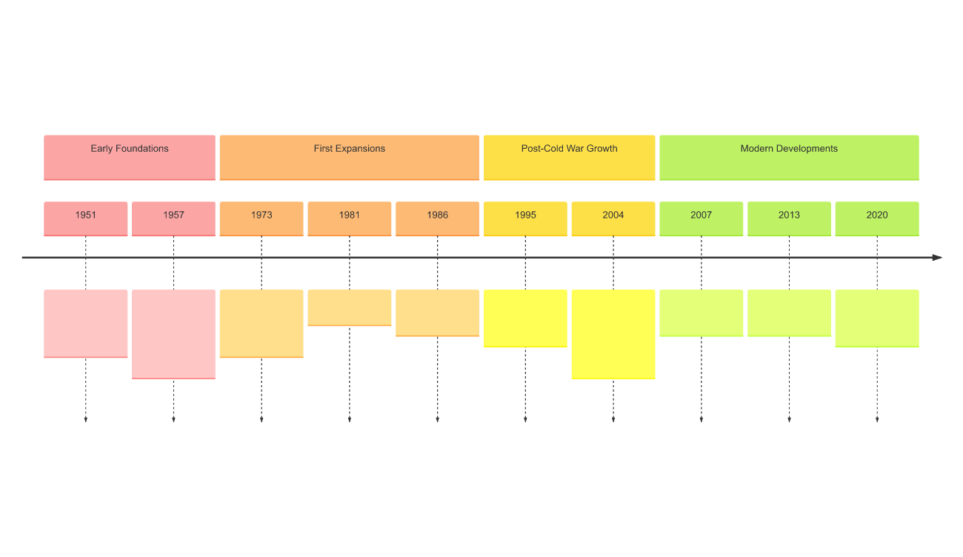

# EU states - current members and candidates

On the following pages you will find information on the current EU member states and about one country that is applying for membership. Read through the information, then fill in the profile and answer the questions.

## Current EU member states

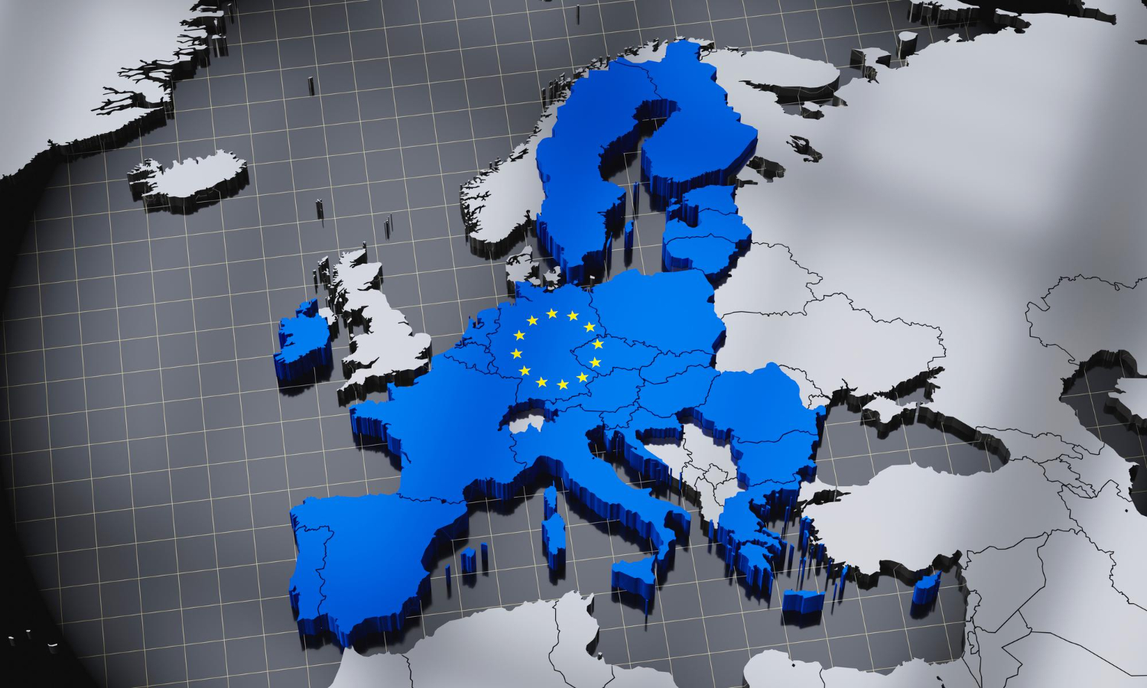

|  |  |  |  |
| --- | --- | --- | --- |
| EU Member State | Entry Date | EU Member State_2 | Entry Date_2 |
| Belgium | 1958 | Austria | 1995 |
| France | 1958 | Finland | 1995 |
| Germany | 1958 | Sweden | 1995 |
| Italy | 1958 | Czech Republic | 2004 |
| Luxembourg | 1958 | Estonia | 2004 |
| Netherlands | 1958 | Hungary | 2004 |
| Denmark | 1973 | Latvia | 2004 |
| Ireland | 1973 | Lithuania | 2004 |
| United Kingdom | 1973 | Poland | 2004 |
| Greece | 1981 | Slovakia | 2004 |
| Portugal | 1986 | Slovenia | 2004 |
| Spain | 1986 | Cyprus | 2004 |
| Sweden | 1995 | Malta | 2004 |
| Finland | 1995 | Romania | 2007 |
| Austria | 1995 | Bulgaria | 2007 |
|  |  | Croatia | 2013 |

Albania

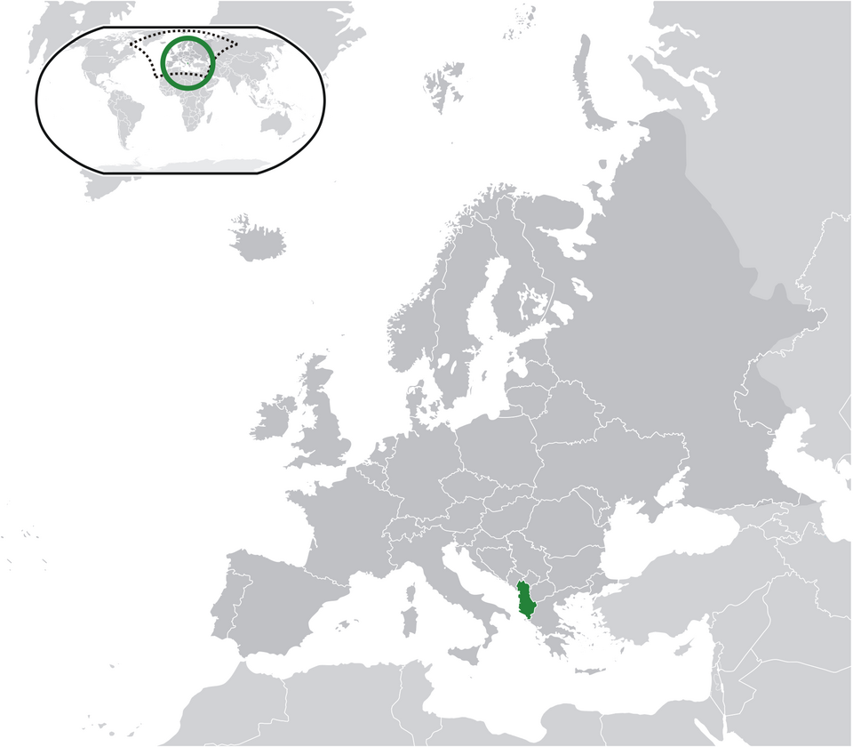

Source

: Wikipedia

Albania, officially the Republic of Albania, is a small country in Southeast Europe on the Balkan Peninsula. It borders Montenegro to the northwest, Kosovo to the northeast, North Macedonia to the east, and Greece to the south, with coastlines on the Adriatic Sea to the west and the Ionian Sea to the southwest. With a total area of 28,748 square kilometers, Albania is characterized by a diverse geography that includes mountains, plains, and a beautiful coastline. The country has a population of approximately 2.4 million people, with Tirana as its vibrant capital and largest city.

Albania's political landscape is marked by its transition from a communist state to a parliamentary republic. Currently, it is governed by a unitary parliamentary republic system, with Bajram Begaj serving as the President and Edi Rama as the Prime Minister. The political situation remains dynamic, with efforts focused on democratic reforms and combating corruption to align with European Union standards.

Economically, Albania has made significant strides since the collapse of communism, shifting from a centrally planned economy to an open-market system. The country's economy is diverse, with key sectors including agriculture, manufacturing, and services. However, challenges such as high unemployment rates and emigration persist. Despite these hurdles, Albania's economy has shown resilience, with gradual improvements in infrastructure and foreign investment.

Albania's EU accession journey has been a central focus of its political agenda. The country applied for EU membership in 2009 and was granted candidate status in 2014. While progress has been made in various sectors, Albania continues to work on meeting the EU's stringent criteria, particularly in areas such as the rule of law, judicial reform, and anti-corruption measures. The Albanian government and its citizens generally view EU membership as a strategic goal that promises economic benefits, political stability, and enhanced international standing.

One of Albania's unique features is its rich cultural heritage, influenced by various civilizations, including the ancient Greeks, Romans, Byzantines, and Ottomans. The country boasts several UNESCO World Heritage Sites, such as the ancient city of Butrint and the historic centers of Berat and Gjirokastër. Albania's natural beauty, with its pristine beaches, rugged mountains, and picturesque landscapes, makes it an emerging destination for tourism.

In conclusion, Albania's journey towards EU membership reflects its aspirations for a stable and prosperous future. Despite the challenges, the country's commitment to reforms and its rich cultural heritage position Albania as a unique and promising candidate for the European Union.

|  |  |
| --- | --- |
|  | Population |
| Capital |
| Geographical location |
| Political situation | |
| Economic situation | |
| EU membership status | |
| Attitude towards Europe | |

Describe in your own words what opportunities the European Union can offer a current candidate for membership in the future. Also discuss possible challenges.

___________________________________________________________________

___________________________________________________________________

___________________________________________________________________

Describe how the EU has developed since its founding and assess its current situation.

___________________________________________________________________

___________________________________________________________________

___________________________________________________________________

In your opinion, what are the biggest challenges that the EU will have to face in the future?

___________________________________________________________________

___________________________________________________________________

___________________________________________________________________