Different electoral systems

Read through the chat between two teenagers, then get together with your classmates: What do you already know about different electoral systems? Do you know any other countries besides those mentioned by Ahmad and Alissa where different electoral systems are used?
Alissa
Hi Alissa! Are you ready for the test on electoral systems?
Hi Ahmad! Kind of. I know a bit about it, but I need more info.
Same here. Do you know how many electoral systems are used in the EU?
I think there are several. Some countries use proportional representation, right?
Yes! Like in Germany. Seats are divided based on the percentage of votes each party gets.
Cool! And what's the system called in the UK?
That's the First-Past-The-Post (FPTP) system. The candidate with the most votes wins.
Right! And isn't there a mixed system too?
Yes, countries like Italy use a mix of both proportional representation and FPTP.
Got it. What about the Single Transferable Vote (STV)?
That's used in places like Ireland. Voters rank candidates, and votes are transferred until the seats are filled.
This is actually interesting. Thanks for the info, Ahmad!
No problem, Alissa! Good luck with the test!

Electoral systems in EU member states

Now read the following infobox with information about the different electoral systems in the EU member states. Then look at the information texts about three different EU member states and their electoral systems.

Overview of electoral systems in the EU

Proportional Representation

Proportional representation aims to allocate seats in a parliament proportionally to the votes received by each party. Parties receive seats corresponding to the percentage of votes they obtain. This promotes fairer representation for smaller parties and minorities.

Used by
: Germany, Austria, Sweden, Finland, Denmark, Belgium, Luxembourg, Netherlands, Spain, Portugal, and many others.

Majoritarian Voting

Majoritarian voting often involves the "First-Past-The-Post" system, where the candidate with the most votes in a constituency wins. This often leads to a stronger concentration of power among larger parties and can disadvantage smaller parties.

Used by
: France (for the National Assembly), United Kingdom (for the House of Commons).

Mixed-Member Proportional Representation
The mixed-member proportional representation system combines elements of proportional representation and majoritarian voting. Voters typically have two votes: one for a direct candidate in their constituency and one for a party at the national level. This balances the advantages of both systems.
Used by
: Germany (Bundestag), Italy (until 2017), Hungary.

Single Transferable Vote
The single transferable vote system allows voters to rank candidates in order of preference. The votes are redistributed according to these preferences until all seats are filled. This minimizes wasted votes and promotes more proportional representation.
Used by: Ireland, Malta.
Block Voting
In block voting, voters select multiple candidates, and the candidates with the most votes win. This system can lead to an overrepresentation of the strongest parties.
Used by
: France (for municipal elections), Spain (for Senate).
The diversity of electoral systems within the EU ensures a wide range of democratic processes and methods of representation.

Spain  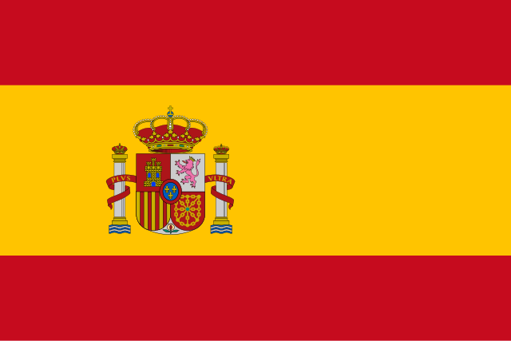  Spain, formally the Kingdom of Spain, is a country in southwestern Europe. It is the largest country in Southern Europe and the fourth-most populous European Union member state. Spain has a population of approximately 48.8 million people and spans an area of 505,990 square kilometers. The country is a unitary parliamentary constitutional monarchy, with King Felipe VI as the monarch and Pedro Sánchez as the Prime Minister. Spain’s political system operates under a proportional representation electoral system. Historically, Spain has had various electoral systems, including majority voting systems during the Francoist era. The next general elections are scheduled for 2026.  Spain's electoral system is based on proportional representation, allowing for a fair representation of the electorate's preferences. This system has been in place since the transition to democracy in the late 1970s. The political landscape is characterized by a multi-party system, leading to coalition governments where multiple parties work together to form a government. | Ireland  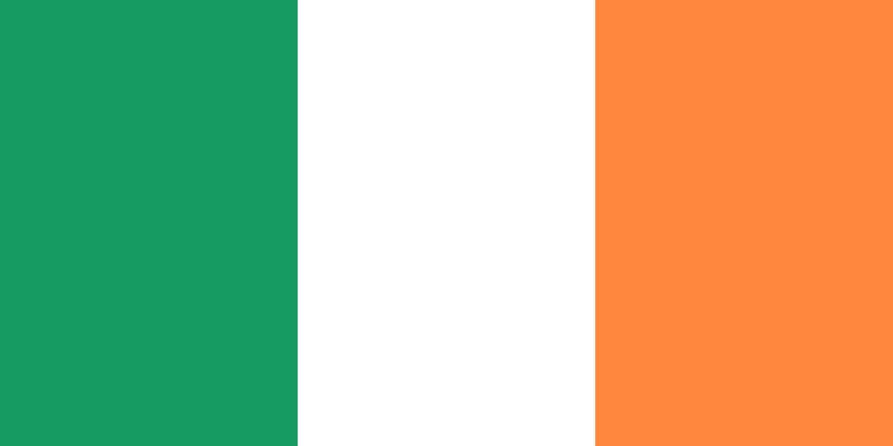  Ireland, officially known as the Republic of Ireland, is a country in northwestern Europe. It occupies most of the island of Ireland, sharing a border with Northern Ireland, part of the United Kingdom. Ireland has a population of approximately 5.1 million people and covers an area of 70,273 square kilometers. The country is a parliamentary democracy with Michael D. Higgins as the President and Leo Varadkar as the Taoiseach (Prime Minister). Ireland uses a single transferable vote (STV) system, a form of proportional representation. Historically, Ireland used different electoral systems, including the majority voting system before gaining independence. The next general elections are anticipated in 2025.  Ireland's electoral system, the single transferable vote (STV), allows voters to rank candidates in order of preference. This method ensures a more proportional representation of parties and candidates in the parliament. STV has been in use since the establishment of the Irish Free State in 1922, promoting a fairer and more inclusive political system. | Romania  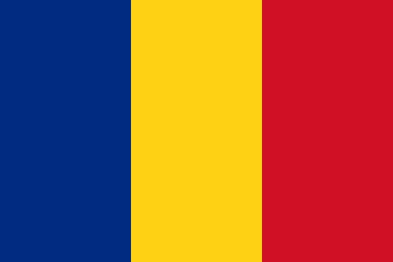  Romania is a country located at the crossroads of Central, Eastern, and Southeast Europe. It borders Ukraine, Hungary, Serbia, Bulgaria, and Moldova. Romania has a population of about 19 million people and spans an area of 238,397 square kilometers. The country is a unitary semi-presidential republic with Klaus Iohannis as the President and Marcel Ciolacu as the Prime Minister. Romania employs a proportional representation electoral system. In the past, Romania used different voting systems including majority voting during the communist era. The next parliamentary elections are scheduled for 2024.  Romania's electoral system is based on proportional representation, ensuring a fair distribution of seats in the parliament according to the votes each party receives. This system has been in place since the fall of the communist regime in 1989, helping to establish a more democratic and representative political environment.

Fill out the table, using the information from the texts about the three countries.
0 | Similarities | Differences
Political Situation
Electoral System / Elections

Elections in the USA
The US presidential election of 2024 will take place on November 5, 2024, and will be the 60th election of its kind. Citizens in all states and the District of Columbia will vote for electors, who will then elect the president and vice president. Incumbent President Joe Biden withdrew his candidacy in July 2024 and endorsed Kamala Harris, who became the Democratic Party's presidential candidate. Her opponent is former President Donald Trump, who is running for a second, non-consecutive term and received the Republican Party's nomination. The election is conducted through an indirect voting system, where voters choose members of the Electoral College, who then determine the president and vice president. The election coincides with the elections for the US Senate, House of Representatives, governors, and state legislatures. The winners of the presidential election will be inaugurated on January 20, 2025.

Now take a look at the infobox with information about the elections in the USA. What electoral system is used here and how does it differ from those of the three countries you learned about in the info texts? Write a short text with your answer.
___________________________________________________________________
___________________________________________________________________
___________________________________________________________________

Quiz

Test your knowledge about the different electoral systems to conclude. Can you answer all the questions? For help, take another look at the info box at the beginning of the worksheet.

Choose the correct answer for each question.

Which electoral system is designed to allocate seats proportionally to the percentage of votes received by each party?
Proportional Representation Majoritarian Voting Single Transferable Vote Mixed-Member Proportional Representation

In which country is the Mixed-Member Proportional Representation system used for the Bundestag elections?
Italy France Hungary Germany

Which electoral system could lead to an overrepresentation of the strongest parties due to voters selecting multiple candidates?
Block Voting Proportional Representation Majoritarian Voting Single Transferable Vote

Why does the Single Transferable Vote system minimize wasted votes?
It allows voters to select multiple candidates It combines proportional representation with majoritarian voting Votes are redistributed according to voter preferences until all seats are filled Votes are only counted once

Which electoral system is used for the National Assembly elections in France?
Single Transferable Vote Majoritarian Voting Proportional Representation Block Voting

Which system combines elements of proportional representation and majoritarian voting?
Mixed-Member Proportional Representation Block Voting Single Transferable Vote Proportional Representation

Which electoral system is used for municipal elections in France?
Majoritarian Voting Single Transferable Vote Block Voting Proportional Representation

Which electoral system is typically used in the United Kingdom for the House of Commons?
Proportional Representation Mixed-Member Proportional Representation Single Transferable Vote Majoritarian Voting

Which electoral system is used in Ireland and allows voters to rank candidates in order of preference?
Proportional Representation Mixed-Member Proportional Representation Majoritarian Voting Single Transferable Vote

