|  |
| --- |
| 📌 Info Imagine you could talk to famous people from your favorite era! In this worksheet, you can immerse yourself in history - discover who lived at the same time and perhaps even interacted with each other. From artists and scientists to politicians: Find out which well-known figures shared their lifetimes and how their stories intertwined. Are you ready to bring history to life? Let's get started!      The following text will give you a first insight into the life of the time and how society has changed. |

### 📋 Work assignment

Read the text and then answer the questions.

### The 1720s: A Decade of Transition

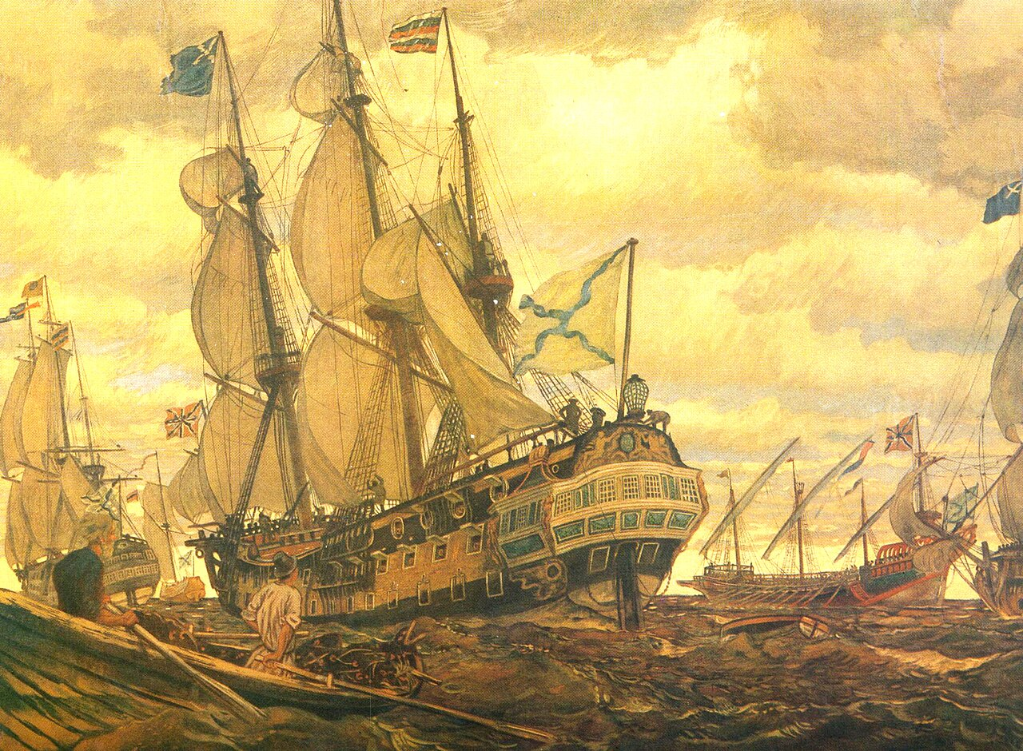

Source: Wikipedia

1720s

conflict

financial

The was a transitional period following years of in Europe, marked by the end of the War of the Quadruple Alliance and the Great Northern War. This decade brought about a time of peace and instability, notably with the South Sea Bubble in Britain and the Mississippi Bubble in France. Despite these economic challenges, both nations experienced relative stability under strong leadership, setting the stage for future alliances.

Baroque

Jonathan Swift

Culturally, the 1720s was part of the era, influencing art and architecture with its ornate and grand style. Socially, the period saw modest advancements in science and philosophy, with figures like beginning to shape thought with works such as "Gulliver's Travels."

Living conditions were challenging; outbreaks like the Great Plague of Marseille in 1720 highlighted the precariousness of city life. Yet, cities were hubs of commerce and ideas, slowly transforming with new regulations and institutions that laid groundwork for modern urban development.

### 📋 Answer the questions with the help of the text.

###### **How did the end of the War of the Quadruple Alliance and the Great Northern War impact Europe in the 1720s?**

It marked the beginning of a peaceful era after years of conflict. It resulted in intensified military conflicts in Western Europe. It led to territorial expansions for both Britain and France. It caused economic prosperity across Europe.

###### **What major economic event in Britain during the 1720s reflected financial instability?**

The Great Depression The Industrial Revolution The South Sea Bubble The Mississippi Bubble

###### **In what cultural era did the 1720s fall, influencing art and architecture?**

Romanticism Modernism Renaissance Baroque

###### **Which literary figure began to shape thought during the 1720s with works like 'Gulliver's Travels'?**

Jonathan Swift Daniel Defoe Alexander Pope Voltaire

###### **What did outbreaks like the Great Plague of Marseille in 1720 highlight about city life?**

The abundance of resources The precariousness of living conditions The rapid urban expansion The effectiveness of healthcare systems

In the following, three people tell you about their lives during this time. Find out what influence they had on the course of history and to what extent they knew each other.

|  |  |  |
| --- | --- | --- |
| Ignatius Sancho (1729-1780)    I am Ignatius Sancho, born around 1729 on a slave ship in the Atlantic Ocean. Despite my harsh beginnings, I became a composer, writer, and shopkeeper in London. My journey was challenging; I was orphaned and sent as a slave to England at two years old. Fortunately, the Duke of Montagu recognized my talent and supported my education. I was the first person of African descent to vote in a British election, advocating for abolitionism. I cherished correspondence with notable figures such as Joseph Süß Oppenheimer, sharing our struggles against prejudice. Sadly, he faced a tragic end in 1738. Anna Maria Mozart, though we never met, was known to me through her son's music, which deeply moved my spirit. I died in 1780, leaving behind letters and music that echo my resilience and hope for equality.  Influential abolitionist in 18th century Britain. | Joseph Süß Oppenheimer (1698-1738)    I am Joseph Süß Oppenheimer, born in 1698 in Heidelberg, Germany. As a financial advisor to Duke Karl Alexander of Württemberg, I thrived in the political sphere, influencing economic reforms. However, my Jewish heritage made me a target of intense prejudice. After the Duke's death, I was imprisoned and executed in 1738, accused of treason and corruption. My life intersected with Ignatius Sancho's through letters; both of us fought societal biases in our own ways. His journey inspired me, knowing we shared the burden of discrimination. Anna Maria Mozart's son, Wolfgang, composed music that touched the hearts of many, including mine. I wished for my legacy to be one of understanding and tolerance, despite the brutality I faced.  Jewish financial advisor who faced prejudice and execution. | Anna Maria Mozart (1720-1778)    I am Anna Maria Mozart, born on December 25, 1720, in St. Gilgen, Austria. As the mother of Wolfgang Amadeus Mozart, I nurtured his genius from a young age, traveling across Europe to showcase his talents. Life was not easy; financial strain and the burden of societal expectations weighed heavily on me. I never met Ignatius Sancho or Joseph Süß Oppenheimer, but their stories of overcoming adversity resonated deeply. My son’s compositions, well-known to them, bridged cultural divides and gave voice to those silenced by prejudice. I passed away in Paris in 1778, but my legacy lives through Wolfgang’s music, a testament to our shared struggles and triumphs.  Mother of Wolfgang Amadeus Mozart, pivotal in his upbringing. |

Describe the connection between Ignatius Sancho and Joseph Süß Oppenheimer and how they corresponded.

___________________________________________________________________

___________________________________________________________________

___________________________________________________________________

Explain how Anna Maria Mozart's son influenced the lives of Ignatius Sancho and Joseph Süß Oppenheimer.

___________________________________________________________________

___________________________________________________________________

___________________________________________________________________

Describe the challenges faced by Anna Maria Mozart and how they relate to the struggles of Ignatius Sancho and Joseph Süß Oppenheimer.

___________________________________________________________________

___________________________________________________________________

___________________________________________________________________