# Treasure hunt - the adventure begins

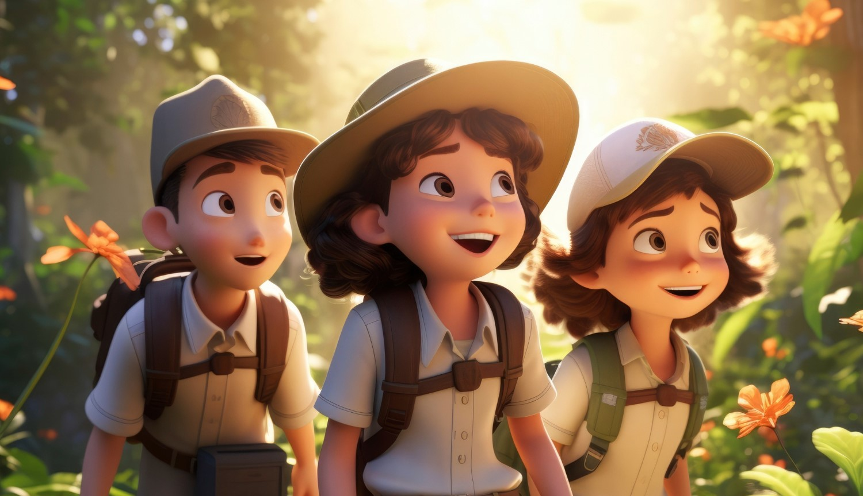

In the heart of New York City, three friends—Medina, Jonas, and Sophie—were always on the lookout for excitement. On a bright Saturday afternoon, they found themselves in a sprawling park, the kind with hidden nooks and winding paths that seemed to promise adventure at every turn.

Medina's keen eyes spotted it first: an old, dusty box nestled under the roots of a grand oak tree. "Hey, look at this!" she called out, her voice brimming with curiosity.

Jonas and Sophie hurried over. Jonas, always the brave one, pried open the box with a stick he found nearby. Inside, they discovered something extraordinary—a faded map, a tattered book filled with riddles, and an ancient-looking compass.

"This is amazing!" Sophie exclaimed, her eyes wide with excitement. "It looks like a real treasure hunt!"

Jonas held up the map, tracing the lines with his finger. "We have to follow this," he said, his voice firm with determination.

Medina picked up the book and flipped through its fragile pages. "Look, the first riddle is right here," she said, pointing to a cryptic verse written in elegant script. Her heart pounded with anticipation.

The three friends exchanged eager glances. They knew they were about to embark on an adventure like no other. With the map in hand, the book of riddles ready, and the compass pointing the way, they took a deep breath.

"Let's get started," Jonas said, and they leaned in to read the first clue.

# The first riddle

"What is the first riddle?" Jonas called excitedly. "Go 200 meters to the east," Sophie read aloud. "We will need the compass for that, but I don't remember how to use one," she said. "It's quite simple," called Medina, who was holding the compass. "The red needle here always points north. If we align the needle to the north, we can read where the other cardinal directions are. For example, south is exactly on the opposite side. And here we've got an 'E'…" "For 'east'!" Jonas exclaimed triumphantly. "That's the direction we need to go in!"

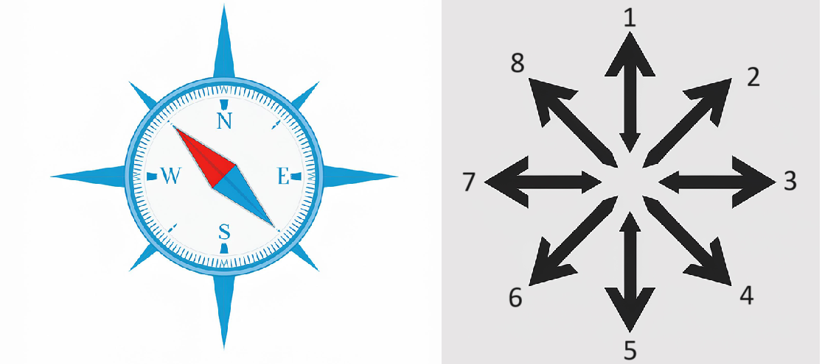

### Choose the correct answer

###### **Which one is the correct direction?**

7 1 2 8 5 6 4 3

# The second riddle

The three friends weaved through the park paths, their hearts racing with excitement. The map led them out of the greenery and into the bustling streets of New York City. Just as Jonas had predicted, they didn't have to walk far. Soon, they found themselves standing in front of an iconic landmark, one that every New Yorker—and nearly every visitor—knew well: the Empire State Building.

"Here we are," Medina said, her eyes wide as she gazed up at the towering skyscraper. "But where's the next hint?"

Jonas frowned, his brow furrowing in concentration as he scanned the area. "I don't see anything unusual," he admitted. Sophie, ever the thinker, pulled out the tattered book of riddles.

"Maybe the answer's in here," she suggested, flipping through its delicate pages. Her fingers stopped on a section that looked different from the rest. "Here! It says something about this landmark."

Medina and Jonas leaned in closer. Sophie read aloud, "To uncover the next clue, answer these three questions about the building that scrapes the sky. Only then will your path continue to unfold."

Their hearts pounded with anticipation as they prepared to read the first riddle. The adventure had only just begun, and they were ready for whatever challenge came next.

### For each of the questions, choose the correct answer to help the kids with their treasure hunt.

###### **What year was the Empire State Building completed?**

1945 1931 1929 1950

###### **Why is the Empire State Building considered an architectural marvel?**

It was the tallest building in the world at the time of its completion It was the first building to use steel reinforcements It was the first building to have a revolving restaurant It was built using the first glass curtain wall

###### **What is a unique feature of the Empire State Building's design?**

It has a helipad on the roof It has a rotating beacon light It has an observation deck on the 102nd floor It has a glass floor on the top level

# The third riddle

After several minutes of intense concentration, the three friends managed to answer all the questions correctly. They high-fived each other, their faces lighting up with relief and excitement.

"That wasn't easy," Medina admitted, wiping a bead of sweat from her forehead. "I didn't know the Empire State Building had so many interesting facts!"

"Yeah," Jonas agreed, his eyes still sparkling from the thrill of solving the riddles. "But we did it. So, what's next?"

Just then, the tattered book of riddles seemed to shimmer slightly. Sophie noticed it first and quickly opened it. A new hint had appeared on the page they were just reading. She read it aloud, "Follow the map you found in the box to uncover your next destination."

They immediately pulled out the old map they'd discovered earlier. It was simple and lacked street names, but a prominent mark stood out, about a kilometer away from their current position in New York City.

"I guess we have to walk to find out what this spot is," Jonas said, peering at the map.

Medina nodded, "It's not too far, but we need to figure out which direction to go."

Sophie reached into her backpack and pulled out a small compass. "We'll need to use this again," she said with determination. "Let's combine it with the map to make sure we're heading the right way."

Their hearts raced once more, ready for the next leg of their adventure.

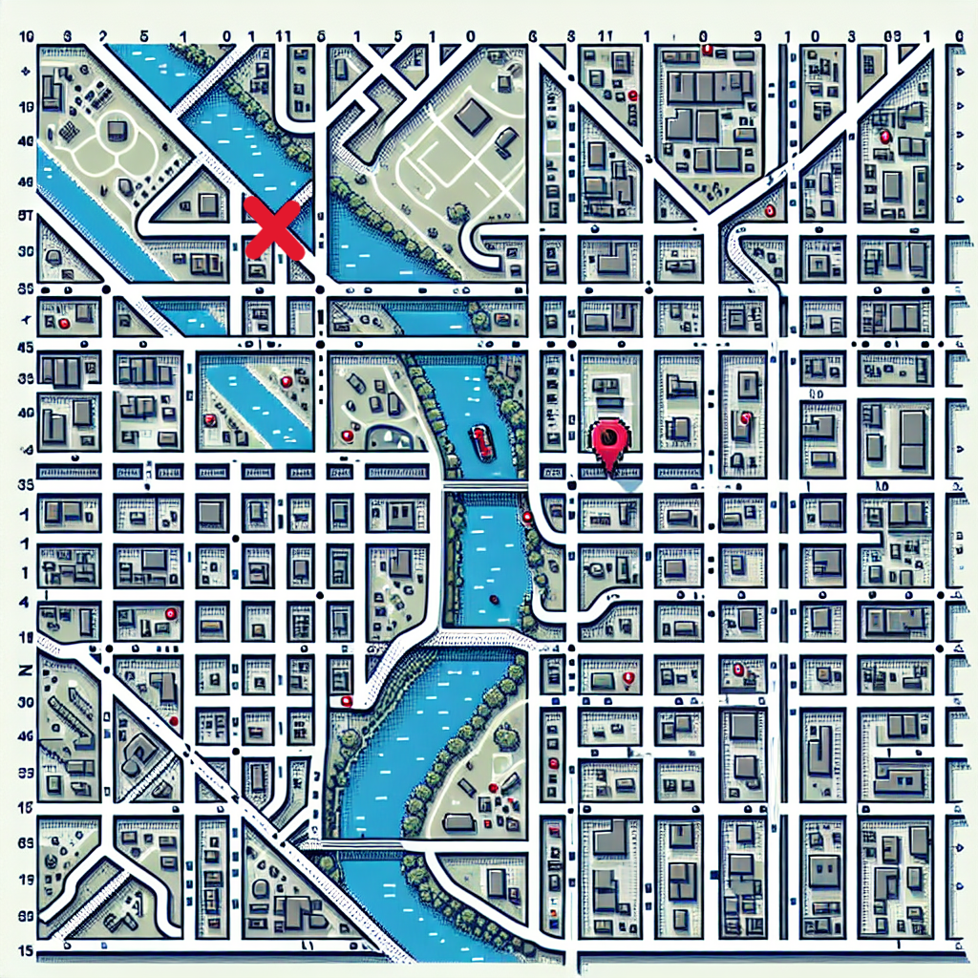

"Okay, if I've got it right, we need to go east from our location over the bridge, then turn north after two cross streets, and then turn northeast by the water," said Jonas. "Nonsense, we need to go west and cross the river, then north after two cross streets, and finally northwest," shouted Sophie. "You're both wrong," Medina interjected. "First, we go east to the intersection, then four cross streets north, and then three cross streets east."

### Choose the correct answer

###### **Which of the three is right?**

Sophie Medina Jonas

# The fourth riddle

Medina, Jonas, and Sophie gathered around the base of the ancient oak tree, the excitement palpable in the air. The tree's shadow loomed over them, adding an air of mystery to their quest. The book in Sophie's hands seemed almost alive, as if it was eager to share its secrets.

"We're so close," Medina whispered, her eyes wide with anticipation. Jonas reached out and gently touched the ornate box within the hollow of the tree. The carvings on the box seemed to tell stories of their own, but the padlock was a stubborn barrier between them and their prize.

Sophie flipped through the pages of the book, her fingers moving quickly as she searched for the right section. Finally, she found it: a series of riddles that promised to reveal the number combination needed to unlock the treasure.

"Here it is," she said, her voice steady but filled with excitement. "The riddles that will help us open the lock."

Jonas leaned in closer, curiosity sparking in his eyes. "Read them out loud, Sophie. Let's solve this together."

With everyone gathered around, Sophie took a deep breath and began to read the first riddle aloud. The ancient oak tree seemed to listen as well, its leaves rustling softly in the wind as if whispering encouragement.

The adventure was far from over, and with each word Sophie spoke, they edged closer to uncovering the hidden secrets of the treasure within the tree.

### Choose the correct answer for each question.

###### **In what year did the Brooklyn Bridge, a major landmark in New York City, open to the public?**

1895 1883 1870 1900

###### **In what year did the first subway line in New York City begin operations?**

1915 1890 1920 1904

###### **In what year did Central Park, a famous park in New York City, officially open?**

1865 1845 1872 1858

# The last riddle

"Wow, that wasn't easy, but I think we answered all the questions correctly," Sophie exclaimed happily. "And now?" "Let me check quickly," said Jonas. Then he said indignantly, "We have to add up the numbers from all three questions. Nobody told me I would have to do math today!" "Don't worry, Jonas, I'll do it," replied Medina and started adding up the numbers.

"I think I've got it!" she finally shouted. "Quick, let's enter the combination immediately!"

Excitedly, they all gathered in front of the number lock.

Now enter the combination.

___________________________________________________________________

___________________________________________________________________

___________________________________________________________________

The lock clicked open, and Medina, Jonas, and Sophie exchanged excited glances. Their hearts raced as they lifted the lid of the treasure box. Inside, instead of the glittering gold they had imagined, they found a worn, leather-bound book. Jonas's face fell for a moment, clearly disappointed. "I thought there'd be gold," he muttered, but then a grin spread across his face as he picked up the book. "Well, this is still pretty cool!"

Medina and Sophie leaned in closer, their curiosity piqued. They opened the book and found it filled with hand-drawn maps, riddles, and lists of fun activities to do all around the city. "Look at this!" Medina exclaimed. "It's like a guide to hidden adventures!"

Sophie pointed to a page that showed a map leading to a secret garden. "We have to find this place next!" she said, her eyes sparkling with excitement.

As they flipped through the pages, they found instructions for a scavenger hunt, recipes for making old-fashioned candies, and even clues to more hidden treasures. The afternoon had turned out to be more magical than they had ever imagined.

"Even though it wasn't gold, this was the best treasure ever," Jonas admitted. Medina and Sophie agreed wholeheartedly. They had spent an unforgettable afternoon together, and the adventure was far from over.

As the sun began to set, they packed up the book and started their journey home. "I wonder who hid the treasure in the first place," Sophie mused aloud.

"Yeah, we'll probably never know," Medina responded thoughtfully.

"But that's okay," Jonas added, smiling. "The mystery makes it even more fun."

With that, the three friends walked off, their minds buzzing with the promise of many more adventures to come.