## 2024 Presidential Elections in the United States of America: The Countdown Begins

The 2024 United States presidential election, set for November 5, 2024, is rapidly approaching, with candidates and their parties gearing up for what promises to be a historic race. This election marks the 60th quadrennial presidential election, involving all 50 states and the District of Columbia. The stakes are high as the American electorate prepares to select the next leader of the free world.

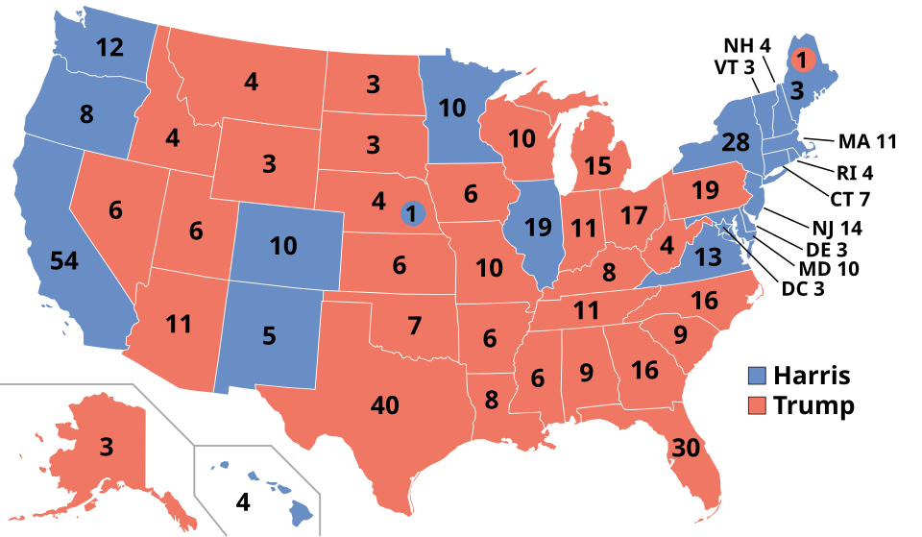

Electoral map for the 2024 election, based on the 2020 census. Source: Wikipedia

Incumbent President Joe Biden, initially the presumptive Democratic nominee, withdrew his bid for re-election in July 2024, citing health concerns. Vice President Kamala Harris has since taken the mantle, becoming the Democratic Party's presumptive nominee. If elected, Harris would be the first woman and the first person of South Asian descent to serve as President of the United States.

On the Republican side, former President Donald Trump is seeking a non-consecutive second term. Despite facing numerous legal challenges, including convictions and ongoing trials, Trump has secured his party's nomination. His running mate is Senator JD Vance of Ohio. Trump's campaign has been marked by controversial rhetoric and claims of electoral fraud, leading to heightened political tensions.

This election also sees a notable third-party presence, with Robert F. Kennedy Jr. running as an independent candidate. Kennedy, a prominent environmental lawyer and member of the Kennedy family, has garnered significant support, reminiscent of Ross Perot's strong showing in the 1992 election.

The key battleground states to watch include Arizona, Georgia, Michigan, Nevada, Pennsylvania, and Wisconsin. These swing states will play a crucial role in determining the election's outcome. Major campaign issues include abortion, immigration, climate change, the economy, and healthcare. With both major parties presenting starkly different visions for America's future, the 2024 presidential election is set to be a pivotal moment in the nation's history.

As November 5 approaches, the candidates will ramp up their campaigns, aiming to secure the crucial 270 electoral votes needed to win. The electoral process, involving the selection of electors through the general elections, remains a cornerstone of American democracy. The winners of this election will be inaugurated on January 20, 2025, ushering in the next chapter of U.S. leadership.

Stay tuned for further updates as the election season unfolds, with debates, rallies, and political strategies shaping the road to the White House. The 2024 election promises to be a defining moment, reflecting the diverse and dynamic nature of American politics.

### Select the correct answer

###### **What significant decision did Joe Biden make in July 2024 regarding the presidential election?**

He changed his party affiliation He launched a new healthcare initiative He selected Kamala Harris as his running mate He withdrew his bid for re-election

###### **If elected, Kamala Harris would achieve which historical milestones?**

First woman and first African American president First person of South Asian descent and first immigrant to be president First woman and first person of South Asian descent to serve as President First person of South Asian descent and first former senator to be president

###### **Despite facing legal challenges, which candidate secured the Republican nomination for the 2024 election?**

Mike Pence Donald Trump Ron DeSantis Ted Cruz

###### **Which states are considered key battlegrounds in the 2024 presidential election?**

California, Texas, New York Ohio, Florida, North Carolina Illinois, Virginia, Washington Arizona, Georgia, Michigan

###### **What major campaign issues are highlighted in the 2024 election?**

Abortion, immigration, climate change, the economy, and healthcare Education, foreign policy, infrastructure, and national security Tax reform, military spending, social security, and gun control Labor laws, trade agreements, minimum wage, and civil rights

###### **What unique position does Robert F. Kennedy Jr. hold in the 2024 election?**

Republican nominee Independent candidate Libertarian candidate Democratic nominee

###### **What is the minimum number of electoral votes a candidate needs to win the 2024 presidential election?**

300 270 280 250

###### **Who is Donald Trump's running mate in the 2024 presidential election?**

Tom Cotton Nikki Haley Mike Pence JD Vance

## Some background information

### Drag the words into the correct panels.

The electoral system of the United States is a complex mechanism designed to elect the President and Vice President. It involves an ______________________________________, which is composed of electors from each state and the District of Columbia. The number of electors for each state is equal to its total number of ______________________________________ representatives. Citizens cast their votes in the general election, and these votes determine which electors are chosen. The candidate who receives a majority of the electoral votes, at least ______________________________________ out of 538, wins the presidency. This system allows for both popular and regional representation, balancing the interests of diverse states. Key ______________________________________ often play a decisive role in the outcome. The process culminates in the inauguration on January 20, following the election year.

270, Congressional, battleground states, Electoral College,

## Meet the candidates

|  |  |  |
| --- | --- | --- |
| Kamala Harris    Kamala Harris is the current Vice President of the United States, having assumed office on January 20, 2021. She was previously a United States Senator from California and the Attorney General of California. Born on October 20, 1964, in Oakland, California, Harris has a diverse background with roots in both South Asia and Jamaica.  Harris's political agenda focuses on social justice, healthcare reform, and climate change. She has been a strong advocate for women's rights, criminal justice reform, and immigration policy reform. | Donald Trump    Donald Trump served as the 45th President of the United States from January 20, 2017, to January 20, 2021. Born on June 14, 1946, in Queens, New York City, Trump is a businessman and media personality who turned to politics. He is the Republican nominee for the 2024 presidential election, seeking a non-consecutive second term.  Trump's political agenda includes strong immigration control, economic nationalism, and deregulation. He has also focused on law and order, tax cuts, and a robust foreign policy stance. | Robert F. Kennedy Jr.    Robert F. Kennedy Jr. is an environmental lawyer, writer, and anti-vaccine activist. Born on January 17, 1954, in Washington, D.C., he is the son of Robert F. Kennedy and a member of the Kennedy family. Kennedy is running as an independent candidate in the 2024 presidential election.  Kennedy's political agenda emphasizes environmental protection, public health, and civil liberties. He is known for his controversial views on vaccines and has written extensively on environmental and health-related issues. |