## Four journalists talk about their work.

Read the texts and learn about the different types of articles they write.

|  |  |
| --- | --- |
|  | Jordan Lee – News Reporter  Hi, I’m Jordan Lee, and I work as a news reporter for a national newspaper. My job is to deliver accurate, up-to-date information about current events—fast. News reports are objective, meaning I leave my opinions out. I focus on facts: who, what, when, where, why, and how. These stories follow the inverted pyramid structure, with the most important details at the top. I often work on tight deadlines and rely on credible sources, interviews, and eyewitness accounts. Readers trust me to keep them informed about things like politics, accidents, or new laws—without bias or fluff. |
|  | Priya Nair – Feature Writer  Hey there! I’m Priya Nair, a feature writer for a weekly city magazine. Unlike a news report, my articles dive deep into a topic, person, or event. I might write about a local artist, a social issue, or a scientific breakthrough. My features are longer, more detailed, and often include narrative elements—think storytelling, description, and quotes. I try to engage the reader emotionally while still being accurate. Feature writing is all about depth over speed. |
|  | Marcus Chen – Opinion Columnist  Hi, I’m Marcus Chen, and I’m an opinion columnist for an online news platform. My articles are different from news reports because they’re subjective—they reflect my personal views on current issues like climate policy, education, or tech ethics. I often use logic, evidence, and persuasive techniques to argue my point. I want readers to think critically, whether they agree with me or not. I always make it clear that I’m expressing an opinion, not reporting facts. A strong voice and clear argument are key to a good op-ed! |
|  | Sofia Alvarez – Magazine Contributor  Hello! I’m Sofia Alvarez, and I write magazine articles for a monthly lifestyle publication. My pieces are often about fashion, culture, travel, or wellness. Magazine writing is all about style, personality, and connection. It’s less formal than news, often written in an engaging, friendly tone. I get to be creative with headings, layout suggestions, and even image ideas. My articles are not always tied to breaking news—they’re more about trends, ideas, or personal experiences. I still fact-check and research, but the voice and visuals matter as much as the content. |

### Complete the table with the information from the four character cards.

|  |  |  |  |  |
| --- | --- | --- | --- | --- |
| Purpose | News reports | Feature articles | Opinion/editorials | Magazine articles |
| Tone |  |  |  |  |
| Length |  |  |  |  |
| Layout |  |  |  |  |
| Time Sensitivity |  |  |  |  |

## Sort through the headlines. What is most likely an actual article? What is clickbait?

|  |  |
| --- | --- |
| Clickbait | Bias |
| Magazine Headline | News Headline |

This Trick Will Change Your Life Forever! · The Ultimate Guide to Gourmet Cooking at Home · Historic Peace Agreement Signed After Years of Negotiation · Is Your Favorite Celebrity Hiding a Shocking Secret? · An Insider's Look at the Corrupt Practices of the Opposition Party · You Won't Believe What Happened Next! · Why This Politician Is the Best Choice for America · Major Earthquake Strikes Southern Region, Hundreds Displaced · 10 Secrets Doctors Don't Want You to Know! · Exploring the Wonders of the World: A Travel Guide · How to Stay Fit and Healthy in Your 40s · Government Announces New Economic Measures amid Crisis · New Technology Promises to Revolutionize Healthcare Industry · Top 10 Fashion Trends for the Upcoming Season · The Real Reason Behind Rising Unemployment Rates · Scientists Agree: Climate Change Is Overblown

### Rewrite 3 of the headlines above to appeal to an academic audience, ensuring they align with scholarly interests and language.

___________________________________________________________________

___________________________________________________________________

___________________________________________________________________

___________________________________________________________________

## Listen to this text about media literacy

|  |  |
| --- | --- |
|  | Audio Content  To listen to audio content just scan the QR code and listen to it on the digital worksheet.  https://to-teach.ai/worksheet/OThASDU5RWLIEoJG6lef |

### Summarize the text, focusing on the things you should look out for when reading an article.

___________________________________________________________________

___________________________________________________________________

___________________________________________________________________

___________________________________________________________________

## Read different types of articles

We have prepared 3 articles for you. You can also bring your own article or find some online.

## The Ever-Changing Phenomenon: Weather

Weather is the atmospheric condition that we experience daily, encompassing aspects such as temperature, humidity, precipitation, and wind. It occurs primarily in the troposphere, the lowest layer of Earth's atmosphere. Unlike climate, which describes long-term trends, weather is the immediate state of the atmosphere that can change rapidly. Driven by factors such as air pressure, temperature, and moisture differences, weather influences our environment and activities significantly.

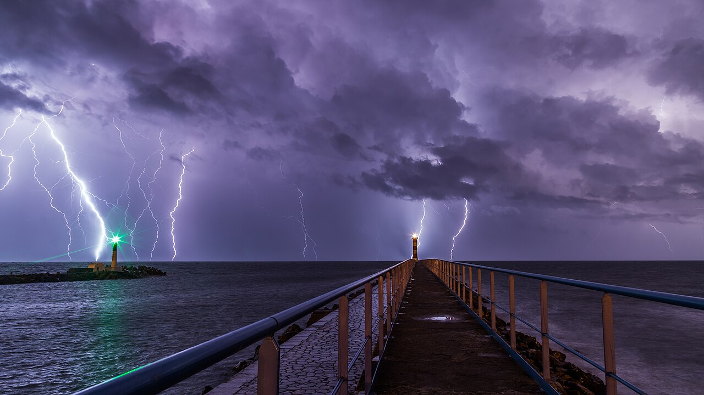

Thunderstorm near Port-la-Nouvelle, France

From gentle breezes to violent storms, weather phenomena are a testament to nature's complexity. These events are often triggered by temperature contrasts between the equator and the poles, facilitated by large-scale atmospheric circulations like the Hadley and Ferrel cells. Weather systems, including cyclones and thunderstorms, emerge from instabilities within these flows. As Earth's axis tilts, seasonal variations occur, further influencing weather patterns.

Weather forecasting, a scientific endeavor, aims to predict these atmospheric changes. Despite its chaotic nature, advancements in technology have enhanced our ability to foresee weather conditions, albeit with limitations. Accurate predictions are crucial, particularly for agriculture, disaster preparedness, and daily life planning. However, the inherent unpredictability of weather remains a challenge, reminding us of its dynamic and powerful presence.

Furthermore, human activities inadvertently modify weather patterns, with industrial emissions contributing to phenomena like acid rain and climate change. Understanding weather's intricacies not only aids in forecasting but also highlights its role in shaping Earth's surface and impacting human history. As we continue to study weather, we gain insights into both terrestrial and extraterrestrial atmospheres, broadening our comprehension of this ever-evolving phenomenon.

## Record-Breaking Weather Events in 2023: A Year of Extremes

2023 has been a landmark year for extreme weather events, showcasing the volatile nature of Earth's climate. From unprecedented heat waves to devastating cyclones, the planet experienced a spectrum of atmospheric phenomena that challenged records and left lasting impacts on global communities. The year marked a transition from La Niña to El Niño, contributing to record high global average surface temperatures. Among these events, Hurricane Otis stood out, making a catastrophic landfall in Acapulco, Mexico, as a Category 5 hurricane, causing significant loss of life and property damage.

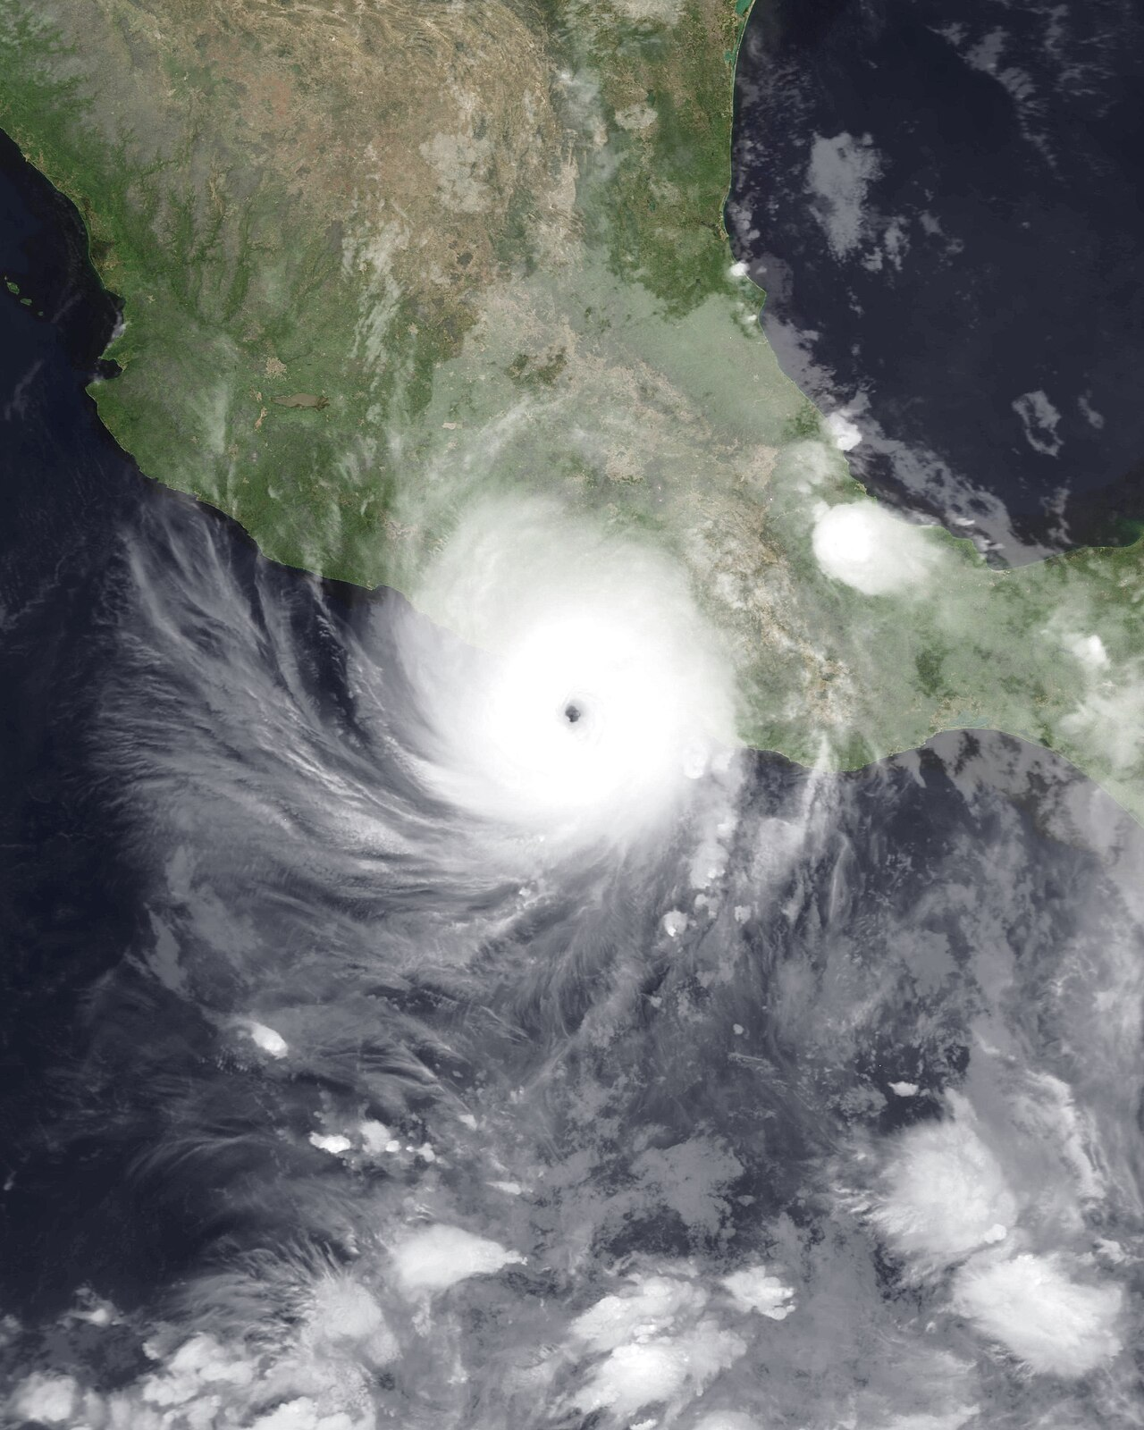

MODIS Imagery from NASA's Terra Satellite

Extreme weather in 2023 was not limited to hurricanes alone. Cyclone Freddy set a new record as the longest-lasting tropical cyclone, surpassing Hurricane John from 1994, and wreaked havoc across Malawi. This year also saw the deadliest weather event, Storm Daniel, which claimed over 5,900 lives, predominantly in Libya. These events underscore the increasing frequency and intensity of extreme weather patterns, attributed partly to climate change.

Looking forward, scientists emphasize the importance of understanding these phenomena to enhance preparedness and minimize impact. Global efforts in climate modeling and weather forecasting continue to evolve, aiming to mitigate the adverse effects of such events. As the world faces the challenges posed by these unpredictable patterns, the need for sustainable practices and proactive measures becomes imperative. 2023 serves as a stark reminder of nature's power and the urgent need to address climate-related concerns.

In conclusion, the extreme weather events of 2023 highlight the ongoing challenges of climate change and its profound effects on human life and the environment. As communities worldwide grapple with the aftermath, the importance of resilience and adaptation becomes clear, urging a collective response to safeguard the future.

Here's an opinion piece related to the topic of extreme weather events, formatted in HTML:

## Weather Extremes: A Call for Collective Responsibility

The year 2023 has been a testament to the unpredictable fury of nature, marked by record-breaking weather events that have left indelible scars on communities worldwide. From Hurricane Otis wreaking havoc in Mexico to Cyclone Freddy's unprecedented rampage across the Indian Ocean, these events underscore the urgent need for global action on climate change. As these natural disasters grow in intensity and frequency, it becomes imperative for nations to unite in addressing the root causes and enhancing our preparedness for future challenges.

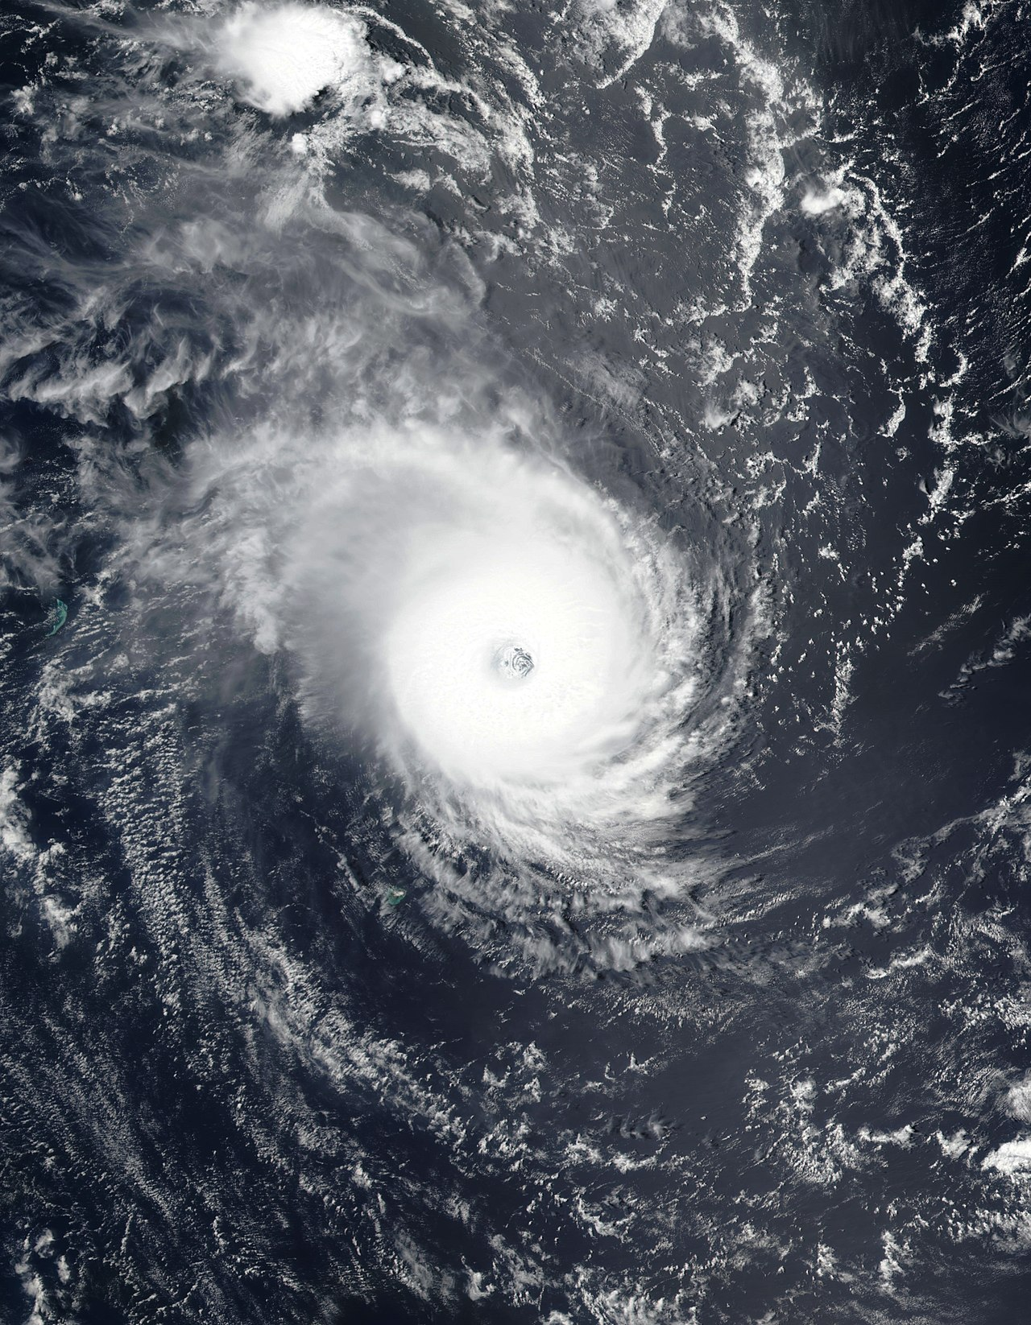

NASA/Suomi-NPP

The devastation caused by Hurricane Otis and Cyclone Freddy serves as a stark reminder of the delicate balance between human activities and nature. Industrial emissions and deforestation continue to exacerbate climate change, creating conditions ripe for such catastrophic events. While technology has improved our ability to forecast weather changes, the inherent unpredictability of these phenomena calls for resilience and proactive measures from all sectors of society. As we face the aftermath, it is crucial to invest in sustainable infrastructure, reinforce disaster management systems, and prioritize environmental conservation.

The collective response to these challenges must transcend borders and politics, focusing on sustainable practices and global cooperation. Governments, businesses, and individuals alike must embrace their roles in mitigating climate change and protecting vulnerable communities. The extreme weather events of 2023 are not merely isolated incidents; they are harbingers of what may become the new norm. As we reflect on the lessons learned, let us commit to a future where resilience, adaptation, and proactive environmental stewardship guide our actions. Only then can we hope to safeguard our planet for generations to come.

In conclusion, the urgent need for a unified global approach to address climate-related challenges cannot be overstated. As we navigate a future fraught with uncertainties, collective responsibility, and sustainable practices will be key to ensuring a resilient and adaptable world.

This article uses an image of Cyclone Freddy from NASA/Suomi-NPP and contains a thoughtful discussion on the global response to climate change and extreme weather events.

### Choose one of the three articles and write a mini media critique. Consider evaluating the article on aspects such as clarity, depth of information, bias, use of sources, and overall impact. Reflect on whether the article effectively communicates its message and supports its claims with evidence.

___________________________________________________________________

___________________________________________________________________

___________________________________________________________________

___________________________________________________________________