An adventurous journey
Have you ever wondered what happens to all the plastic we use? In this worksheet, we explore this question and embark on an adventurous journey. We follow a tiny piece of plastic and discover how it sets off to explore the world!

The Journey of Tyre Abrasion

Hello there! I'm Polly, a tiny piece of plastic, living in a car tyre. Every time the car speeds down the road, I slowly break free from the tyre, along with many of my friends. This happens because of the constant rubbing between the tyre and the road, especially when the car brakes hard or makes sharp turns. Did you know that a tyre can lose up to a kilo of weight throughout its life due to this process? It's fascinating!

My journey starts on the busy roads. I get swept away by rainwater and find myself traveling through the sewer system. Sometimes, I sink directly into the soil or get washed into streams and rivers. I'm not alone on this adventure; many other particles join me, made not only of rubber but also of dust and various substances from the road.

Once in the water, thrilling adventures await. I encounter fish and other aquatic creatures. Unfortunately, I'm a hazard to them. They might accidentally swallow me while eating, and since I'm stubborn and don't break down easily, I stick around in their bodies for a long time. This can make them sick and even upset the balance of the food chain.

Tyre abrasion is one of the largest sources of microplastics in the environment. In Germany alone, around 150,000 tonnes of it end up in nature every year. It's a big problem because these tiny plastic bits hurt not just the water, but living creatures too, possibly making their way to our dinner plates.

So, here I am, Polly, a small plastic particle, entering the world through tyre abrasion, causing trouble without meaning to. But my journey is just beginning! There's much more to explore soon.

Polly is still travelling. Listen to what she's experiencing!
 | Audio Content  To listen to audio content just scan the QR code and listen to it on the digital worksheet.  https://to-teach.ai/worksheet/WzCVYvaLa1W35ivB7t9t

📋 Select the correct answer from the options provided.

What is a major environmental concern caused by tyre abrasion?
It contributes to air pollution It is a leading source of microplastics It increases the weight of vehicles It reduces road noise

How can tyre abrasion particles affect aquatic life?
They provide nutrients to fish They can be swallowed and cause harm They improve water quality They increase oxygen levels in water

What happens to tyre abrasion particles once they enter the sewer system?
They disintegrate quickly They contribute to soil erosion They can be washed into streams and rivers They are completely filtered out

What is the approximate amount of tyre abrasion that ends up in nature annually in Germany?
50,000 tonnes 150,000 tonnes 250,000 tonnes 350,000 tonnes

How does tyre abrasion occur?
Through chemical reactions in tyres From tyre and road friction during driving From sunlight breaking down tyres Through tyre expansion in heat

What might be a long-term consequence of microplastics entering the food chain?
They enhance the nutritional value of food They may upset the balance of ecosystems They help in the decomposition of organic matter They improve the taste of seafood

What is one way tyre abrasion particles enter the environment?
Through vehicle exhaust emissions By being washed away by rainwater Through the natural movement of soil By evaporation into the air

📋 Assignment

Write a short text on the given question.

Explain how tyre abrasion contributes to microplastic pollution in the environment.
___________________________________________________________________
___________________________________________________________________
___________________________________________________________________

Polly's journey is coming to an end. Let's see what she experiences!

Polly and the Never-Ending Journey of Tyre Wear Particles

As I swirl through the stream, the journey continues. The current carries me swiftly, surrounded by curious fish and vibrant algae. I hope they don't swallow me, as my stubborn nature can harm them. This stream leads to a larger river, and the adventure unfolds further.

The river's flow is powerful, sweeping me along its path. I drift past bustling towns and serene landscapes, witnessing the world from a unique perspective. Unfortunately, my presence poses a threat to aquatic life. When fish mistake us for food, we linger in their bodies, causing health issues and upsetting the delicate balance of the ecosystem.

Eventually, the river empties into the vast ocean. Here, the problem escalates as billions of microplastics like me accumulate, forming floating islands of trash. These islands disrupt marine habitats, endangering countless creatures. It's a somber realization, seeing the harm we cause to this beautiful world.

In the ocean, I become part of a cycle that seems endless. Some particles find their way back to the shore, where they might start the journey anew. Others, however, remain adrift for decades, affecting marine life and ecosystems far and wide. Although I long to return to the land, the ocean is my home for now, amidst this vast expanse of water and life.

Despite the challenges, there's hope that solutions will emerge to minimize the impact we have. Until then, my journey as a tyre wear particle continues, full of adventures and lessons about the interconnectedness of nature. And so, my story concludes for now, but the journey never truly ends. Wherever the current takes me next, I'll be a witness to the wonders and trials of the natural world, hoping for a brighter future for all its inhabitants.

📋 Assignment

Complete the two tasks by taking into account all the information provided by our protagonist.

Describe the journey of Polly, the tiny plastic particle, from the tyre to the ocean.
___________________________________________________________________
___________________________________________________________________
___________________________________________________________________
Explain why Polly and other tyre wear particles are a problem for the environment and aquatic life.
___________________________________________________________________
___________________________________________________________________
___________________________________________________________________

📋 Complete the crossword puzzle using the texts.
 |  |  |  |  |  |  |  | 2 |  |  |  | 5
1 |  |  |  | 6
 |  |  | 3
4

Across
1 What is the name for small plastic pieces from tyres? (13)
3 Where do tyre particles often end up after rain? (5)
4 What do tyre particles form in the ocean? (7)

Down
2 What do tyre particles pose a threat to in water? (4)
5 What is another word for rubber pieces from tyres? (4)
6 What is the large body of water where rivers empty? (5)

💡 Bonus

Fill in the "Plastic CV" using the texts.
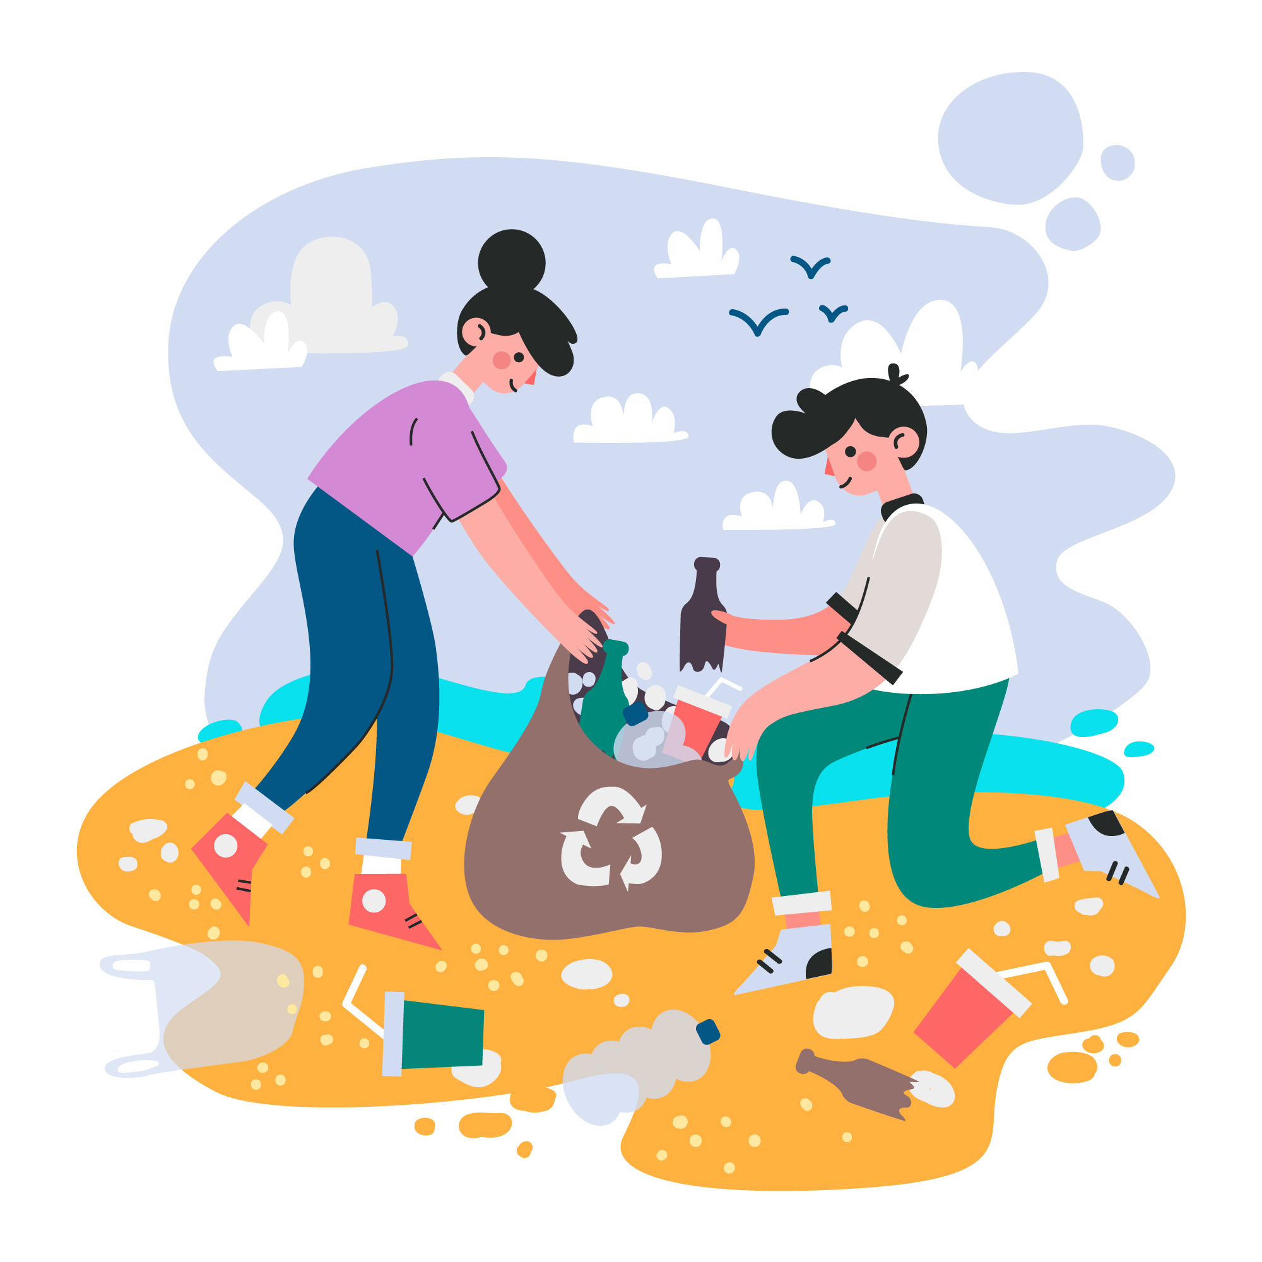 | "Family name" (type of plastic)
 | "Place of birth" (factory)
 | "Education" (intended use, e.g. packaging)
"Work experience" (stations in the ecosystem)

"Special skills" (e.g. long shelf life, ability to bind toxins)

"Personal characteristics" (e.g. fragile, resilient)

"Goals for the future" (ironic, e.g. "float in the ocean forever")

