# A day in the year 2054

The sun rises over the futuristic Berlin, casting the city in a warm, golden glow. On the streets, silent hovering vehicles glide by, guided by intelligent algorithms. The air is clear and fresh, thanks to years of emission-free transportation. The automotive industry has undergone a dramatic transformation: cars are now produced in massive, sustainable factories powered by solar and wind energy.

People use car-sharing services through their holo-watches, which display the nearest available vehicle. These cars are more than just means of transportation; they are mobile living spaces, equipped with everything needed for a long journey – from cozy seats to entertainment systems. Thanks to groundbreaking recycling technology, the vehicles are 100% recyclable, eliminating waste piles.

In the cities, there are green oases and vertical gardens that enhance air quality. Self-driving vehicles have become the norm, reducing traffic accidents and enabling efficient travel. The roads are filled with electric and hydrogen-powered cars, making fossil fuels a thing of the past.

You look around and ask yourself: "How did we get here?"

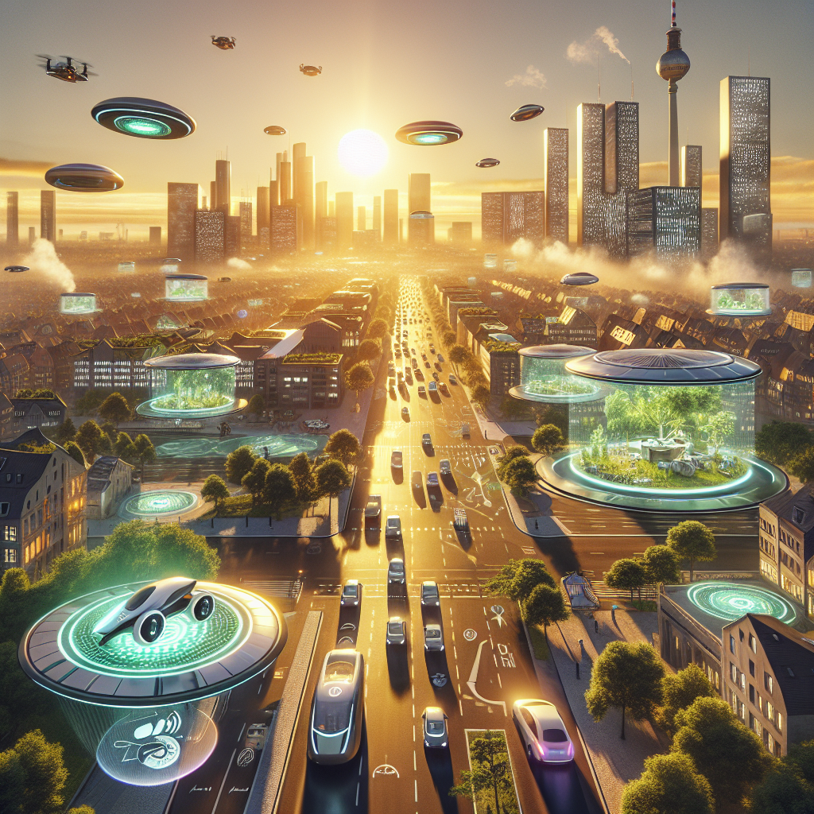

### 📝 Task

What technological and social changes have made this sustainable and efficient future possible? Write down your ideas.

___________________________________________________________________

___________________________________________________________________

___________________________________________________________________

___________________________________________________________________

|  |
| --- |
| Is this really the future that awaits us? In this worksheet, we will take a close look at one sector of the economy. We will identify the challenges and opportunities that await it and you will assess for yourself how the future of this sector could develop. |

# Automotive Industry in Germany

The automotive industry in Germany is one of the largest and most influential sectors within the country's economy. This industry employs over 857,336 people as of 2016 and is integral to the nation's manufacturing and export activities. Germany is renowned globally for its automotive innovation and production, ranking third in car production and fourth in total motor vehicle production worldwide. In 2017, German-designed cars had a 31.5% share of the European Union's market, underscoring their dominance in Europe.

Germany's automotive sector produces a wide range of vehicles, including passenger cars, commercial trucks, buses, and motorcycles. Key players in this industry are some of the most recognized automotive brands globally, such as Volkswagen, BMW, Daimler AG (Mercedes-Benz), Porsche, and Audi. These companies not only manufacture vehicles in Germany but also have extensive international operations and subsidiaries. The sector falls under the category of the manufacturing industry and significantly contributes to Germany's GDP.

Historically, the German automotive industry has deep roots, dating back to the late 19th century when pioneers like Karl Benz and Nicolaus Otto developed the four-stroke internal combustion engine. Benz's creation of the modern automobile in 1887 laid the foundation for the industry's growth. By 1926, Daimler-Benz was formed, and BMW commenced auto production in 1928, marking the beginning of Germany's automotive ascendancy. However, the industry faced setbacks during the Great Depression in the early 1930s, with many companies failing to survive.

The Nazi regime's Motorisierung policy in the 1930s, which included the development of the Volkswagen Beetle and the construction of Autobahns, was pivotal in revitalizing the automotive sector. Post World War II saw a resurgence with companies like Volkswagen, which produced millions of Beetles, symbolizing Germany's economic recovery. The 1970s and 1980s saw further innovation and expansion, with Volkswagen introducing successful models like the Golf and Passat, and BMW and Mercedes-Benz enhancing their global stature.

Economic fluctuations have significantly impacted the automotive industry. The oil crises of the 1970s and the global financial crisis of 2008 led to periods of reduced production and demand. Nonetheless, the industry's resilience, bolstered by innovative models and high export rates, facilitated recovery. State support during economic downturns also played a crucial role in stabilizing the sector.

Current trends in the German automotive industry include a strong focus on electric mobility and digitization. Companies like Volkswagen and BMW are investing heavily in electric vehicle technology and autonomous driving systems. The establishment of Tesla's Gigafactory in Grünheide, near Berlin, highlights Germany's role as a hub for automotive innovation.

In conclusion, the automotive industry in Germany is a cornerstone of both the national and global economy. Its historical evolution, marked by pioneering innovations, strategic policies, and economic resilience, has ensured its continued prominence and influence. The industry's adaptability to modern trends like electrification and digitalization promises to maintain its leading position in the global market.

|  |
| --- |
| Status quo With the help of the following tasks, you will take a closer look at the characteristics and historical developments of the economic sector. |

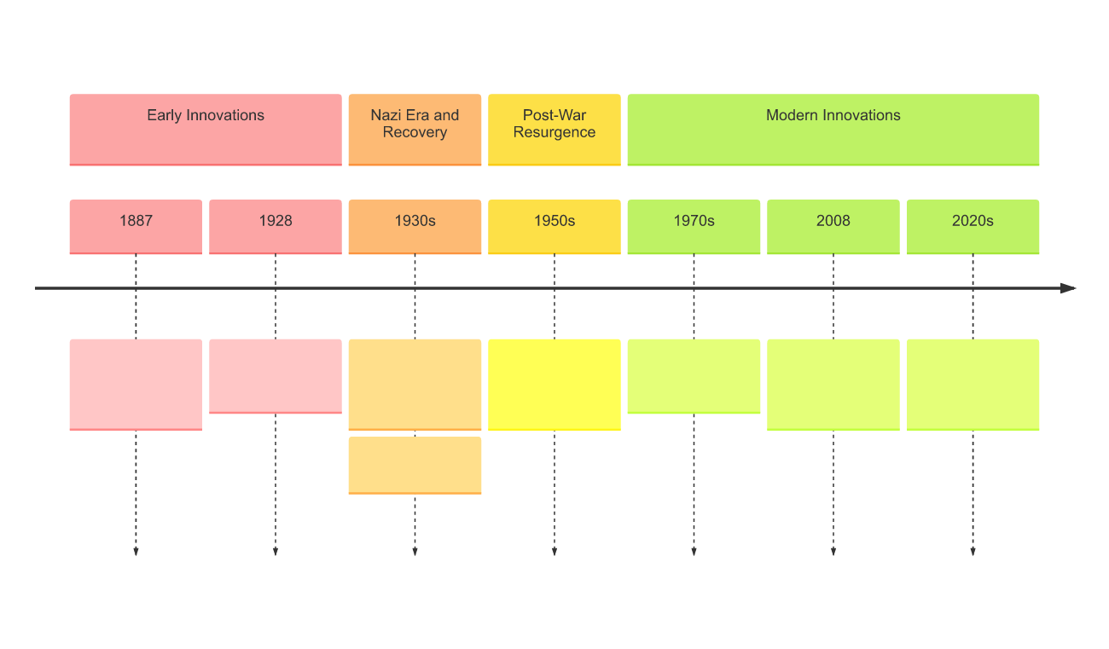

### 📝Task

Record the most important developments in the industry in this timeline.

### 📝 Fill in the profile about the industry.

|  |  |
| --- | --- |
|  | Economic sector |
| Sector |
| Employees in the sector |
| Key Players | |
| Regional significance | |
| Global significance | |
| Current trends | |

|  |
| --- |
| Challenges and opportunities |

|  |  |
| --- | --- |
| Environmental Activist    As an environmental activist, I see the German automotive industry's focus on electric mobility as a significant opportunity. The shift towards electric vehicles can substantially reduce carbon emissions and combat climate change. However, I also recognize the challenge posed by the industry's reliance on rare earth materials for battery production. The environmental impact of mining these resources can be detrimental and needs to be addressed to ensure truly sustainable practices.  A male environmental activist discussing the opportunities of electric mobility in reducing carbon emissions and the challenges of rare earth material mining in battery production. | Entrepreneur    As an entrepreneur in the automotive industry, I see tremendous potential in Germany's innovative capabilities, particularly in autonomous driving technology. This advancement can revolutionize transportation, enhance safety, and create new business opportunities. However, the challenge lies in navigating regulatory frameworks and ensuring cybersecurity. These hurdles must be overcome to fully capitalize on the benefits of autonomous vehicles.  A female entrepreneur discussing the opportunities of autonomous driving technology and the challenges of regulatory frameworks and cybersecurity in the automotive industry. |
| Consumer    As a consumer, I am excited about the variety and innovation in the German automotive market. The availability of electric and hybrid vehicles offers me eco-friendly choices that align with my values. However, I am concerned about the affordability of these new technologies. The high cost of electric vehicles and the need for extensive charging infrastructure pose significant challenges for widespread adoption.  A male consumer discussing the opportunities of eco-friendly vehicle choices and the challenges of affordability and charging infrastructure in the automotive industry. | Politician    As a politician, I believe the German automotive industry's investment in electric mobility and digitization is crucial for our economic growth and environmental goals. It presents an opportunity to lead globally in sustainable transportation solutions. However, the challenge is to ensure a fair transition for workers in traditional automotive sectors. We must provide retraining programs and support to mitigate job losses and maintain social stability.  A female politician discussing the opportunities of electric mobility and digitization for economic growth and the challenges of ensuring a fair transition for workers in traditional automotive sectors. |

### 📝 Arrange the opportunities and challenges from the texts correctly in the table.

|  |  |
| --- | --- |
| Opportunities | Challenges |

Implementation of sustainable production methods · Economic uncertainties and global crises impacting demand and production · Intense global competition from countries like China and the USA · Development of electric vehicles and charging infrastructure · Increasing demand for eco-friendly vehicles · Advancements in digitalization and autonomous driving technology · Leading global position in innovative automotive solutions · Navigating regulatory frameworks and environmental requirements · High cost of electric vehicles and extensive charging infrastructure needs · Ensuring a fair transition for workers in traditional automotive sectors

📝 Decide on an opportunity and a challenge that seems particularly important to you. Explain them in detail.

___________________________________________________________________

___________________________________________________________________

___________________________________________________________________

📝 Can the challenge you have chosen also become an opportunity? If so, how? Describe a possible solution.

___________________________________________________________________

___________________________________________________________________

___________________________________________________________________

|  |
| --- |
| Own opinion/recommendations for action |

### 📝 Do you think that the industry will develop as described in the future scenario?

Explain your opinion with regard to the opportunities and challenges.

___________________________________________________________________

___________________________________________________________________

___________________________________________________________________

___________________________________________________________________