|  |
| --- |
| Introduction This worksheet is about financial differences between men and women. You will learn about differences and reflect on their causes and effects. |

# Gender Wealth Gap

Income and wealth are extremely unequally distributed between the sexes. Worldwide, women earn on average around 23% less than men. On average, men own 50% more wealth than women. An analysis by the World Economic Forum shows that Germany ranks 102nd out of 146 countries in terms of estimated earned income. On average, women in Germany achieve 76% of the wealth of men when they retire.

Quelle

### 📝 Task

What could be the reason for this? Name possible reasons for the inequality between men and women in relation to the data.

___________________________________________________________________

___________________________________________________________________

___________________________________________________________________

___________________________________________________________________



## Causes of the Gender Wealth Gap

The Gender Wealth Gap is a multifaceted issue influenced by a combination of structural, social, and economic factors. One primary cause is the persistent wage gap between men and women. Despite progress in some areas, women still earn significantly less than men on average. This wage disparity directly impacts their ability to accumulate wealth over time. Lower earnings mean less money available for savings, investments, and retirement funds, which are crucial components of wealth-building.

Another significant factor is the disproportionate share of unpaid labor that women undertake. According to the World Economic Forum, women globally perform the majority of unpaid household and caregiving tasks. These responsibilities not only limit the time women can dedicate to paid work but also often lead to career interruptions or part-time employment, further reducing their income potential and opportunities for wealth accumulation.

Additionally, occupational segregation plays a crucial role. Women are often overrepresented in lower-paying industries such as education, healthcare, and social services, while men dominate higher-paying fields like technology, engineering, and finance. This segregation limits women's earning potential and, consequently, their ability to build wealth. Even within the same industry, women are less likely to hold high-paying executive positions, which exacerbates the wealth gap.

Financial literacy and investment behavior also contribute to the gender wealth gap. Studies have shown that women are generally less likely to invest in high-return assets like stocks and bonds compared to men. This is partly due to a lack of confidence in financial decision-making and lower levels of financial education. As a result, women miss out on significant opportunities for wealth growth through investments.

In many countries, systemic issues such as inadequate maternity leave policies and lack of affordable childcare further hinder women's economic advancement. These challenges force many women to choose between career progression and family responsibilities, often resulting in reduced income and savings.

Moreover, societal norms and stereotypes play a role in perpetuating the gender wealth gap. Traditional gender roles that prioritize men's careers and view women as primary caregivers create barriers to women's economic participation and advancement. These cultural expectations can influence hiring practices, promotion decisions, and access to professional networks, all of which are critical for career development and wealth accumulation.

Lastly, women are more likely to experience economic insecurity due to life events such as divorce or widowhood. These events can have a disproportionate impact on women, as they often have less financial independence and fewer assets to fall back on compared to men.

In conclusion, the gender wealth gap is driven by a complex interplay of wage disparities, unpaid labor, occupational segregation, financial literacy, systemic issues, societal norms, and economic vulnerabilities. Addressing this gap requires comprehensive policy interventions, increased financial education, and cultural shifts towards greater gender equality in both the professional and personal spheres.

### 📝 Complete the causes in the previous task with the help of the text.

📝 Explain how the inequalities described in the text can affect women's long-term financial security, particularly in relation to aspects such as retirement planning, wealth accumulation and personal quality of life.

___________________________________________________________________

___________________________________________________________________

___________________________________________________________________

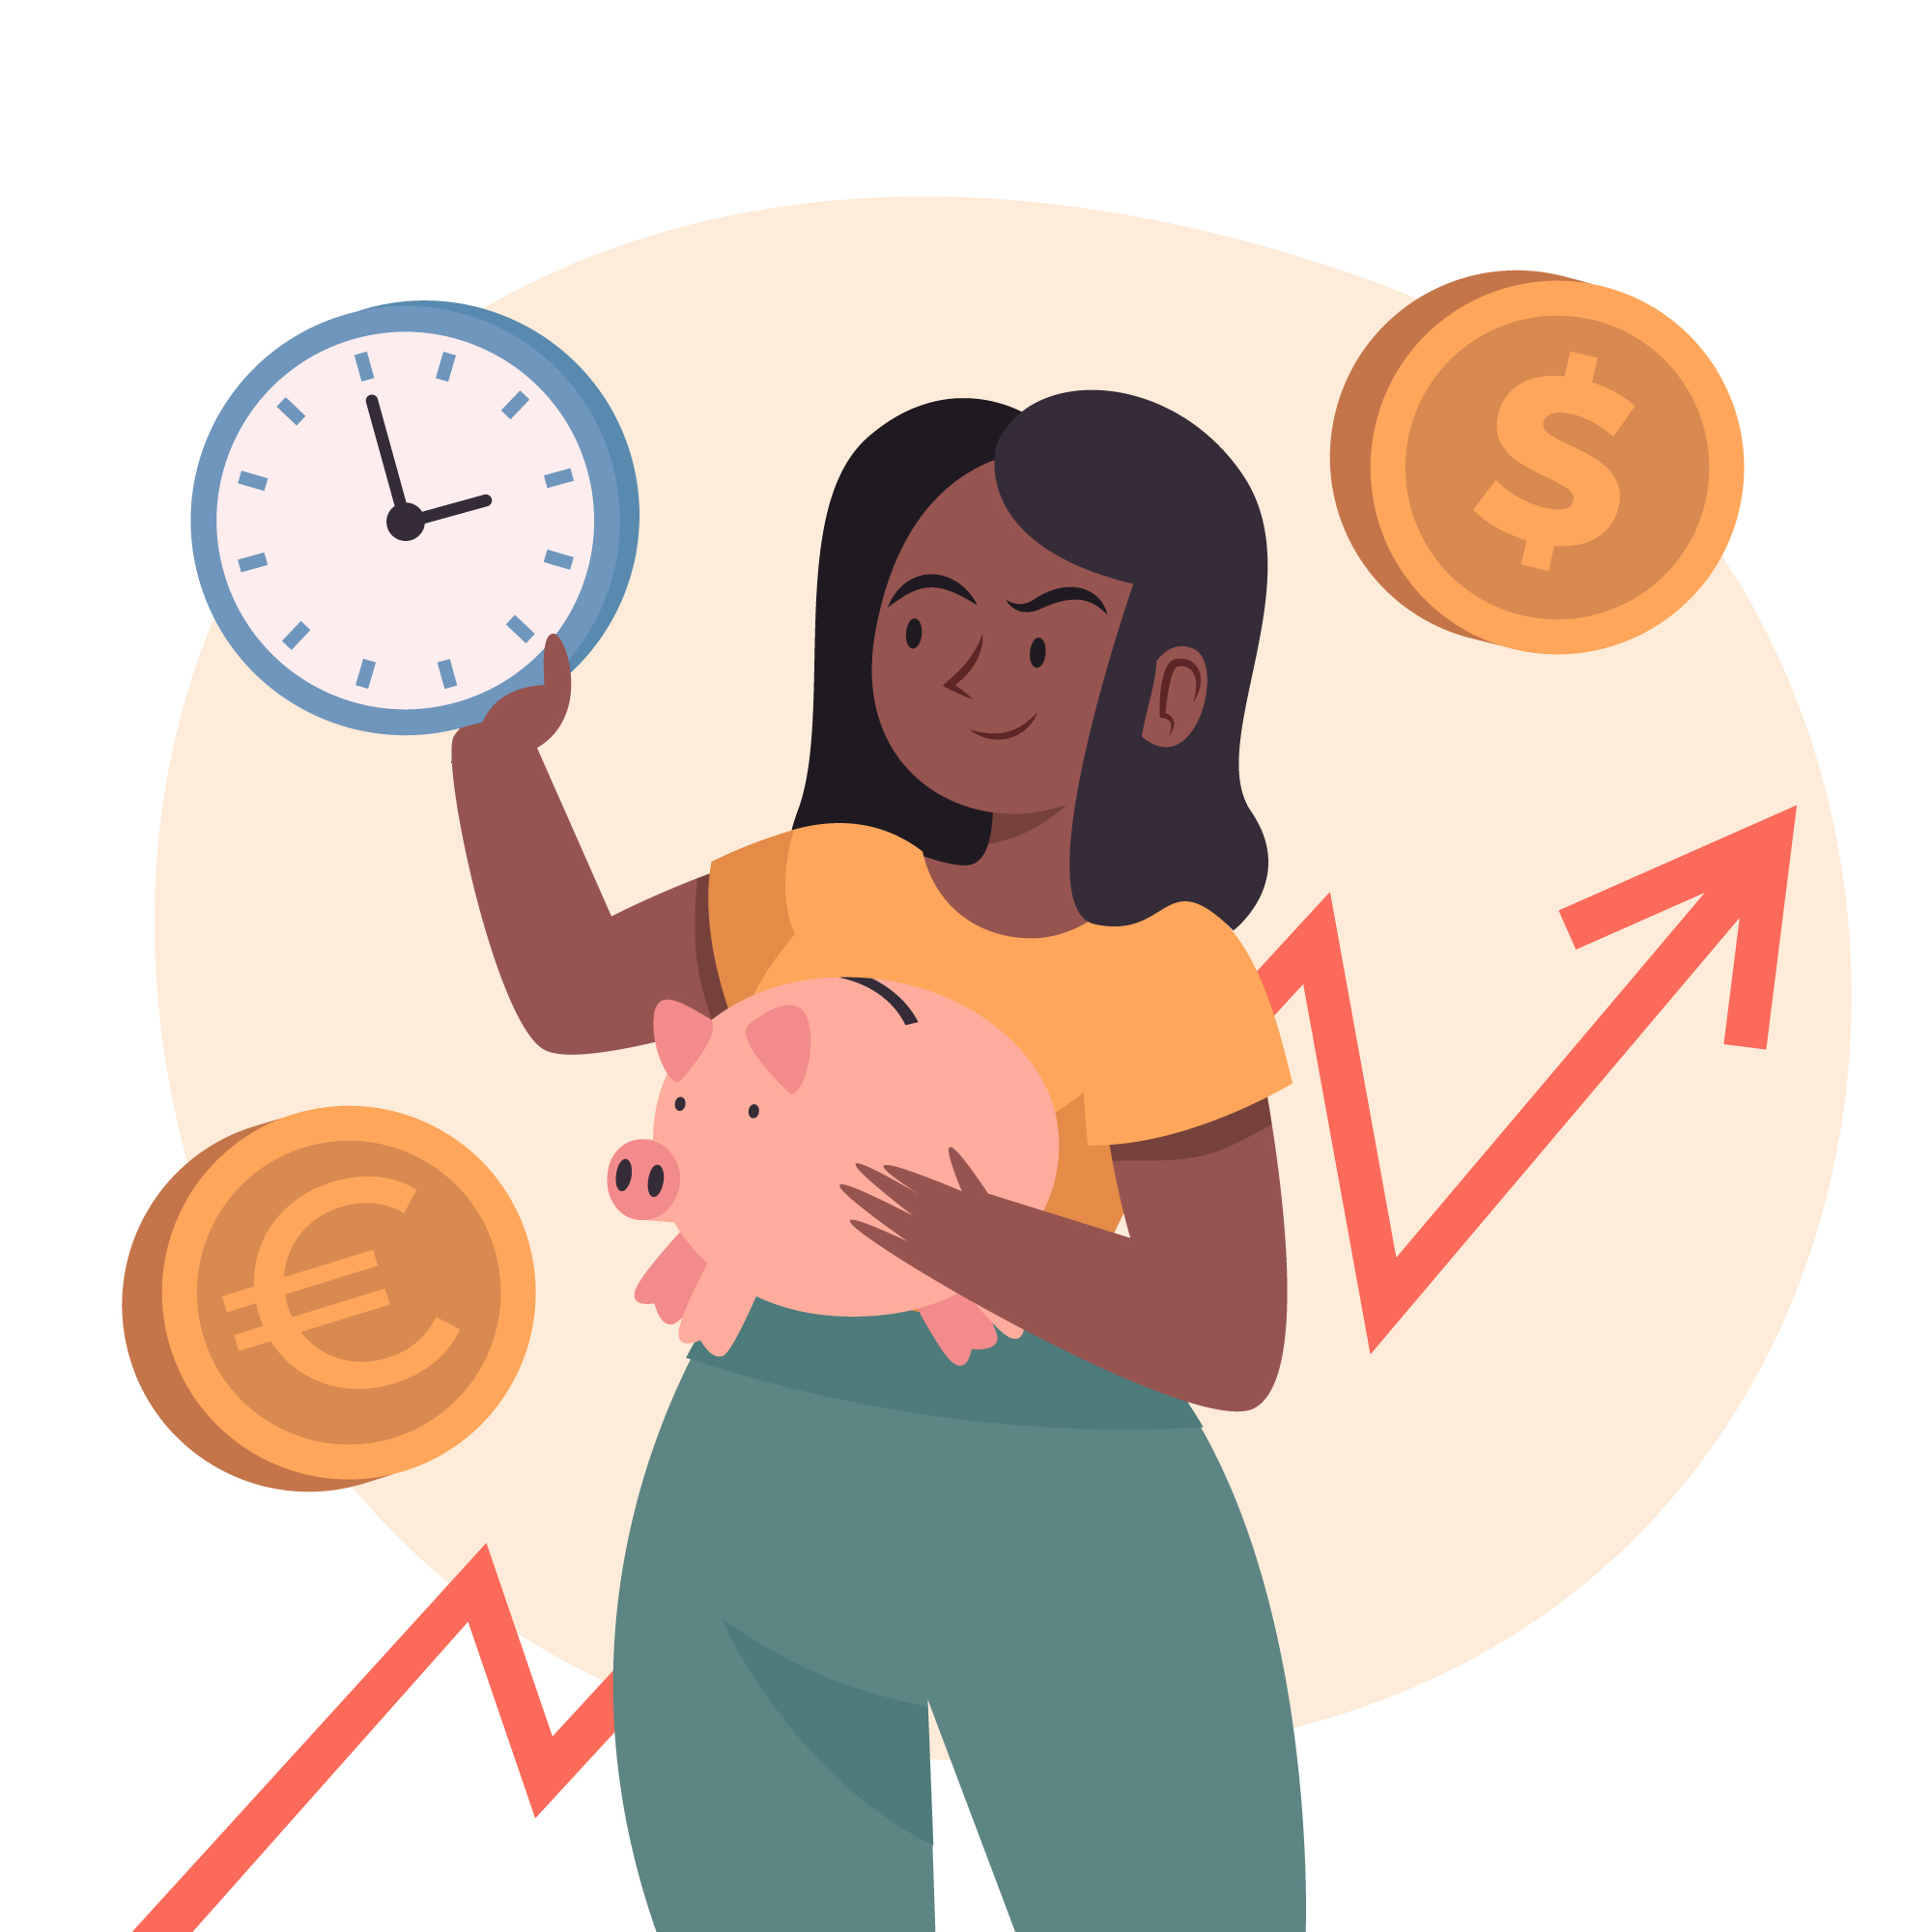

# Development of measures

## 📝 Write down possible measures in the table that could reduce the inequality from the text. Differentiate between individual, social and political measures.

|  |  |  |
| --- | --- | --- |
| Individual | Social | Political |
|  |  |  |
|  |  |  |
|  |  |  |
|  |  |  |
|  |  |  |

### 📝 Task

Imagine you were in charge of a company or a political initiative. What three specific measures would you take to promote financial equality between men and women? Give reasons.

___________________________________________________________________

___________________________________________________________________

___________________________________________________________________

___________________________________________________________________

### 📝 Task

What would our society be like if this financial inequality did not exist? Describe the benefits for individuals, companies and society as a whole.

___________________________________________________________________

___________________________________________________________________

___________________________________________________________________

___________________________________________________________________

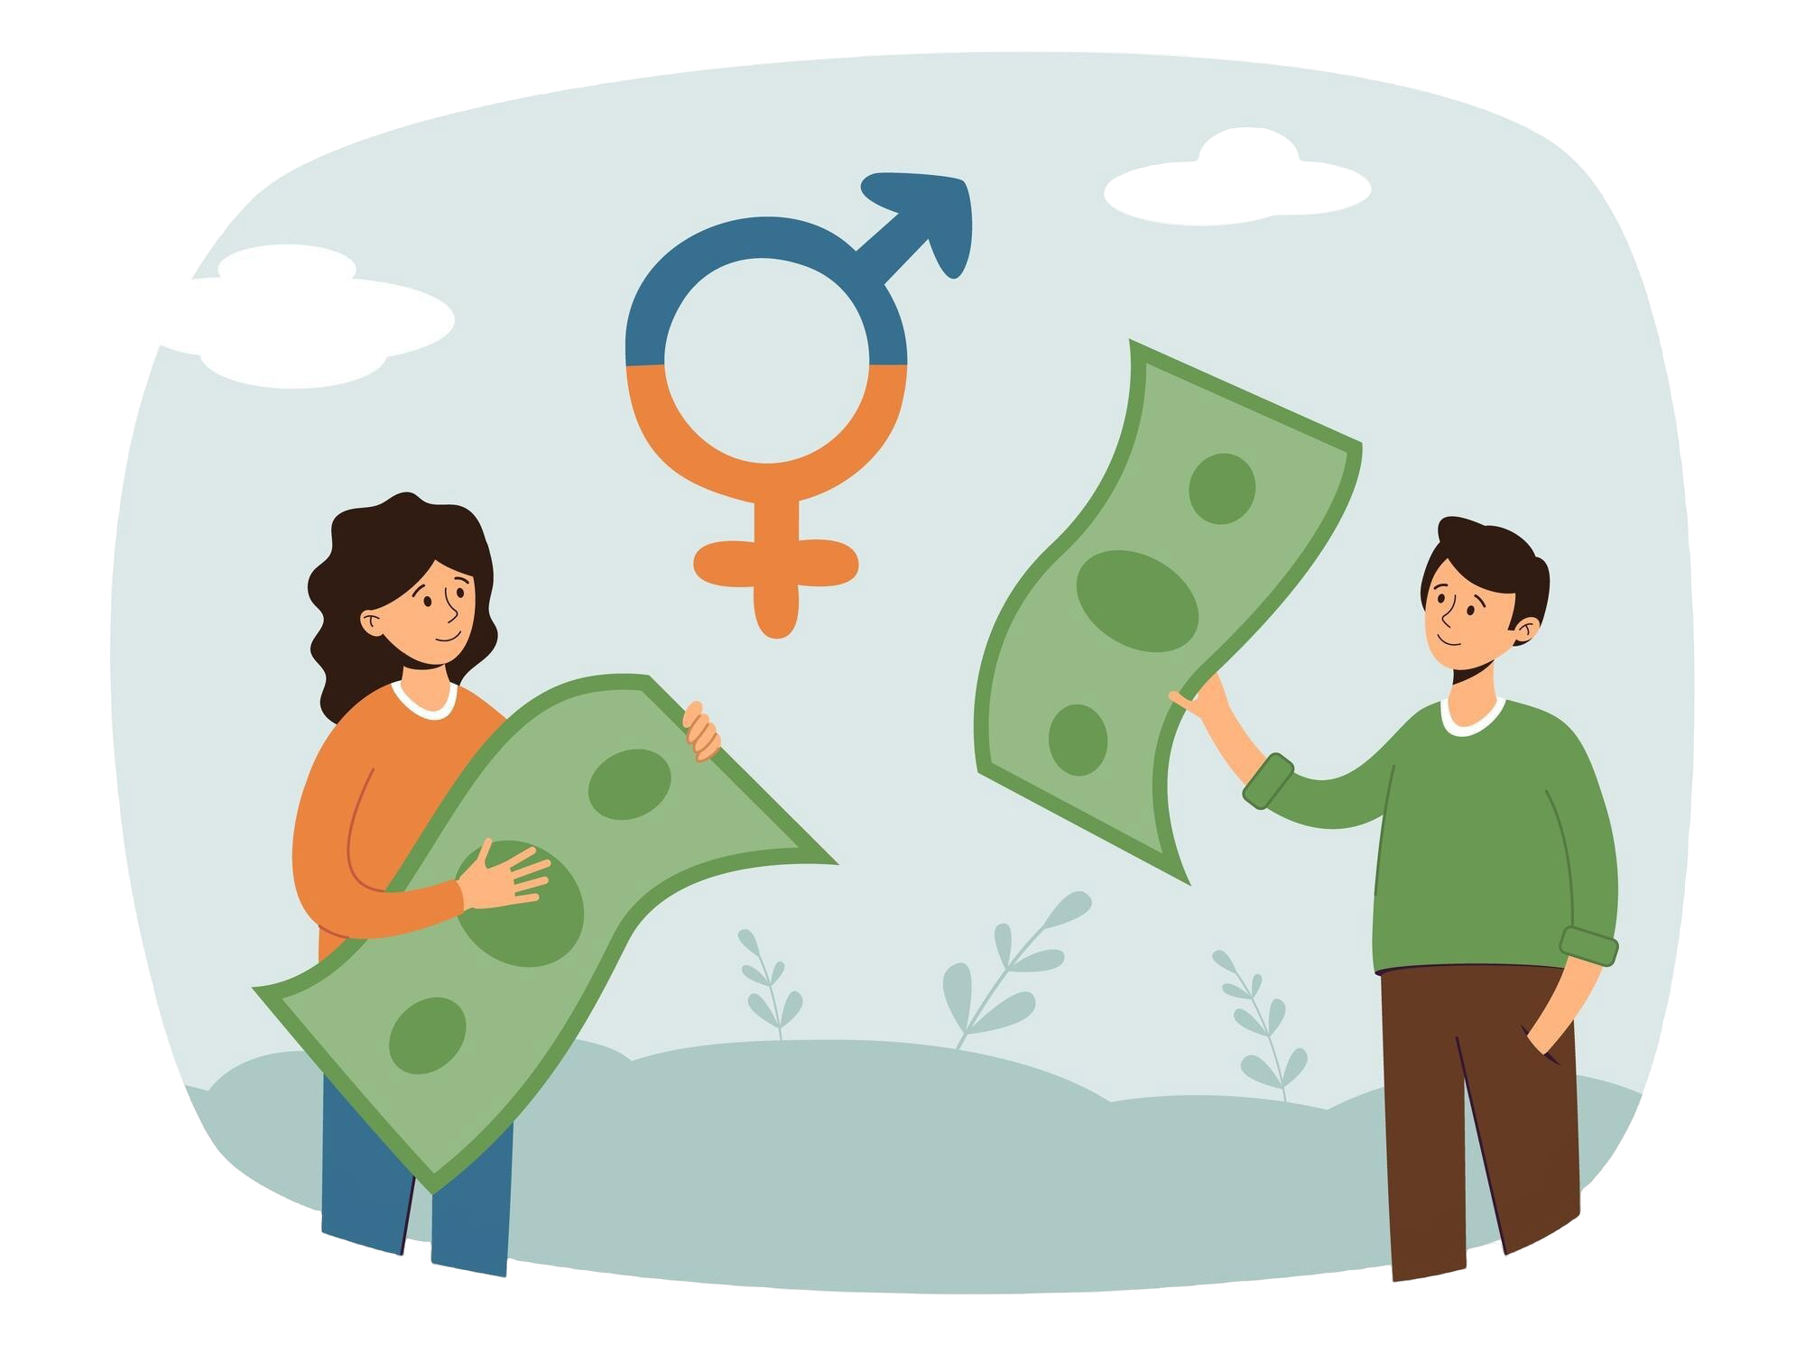

### ✅ Example

# Development of measures

### 📝 Write down possible measures in the table that could reduce the inequality from the text. Differentiate between individual, social and political measures.

|  |  |  |
| --- | --- | --- |
| Individual | Social | Political |
| Increase financial education and literacy among women | Promote equal sharing of household and caregiving responsibilities | Implement and enforce equal pay legislation |
| Encourage women to negotiate salaries and seek higher-paying positions | Challenge and change traditional gender roles through media and education | Provide affordable childcare and comprehensive maternity leave policies |
| Invest in high-return assets like stocks and bonds | Support women’s career advancement through mentorship programs | Promote policies that support work-life balance, such as flexible working hours |
| Plan and save for retirement early | Encourage companies to adopt inclusive hiring and promotion practices | Address occupational segregation by encouraging women into STEM fields |