### Part I: What is power?

### Alone or in small groups, come up with a definition of the term 'power'.

How would you define the concept of power in your own words?

___________________________________________________________________

___________________________________________________________________

___________________________________________________________________

### Imagine, you have been granted absolute power for one month, with no consequences for your actions.

### Answer the following questions.

Describe what you would do, if you had absolute power for a month.

___________________________________________________________________

___________________________________________________________________

___________________________________________________________________

Debate whether you would use it for personal gain or the greater good.

___________________________________________________________________

___________________________________________________________________

___________________________________________________________________

Explain to what extent it would change you.

___________________________________________________________________

___________________________________________________________________

___________________________________________________________________

### Describe and analyze the cartoon. Share your thoughts with a partner.

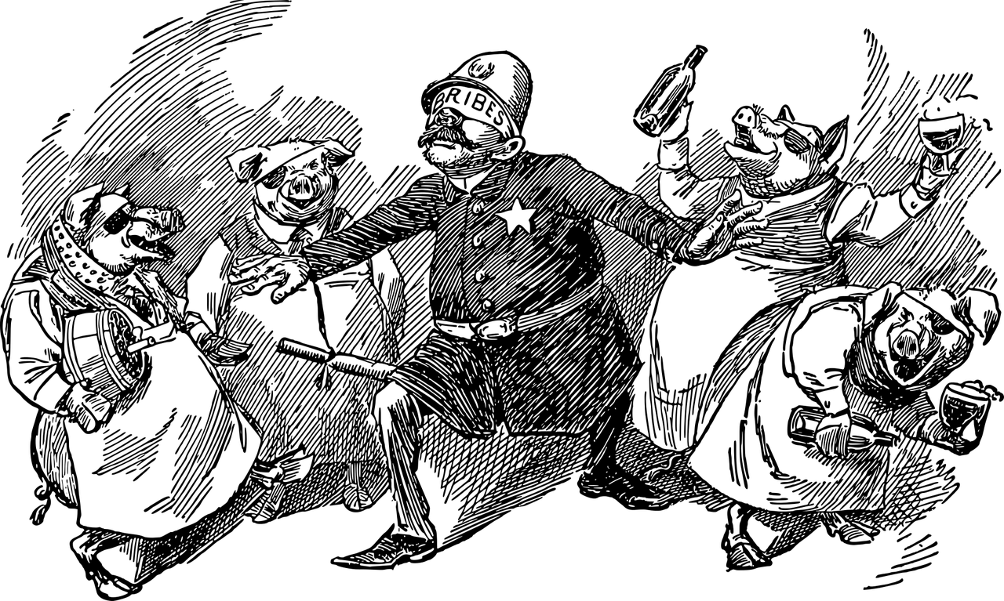

Image by <a href="https://pixabay.com/users/gdj-1086657/?utm_source=link-attribution&utm_medium=referral&utm_campaign=image&utm_content=7297651">Gordon Johnson</a> from <a href="https://pixabay.com//?utm_source=link-attribution&utm_medium=referral&utm_campaign=image&utm_content=7297651">Pixabay</a>

### Cartoon

Space for your notes.

___________________________________________________________________

___________________________________________________________________

___________________________________________________________________

___________________________________________________________________

Comment on the statement 'power corrupts'.

___________________________________________________________________

___________________________________________________________________

___________________________________________________________________

### Part II: Power and corruption in Shakespeare

Read the excerpts and complete the assignment.

### Form groups. Read and annotate the scenes, then create a character evolution chart, tracking the character's initial mindset, their justifications for their actions, and their emotional and psychological changes.

___________________________________________________________________

___________________________________________________________________

___________________________________________________________________

___________________________________________________________________

## Excerpt

Act 1, Scene 3: Macbeth hears the witches’ prophecy.

First Witch: All hail, Macbeth! hail to thee, Thane of Glamis!

Second Witch: All hail, Macbeth! hail to thee, Thane of Cawdor!

Third Witch: All hail, Macbeth, that shalt be king hereafter!

Act 1, Scene 7: Macbeth debates killing Duncan.

Macbeth: If it were done when 'tis done, then 'twere well
It were done quickly: if the assassination
Could trammel up the consequence, and catch
With his surcease success; that but this blow
Might be the be-all and the end-all–here,
But here, upon this bank and shoal of time,
We'ld jump the life to come. But in these cases
We still have judgment here; that we but teach
Bloody instructions, which, being taught, return
To plague the inventor: this even-handed justice
Commends the ingredients of our poison'd chalice
To our own lips.

Act 2, Scene 1: Macbeth hallucinates the dagger.

Macbeth: Is this a dagger which I see before me,
The handle toward my hand? Come, let me clutch thee.
I have thee not, and yet I see thee still.
Art thou not, fatal vision, sensible
To feeling as to sight? or art thou but
A dagger of the mind, a false creation,
Proceeding from the heat-oppressed brain?
I see thee yet, in form as palpable
As this which now I draw.
Thou marshall'st me the way that I was going;
And such an instrument I was to use.
Mine eyes are made the fools o' the other senses,
Or else worth all the rest; I see thee still,
And on thy blade and dudgeon gouts of blood,
Which was not so before. There's no such thing:
It is the bloody business which informs
Thus to mine eyes. Now o'er the one halfworld
Nature seems dead, and wicked dreams abuse
The curtain'd sleep; witchcraft celebrates
Pale Hecate's offerings, and wither'd murder,
Alarum'd by his sentinel, the wolf,
Whose howl's his watch, thus with his stealthy pace.
With Tarquin's ravishing strides, towards his design
Moves like a ghost. Thou sure and firm-set earth,
Hear not my steps, which way they walk, for fear
Thy very stones prate of my whereabout,
And take the present horror from the time,
Which now suits with it. Whiles I threat, he lives:
Words to the heat of deeds too cold breath gives.
[A bell rings]
I go, and it is done; the bell invites me.
Hear it not, Duncan; for it is a knell
That summons thee to heaven or to hell.

Act 3, Scene 1: Macbeth decides to kill Banquo.

Macbeth: To be thus is nothing;
But to be safely thus. Our fears in Banquo
Stick deep; and in his royalty of nature
Reigns that which would be fear'd: 'tis much he dares;
And, to that dauntless temper of his mind,
He hath a wisdom that doth guide his valour
To act in safety. There is none but he
Whose being I do fear: and, under him,
My Genius is rebuked; as, it is said,
Mark Antony's was by Caesar. He chid the sisters
When first they put the name of king upon me,
And bade them speak to him: then prophet-like
They hail'd him father to a line of kings:
Upon my head they placed a fruitless crown,
And put a barren sceptre in my gripe,
Thence to be wrench'd with an unlineal hand,
No son of mine succeeding. If't be so,
For Banquo's issue have I filed my mind;
For them the gracious Duncan have I murder'd;
Put rancours in the vessel of my peace
Only for them, and mine eternal jewel
Given to the common enemy of man,
To make them kings, the seed of Banquo kings!
Rather than so, come, Fate, into the list,
And champion me to the utterance!
Who's there?

Act 5, Scene 5: Macbeth’s famous “Tomorrow, and tomorrow, and tomorrow” speech.

Macbeth: She should have died hereafter;
There would have been a time for such a word.
To-morrow, and to-morrow, and to-morrow,
Creeps in this petty pace from day to day
To the last syllable of recorded time,
And all our yesterdays have lighted fools
The way to dusty death. Out, out, brief candle!
Life's but a walking shadow, a poor player
That struts and frets his hour upon the stage
And then is heard no more: it is a tale
Told by an idiot, full of sound and fury,
Signifying nothing.

### Part III: Interactive activities

Option 1: Create a modern news report on the character's rise and fall. Include a headline, an eyewitness report and a psychological report.

___________________________________________________________________

___________________________________________________________________

___________________________________________________________________

Option 2: Create an artistic representation of the character's development, focusing on symbols and imagery from the play.

___________________________________________________________________

___________________________________________________________________

___________________________________________________________________

### Part IV: Connection to the real world

How does the Shakespearean character compare to today's powerful people?

Explore the theme of ambition in Macbeth and compare it to the ambitions of contemporary business leaders. How does unchecked ambition lead to corruption in both instances?

___________________________________________________________________

___________________________________________________________________

___________________________________________________________________

Evaluate the consequences of Macbeth's tyranny on Scotland and compare them to the effects of a modern tyrant on their nation. How does absolute power corrupt leaders and impact their people?

___________________________________________________________________

___________________________________________________________________

___________________________________________________________________

Compare Macbeth's initial reluctance to commit murder with the ethical dilemmas faced by real-world leaders. How does the struggle between moral integrity and the pursuit of power manifest in both situations?

___________________________________________________________________

___________________________________________________________________

___________________________________________________________________

### EXTRA

### Debate whether the character is responsible for their own tyranny or if someone else is to blame.

|  |  |
| --- | --- |
| Blame the Witches    Role: Argue that the witches are responsible for Macbeth's tyranny. Responsibilities: - Highlight the witches' manipulation and their prophecies. - Discuss how their predictions influenced Macbeth's actions and ambitions. - Emphasize the supernatural element and its impact on Macbeth's mental state. - Suggest that without the witches' interference, Macbeth would not have pursued tyranny.  The advocate believes that the witches' prophecies set Macbeth on his dark path and manipulated him into committing heinous acts. | Blame Lady Macbeth    Role: Argue that Lady Macbeth is responsible for Macbeth's tyranny. Responsibilities: - Highlight Lady Macbeth's ambition and her influence over Macbeth. - Discuss her role in planning Duncan's murder and her manipulation of Macbeth. - Emphasize her relentless encouragement and pressure on Macbeth to seize power. - Suggest that without Lady Macbeth's instigation, Macbeth would not have become a tyrant.  The advocate believes that Lady Macbeth's ambition and manipulation drove Macbeth to commit acts of tyranny. |