Introduction

Welcome to 1929. You are in the United States, stepping into the role of a crisis manager. Your mission: guide the government through turbulent times and help steer the nation back to prosperity. Are you ready to confront the challenges and uncover the path out of the Great Depression? Immerse yourself in the thrilling world of economics and politics, and become part of the solution!

### Breaking news:

"Stock prices plummet dramatically! A unprecedented crash unfolds at Wall Street, leaving companies in disarray and banks teetering on the brink of collapse. The full extent of the shockwave is yet to be realized. Across the United States, American citizens face uncertainty and fear grips the nation. The mood is ominous."



|  |
| --- |
| Phase: Recession |

## A letter from the government

Dear Crisis Managers,

The United States Government reaches out to you in this grave hour with an urgent message. Our nation is engulfed in an ever-deepening recession. The catastrophic stock market crash has brought our economy to its knees and shattered the trust of the American people in our financial system.

Bank accounts are depleted, businesses are closing their doors forever, and millions of Americans are losing their jobs and means of livelihood. The streets are filled with the despair of those who have lost everything. An atmosphere of uncertainty and fear threatens to tear apart the social fabric of our country.

In this dark hour, we place all our hope in you, our capable and wise crisis managers. You embody the last chance we have to lead this nation out of the abyss. But before you can undertake this honorable task, you must prove to us that you are up to the challenge.

We therefore urge you to thoroughly investigate the causes of this crisis and to find a sought-after numerical code. This task will test your analytical skills, your acumen, and your resolve. Only if you master this challenge will you be granted the opportunity to save our country and receive a rich reward.

Your decisions must be prudent and insightful. The future of our nation depends on your ability to take the right actions amidst uncertainty and chaos. Show us that you are the leaders we need in this emergency.

With grave regards,

The Government

|  |
| --- |
| Let's go Now it's up to you to get the situation under control. Can you work out the causes that led to the crisis and find the numerical code?&nbsp;    booming  downturn  The economy was for a long time - and now everything seems to be on the brink of collapse. To determine the causes, you need to understand what happened during the boom and how this drastic came about. You will certainly learn more about the real causes of the crisis at the government office. |

|  |
| --- |
| Phase: Boom |

💡 Info

The government representative is so upset that he hurriedly lets you into the office and immediately disappears again. As you look around, you discover a few clues that could shed light on the causes of the crisis. These include a newspaper article, a note, a letter and a message on the answering machine. Examine the clues carefully to understand the background to the crisis and to be able to determine the numerical code at the end.



## 1920s Economic Boom: A Flourishing Era

The 1920s witness a remarkable surge in economic prosperity across the United States, where innovation and optimism fuel growth. The streets are lively with bustling activity, cities expand rapidly, and the pace of life accelerates dramatically. The era is defined by technological advancements, with industries like automotive and electronics leading the charge. Henry Ford's assembly line makes cars accessible to the masses, while companies like General Electric thrive. The economic landscape is vibrant, offering abundant opportunities for employment and rising wages, enhancing the purchasing power of citizens.



Businessman at Work - Freepik

Stock markets experience a steady climb, driven by investor confidence and speculation. Banks extend generous credit, encouraging investments. This period of economic expansion creates an atmosphere of optimism and progress. Entrepreneurs launch new ventures, capitalizing on the buoyant mood. The middle class grows, and small businesses flourish, bolstered by the era's economic dynamism.

Beyond economics, society undergoes transformation. Jazz music takes over dance floors, fashion becomes more daring, and women gain more rights and freedoms. The public revels in newfound prosperity, with leisure and cultural activities reflecting the exuberance of the times. People embrace the joys of life, looking ahead to a promising future.

As a historian economist, one observes this era with enthusiasm, noting how the positive impacts ripple through communities and businesses alike. Better job prospects and rising incomes signal a bright outlook, as innovation continues to drive growth. The economic boom of the 1920s stands as a testament to human ingenuity and ambition, creating a legacy of prosperity that seems destined to endure.

📝 What information does the newspaper article contain about the economy in the boom period before the crisis? Summarize in your own words.

___________________________________________________________________

___________________________________________________________________

___________________________________________________________________

📌 Meeting Note

To-do:

Discuss with Mr. Smith the concerns about forming a speculative bubble in the stock market. (Investors are buying stocks on margin, expecting prices to rise. Stock prices inflated beyond company value. Low interest rates &amp; easy credit are questionable. Should we consider government intervention?)

📝 Explain the meaning of this message. Research terms whose meaning you do not know.

___________________________________________________________________

___________________________________________________________________

___________________________________________________________________

# Concerns About Banking Practices

Esteemed Government,

As an economic analyst during these tumultuous times, I am compelled to express my grave concerns regarding the banking system's reckless lending practices as elucidated in recent observations. The eagerness of banks to exploit the ongoing economic boom has led to a perilous environment where loans are extended without due diligence concerning borrowers' repayment capabilities. This imprudence has significantly contributed to the inflation of the speculative bubble, particularly within the stock market.

The ramifications of these practices are deeply troubling. As stock prices inevitably plummet, the ensuing wave of loan defaults has precipitated widespread bank failures. Such failures are not just isolated financial mishaps; they are systemic risks that threaten the very foundation of our economy. The resultant contraction of credit availability poses dire consequences, stifling business operations and leaving consumers in financial distress.

It is imperative that immediate measures be taken to restore prudent risk management within our financial institutions. The establishment of stringent lending standards and rigorous borrower assessments must be prioritized to prevent further destabilization. Moreover, the government should consider implementing oversight mechanisms to ensure compliance and safeguard against future crises.

The urgency of addressing these structural weaknesses cannot be overstated. Our economy's resilience and recovery depend on decisive action and robust safeguards to prevent recurrence.

With utmost regard,

James Harrington

📝 Explain the significance of this news. Why might this have contributed to the economic crisis?

___________________________________________________________________

___________________________________________________________________

___________________________________________________________________

🔊 A message on an answering machine.

|  |  |
| --- | --- |
|  | Audio Content  To listen to audio content just scan the QR code and listen to it on the digital worksheet.  https://to-teach.ai/worksheet/doAJdoJPBLRbwFEMRsko |

📝 Explain the significance of this news. Why might this have contributed to the economic crisis?

___________________________________________________________________

___________________________________________________________________

___________________________________________________________________

|  |
| --- |
| Note for the teacher In the PDF version, learners write a number in front of each paragraph to determine the correct order. The number code results from the correct numbering of the paragraphs. |

### 📝 Rearrange the paragraphs to form a coherent text. Use this to find the numerical code. The clues you have found will help you do this. Then you'll get the job!

|  |  |
| --- | --- |
|  | Franklin D. Roosevelt's New Deal introduces social welfare programs and financial reforms to aid recovery. |
|  | The unemployment rate soars to 25%, and millions lose their livelihoods as industrial production, trade, and employment decline. |
|  | Despite the prosperity of the 1920s, wealth was unevenly distributed, leading to significant economic fragility. |
|  | The economic boom of the 1920s, known as the "Roaring Twenties," is characterized by industrial growth, technological advancements, and widespread speculation. |
|  | Panic ensues after the crash, leading to widespread bank failures and a contraction of credit. |
|  | The stock market crash of October 1929, fueled by speculation and excessive debt, marks the beginning of the Great Depression. |
|  | The gold standard restricts monetary policy, exacerbating the economic downturn. |
|  | World War II's economic stimulus contributes to ending the Great Depression, reshaping economic policies and theories. |
|  | Programs like the Civilian Conservation Corps (CCC) and the Works Progress Administration (WPA) create jobs and support economic recovery. |

### Numerical code

Write down the numerical code here. You can use the code to apply for the job as a crisis manager.

___________________________________________________________________

___________________________________________________________________

___________________________________________________________________

___________________________________________________________________

Super! You've found out how the crisis came about and deciphered the code. You get the job and receive a deposit.

The country is now in a deep recession/depression and needs your help more than ever. You are given the contact details of various economic players affected by the crisis. Get in touch with them and use your economic expertise to improve their economic situation and lead the country out of the crisis.

|  |
| --- |
| Phase: Deep recession/depression |



|  |  |
| --- | --- |
|  | Entrepreneur  As an entrepreneur, I face immense challenges due to the Great Depression. The once-thriving demand for our products has evaporated. With household incomes severely reduced, customers are hesitant or unable to purchase as before. The financial conditions have worsened drastically; securing loans for expansion or new investments is nearly impossible. Banks are failing, and credit is contracting. The drop in prices means we must reduce production, leading to layoffs. I never imagined my business would be in such a precarious position. Every day feels like a new battle against uncertainty. |
|  | Consumer  The economic downturn has drastically altered my life. My husband lost his job, and our income is now insufficient for basic needs. With unemployment soaring, our household's purchasing power has plummeted. Before the crash, we could occasionally afford small luxuries, but now we struggle to buy even essential items. Prices for food may have dropped, but we still can't afford them. Lately, we've been relying on soup kitchens. It feels like we're sliding deeper into hardship, unsure how long we can endure without change. |
|  | Finance Director  As the finance director of a large bank, the impact of the 1929 crash is palpable. Panic has spread among customers, leading to mass withdrawals. Stabilizing bank deposits is nearly impossible amidst declining trust in the financial system. Many clients are defaulting on loans, forcing us to tighten lending. The pressure is mounting, and the fear of bankruptcy looms. Investment opportunities are dwindling as businesses become cautious, delaying new projects. If we don't act quickly, our bank might collapse. |
|  | Minister of Economic Affairs  The global economic crisis has severely impacted the state treasury. With rising unemployment and falling household incomes, tax revenues are decreasing while public spending increases. We must enhance unemployment benefits and support programs for economic recovery. These measures are essential but strain the national debt. The challenge is creating jobs and boosting demand with limited resources. Balancing the budget becomes increasingly difficult as the crisis deepens. |
|  | International Trade Expert  The crisis's effects are felt globally. As an expert in international trade, I observe daily declines in exports and reduced demand for goods abroad. Countries worldwide face similar challenges, slowing international trade significantly. Capital outflow is rising as investors seek safer havens. Our currency is depreciating, making imports more expensive while domestic demand falls. The international markets are tumultuous, making recovery increasingly challenging. |

### 📝 To solve the people's problems, make notes for each sector. Record the notes in the table.

|  |  |  |
| --- | --- | --- |
| Sector | Problem | Impact on other sectors |
|  |  |  |
|  |  |  |
|  |  |  |
|  |  |  |
|  |  |  |



## Solution

|  |  |  |
| --- | --- | --- |
| Sector | Problem | Impact on other sectors |
|  |  |  |
|  |  |  |
|  |  |  |
|  |  |  |
|  |  |  |

### 💡 Info

Now you know the problems and get to work. At a team meeting, you have collected ideas for solutions in a mind map. As the team leader, however, it is now up to you to work on the notes so that they can be shown to the government. Create a proposal for an economic stimulus package by working through the tasks.

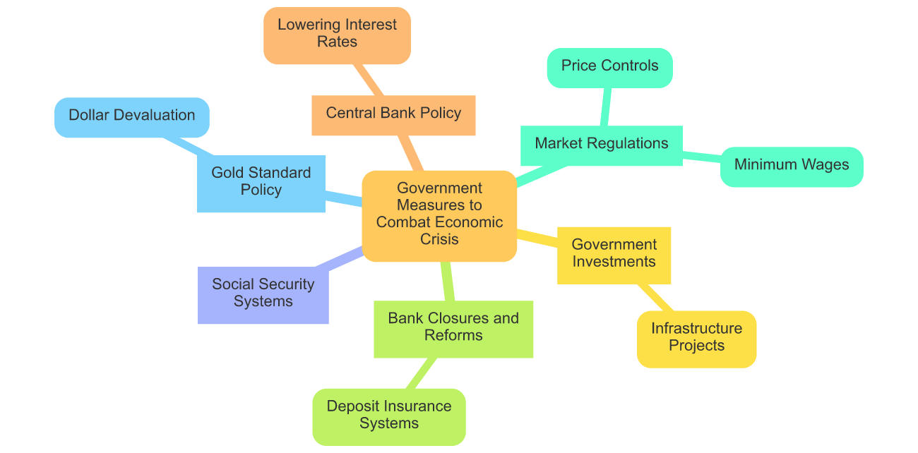

📝Explain the ideas for measures from the mind map.

___________________________________________________________________

___________________________________________________________________

___________________________________________________________________

📝Write a letter to the government in which you propose sensible measures to overcome the crisis. Explain why these measures would help people in the various sectors.

___________________________________________________________________

___________________________________________________________________

___________________________________________________________________

upswing phase

Great! You've done it and selected the right measures. The government implements your proposals. As a result, you bring the country into the and things finally start to pick up again. You receive the promised fee.

## Reviving the American Dream: Lessons from the New Deal

In the aftermath of the Great Depression, the United States embarked on a path of recovery, marked by remarkable government intervention. As a present-day historian economist, I reflect on how Franklin D. Roosevelt's New Deal reshaped the socio-political and economic landscape, laying a foundation for future prosperity.



Image Source: Freepik

The New Deal, a series of programs and reforms, aimed to provide relief, recovery, and reform to an ailing nation. Initiatives like the Civilian Conservation Corps (CCC) and the Works Progress Administration (WPA) not only created jobs but infused hope into millions of American lives. The Social Security Act emerged as a safety net, providing financial support to the vulnerable, ensuring dignity in the face of adversity.

Politically, the New Deal signaled a shift towards liberal policies, challenging the laissez-faire approach. It fostered a new era of government accountability, emphasizing the role of the state in safeguarding economic stability. Economically, the reforms curbed the reckless financial practices that had led to the Depression, with regulations like the Glass-Steagall Act restoring trust in the banking system.

Today, as we analyze the recovery phase post-Great Depression, we witness the enduring legacy of the New Deal. It underscored the necessity of government intervention during crises, shaping modern economic policies that continue to protect citizens. The resilience shown during this period offers timeless lessons for navigating future economic challenges.

|  |
| --- |
| Phase: Recovery |

### 💡 Info

Great, you got the country out of the crisis and the government was able to adopt rescue measures thanks to you.

The government is so enthusiastic about your work that it asks you to record your findings on the various phases of the economic cycle in order to better prepare the country for future crises. Complete the last assignment and you will receive a bonus.

📝 Explain the phases of the economic cycle so that other crisis managers can also benefit from your knowledge.

___________________________________________________________________

___________________________________________________________________

___________________________________________________________________

### You made it and completed all the tasks!

