# Oxidation

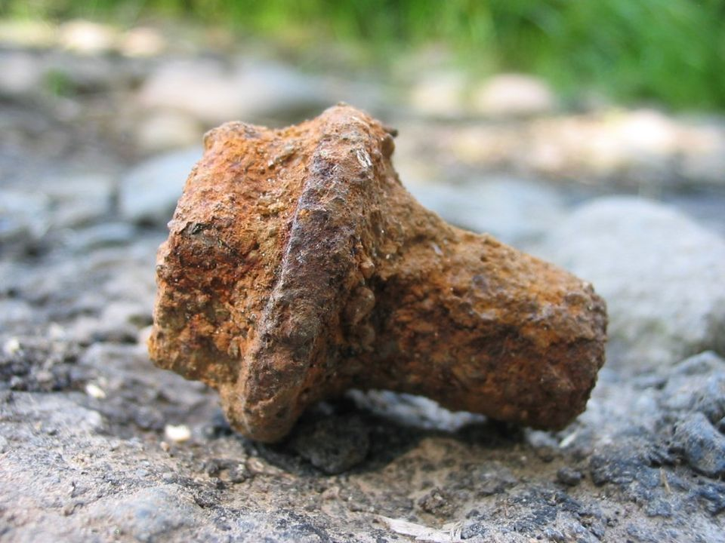

Source: Wikipedia

Have you ever noticed how a shiny, new bicycle left outside in the rain starts developing a reddish-brown coating? This process, commonly known as rusting, is a classic example of **oxidation**. Oxidation is a chemical process where a substance combines with oxygen or loses electrons.

**Oxidation** can be defined as the process in which a substance loses electrons or gains oxygen. This is part of a larger set of reactions known as redox (reduction-oxidation) reactions. In these reactions, while one substance gets oxidized (loses electrons), another gets reduced (gains electrons).

The underlying theory of oxidation involves the transfer of electrons between substances. When a substance undergoes oxidation, it loses electrons and increases its oxidation state. This electron transfer is what causes the chemical changes we observe.

A common example of oxidation is the rusting of iron. When iron (Fe) reacts with oxygen (O₂) in the presence of water, it forms iron oxide (rust). In this process, iron atoms lose electrons to oxygen atoms:

Iron loses electrons and becomes oxidized.

Oxygen gains electrons and becomes reduced.

Another example is the browning of fruits like apples. When an apple is cut, the exposed surface reacts with oxygen in the air. This reaction is facilitated by enzymes in the apple, leading to the formation of brown pigments.

In everyday life, oxidation has many practical applications and implications. For instance, the combustion of fuels in cars and power plants is an oxidation process where fuels (like gasoline) react with oxygen to release energy, carbon dioxide, and water. This energy powers our vehicles and generates electricity.

Industrially, oxidation processes are crucial in various fields. For example, in the production of metals, ores are often oxidized to extract pure metals. The oxidation of sulfide ores results in the production of sulfur dioxide, which can be further processed into sulfuric acid, an important industrial chemical.

The key concepts related to oxidation include:

**Oxidizing Agent**: A substance that causes oxidation by accepting electrons.

**Reducing Agent**: A substance that causes reduction by donating electrons.

**Oxidation State**: A number that represents the total number of electrons lost or gained by an atom in a compound.

**Redox Reactions**: Combined reactions where one substance is oxidized and another is reduced.

In summary, oxidation is a fundamental chemical process that plays a vital role in both natural phenomena and industrial applications. From the rusting of metals to the browning of fruits and the combustion of fuels, understanding oxidation helps us make sense of various chemical changes that occur around us. The ability to harness and control oxidation processes has led to significant advancements in technology and industry, making it an indispensable concept in the field of chemistry.

### Mark the correct answer.

###### **What happens to a substance during the oxidation part of a redox reaction?**

It gains oxygen and decreases its oxidation state It loses electrons and increases its oxidation state It gains electrons and decreases its oxidation state It combines with hydrogen and decreases its oxidation state

###### **Why does an apple turn brown after being cut?**

The sugars in the apple ferment The cut surface dries out due to dehydration The cut surface absorbs moisture from the air The exposed surface reacts with oxygen, facilitated by enzymes

###### **In the rusting of iron, what role does oxygen play?**

It acts as a reducing agent It acts as an oxidizing agent It acts as a catalyst It acts as a solvent

###### **Which of the following is an example of an oxidation process in everyday life?**

Dissolution of salt in water Combustion of fuels in cars Freezing of water into ice Photosynthesis in plants

###### **What is the significance of oxidation in industrial applications?**

It is used to solidify molten metals It helps in the fermentation of beverages It is used to cool down reactors It is crucial for the extraction of pure metals from ores

###### **What forms when iron reacts with oxygen in the presence of water?**

Iron oxide Iron chloride Iron sulfate Iron nitrate

Name a common example of oxidation in everyday life.

___________________________________________________________________

___________________________________________________________________

___________________________________________________________________

Describe what happens during the browning of cut fruits like apples.

___________________________________________________________________

___________________________________________________________________

___________________________________________________________________

Explain the role of oxidation in the combustion of fuels.

___________________________________________________________________

___________________________________________________________________

___________________________________________________________________