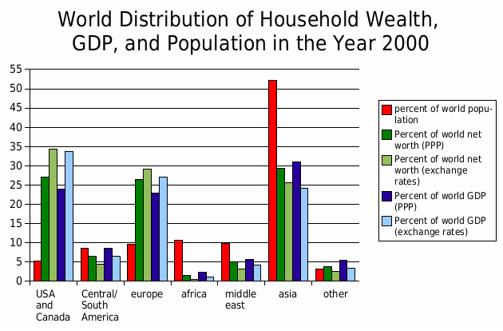

World distribution of wealth, GDP, and population by region in the year 2000

|  |
| --- |
| First impression To analyze a statistic or diagram, you should first record your first impression. This will help you with your further analysis. |

### Task

Record your first impression in the cloud. What is the first thing you notice? Are there any obvious trends or special features? Does looking at the statistics or diagram for the first time trigger a feeling in you?



|  |
| --- |
| Description The next step is to describe the statistic or diagram in detail. |

### Task: 📝 Use the table to describe the diagram or statistics.

|  |  |
| --- | --- |
| Source  Include the source of the data, such as the institution or dataset where the diagram originates. |  |
| Time/Period  Specify the time period or years covered by the data, including the location if relevant. |  |
| Type of Chart  Identify the type of chart used (e.g., bar chart, pie chart) and describe its characteristics. |  |
| Components of the Chart and Units of Measurement  Describe the components of the chart, such as the x-axis, y-axis, segments, and units of measurement. |  |
| Data Description  Explain the data represented in the chart, including key trends and any notable changes or patterns. |  |

### True or false? Put a cross in the box.

###### **The diagram illustrates the distribution of individual net wealth in the adult population of Germany by deciles for the years 2002 and 2007.**

True False

###### **The data source for the diagram is the Federal Statistical Office based on calculations by the SOEP at DIW Berlin.**

True False

###### **The wealth distribution diagram uses a line graph to differentiate between the years 2002 and 2007.**

True False

###### **The X-axis of the diagram shows the deciles of the population, while the Y-axis represents the percentage share of total wealth.**

True False

###### **According to the diagram, the wealth concentration in the top decile increased from 57.9% in 2002 to 61.1% in 2007.**

True False

###### **The lower 50% of the population held a significant portion of the net wealth in both 2002 and 2007.**

True False

|  |
| --- |
| Analysis Now take a close look at the data and put it into an economic context. |

📝 Declare the trends in wealth distribution in Germany between 2002 and 2007, as depicted in the diagram. What significant changes can be observed?

___________________________________________________________________

___________________________________________________________________

___________________________________________________________________

📝 Analyze the potential factors that could have influenced the increase in wealth concentration in Germany from 2002 to 2007. What economic contexts and external factors might have contributed to this trend?

___________________________________________________________________

___________________________________________________________________

___________________________________________________________________

|  |
| --- |
| Interpretation What could the data mean for the future? Here you make assumptions about potential future developments and develop corresponding recommendations for action. |

📝Write a short newspaper article with a meaningful headline. How could the trend described develop in the future? What factors could influence further development? Give reasons for your assumptions.

___________________________________________________________________

___________________________________________________________________

___________________________________________________________________

📝 What opportunities and risks arise from this development?

___________________________________________________________________

___________________________________________________________________

___________________________________________________________________

📝 Develop recommendations for action for suitable economic actors: Politicians, Entrepreneurs, and Consumers.

___________________________________________________________________

___________________________________________________________________

___________________________________________________________________