Charlie (Charlie_Haworth10)
Went for a hike on the moors today. The view from the top is amazing! #Haworth #VillageLife
-----------------------------------
Charlie (Charlie_Haworth10)
Visited the Brontë Parsonage Museum with my class. So cool to learn about the Brontë sisters! #SchoolTrip #Haworth
-----------------------------------
Charlie (Charlie_Haworth10)
Picked some blackberries in the fields with Mum. Can't wait to make a pie! #BerryPicking #Haworth
-----------------------------------
Charlie (Charlie_Haworth10)
Had fun playing cricket with friends in the village green. I scored a run! #Cricket #Haworth
-----------------------------------
Charlie (Charlie_Haworth10)
Helped Dad fix the dry stone wall in our garden. It's harder than it looks! #FamilyTime #Haworth
-----------------------------------

Which impression do you get of Haworth as a place to live after reading the tweets?

___________________________________________________________________

___________________________________________________________________

___________________________________________________________________

## Haworth

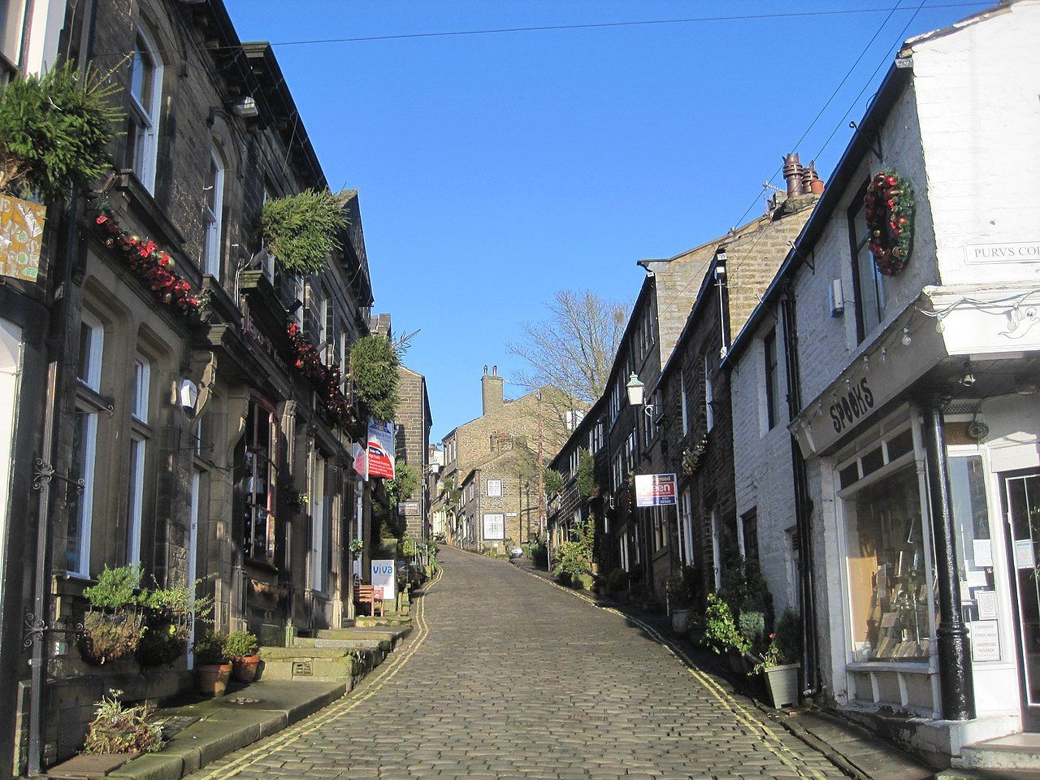

ianpudsey

File:Haworth Main Street - panoramio.jpg

CC BY 3.0

Source:

Haworth is a charming village located in West Yorkshire, England. It has a population of about 6,733 people as recorded in the 2021 census. The village is known for its historical significance and picturesque setting in the Pennines, a range of hills and mountains.

The origin of Haworth dates back to 1209. The name likely refers to a "hedged enclosure" or "hawthorn enclosure." Over the years, it has transformed into a popular tourist destination, largely due to its connection with the Brontë sisters, famous authors of classic English literature.

Haworth is surrounded by beautiful nature and offers various outdoor activities. Visitors can explore the Brontë Parsonage Museum, take a ride on the heritage Keighley and Worth Valley Railway, or hike along the scenic Brontë Way. The village is also known for its vibrant cultural scene, including events like the annual 1940s weekend and the Haworth Arts Festival.

The village is small in size but offers a rich cultural life. It is close to bigger cities like Bradford and Leeds, making it easily accessible for day trips. For transport, Haworth is well connected by bus services to nearby towns such as Keighley and Hebden Bridge.

One of the unique features of Haworth is its steep, cobbled Main Street lined with tea rooms, antique shops, and historic pubs. The Black Bull pub is particularly famous as it was frequented by Branwell Brontë. The village is also a Fairtrade Village, promoting fair trade practices.

Haworth offers a delightful blend of history, culture, and natural beauty, making it a must-visit destination for anyone interested in England's rich literary heritage and scenic landscapes.

Read the text and write down three aspects you think are especially interesting about Haworth.

___________________________________________________________________

___________________________________________________________________

___________________________________________________________________

What do you think is better about Haworth, and what is worse compared to your hometown?

___________________________________________________________________

___________________________________________________________________

___________________________________________________________________

## Word search puzzle

Find the 8 words that are hidden in the puzzle.

|  |  |  |  |  |  |  |  |  |  |  |  |  |  |  |  |  |  |  |
| --- | --- | --- | --- | --- | --- | --- | --- | --- | --- | --- | --- | --- | --- | --- | --- | --- | --- | --- |
| H | V | E | J | C | O | H | G | G | H | N | K | L | H | D | B | M | A | E |
| D | J | U | A | J | X | E | L | Y | O | U | C | X | A | O | R | J | T | M |
| K | K | I | S | M | B | R | E | Q | L | L | U | E | W | N | O | K | O | B |
| U | E | A | U | M | Q | I | C | O | L | T | L | C | O | J | N | R | U | B |
| M | V | H | P | B | T | T | K | I | L | I | T | E | R | A | T | U | R | E |
| P | A | R | S | O | N | A | G | E | L | R | U | C | T | D | Ë | E | I | N |
| N | U | H | K | K | C | G | G | U | G | O | R | R | H | C | L | K | S | R |
| L | J | M | I | D | P | E | N | N | I | N | E | S | A | W | J | O | M | F |

HAWORTH

BRONTË

PARSONAGE

LITERATURE

HERITAGE

TOURISM

PENNINES

CULTURE