## Trump 2024: A Journey of Controversy and Conviction

Donald Trump's 2024 presidential campaign, launched on November 15, 2022, has been a whirlwind of promises, controversies, and resilient slogans. From "Save America" to "Make America Great Again," Trump has been relentless in his pursuit to win back the White House. The campaign, marked by intense rallies and fiery speeches, addressed several crises that resonated with his base, including immigration, economic instability, and crime.

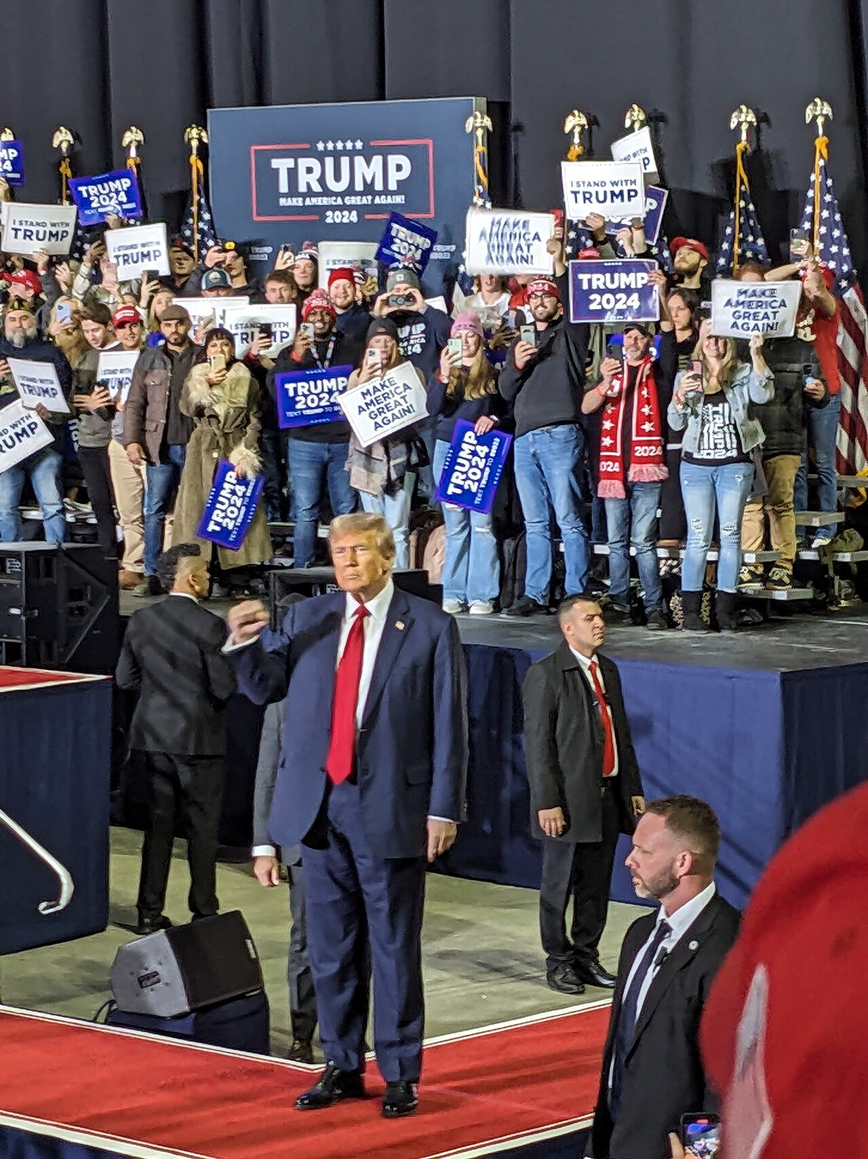

Donald Trump at a rally in Manchester, New Hampshire. Photo by Artaxerxes [CC BY-SA 4.0]

Trump's rhetoric against opposing candidates like Joe Biden and Kamala Harris was harsh, often labeling them as threats to American democracy. His speeches frequently highlighted his expertise in foreign policy and economic negotiations, promising to end the Russo-Ukrainian War within 24 hours and to implement a 'universal baseline tariff' on imports to boost the American economy.

Throughout the campaign, Trump has vowed to expand executive power, enforce strict immigration policies, and dismantle the Affordable Care Act. Despite facing four criminal indictments, Trump has used these challenges to fortify his narrative of political persecution, vowing to seek retribution for his supporters. He promises to pardon those involved in the January 6 Capitol attack if elected.

While the campaign has been marred by allegations of past mistakes and controversies, including the Stormy Daniels scandal and the January 6 attack, Trump has remained steadfast, dismissing these issues as politically motivated attacks. His 2024 bid reflects a blend of defiance and determination, with a promise to restore what he calls "true American values."

|  |
| --- |
| Analyzing Election Campaign Narratives Election Campaign Narratives  why  vote for them  who  why  the best choice  five  often used narrative types  are stories that politicians use to explain people should . These stories help voters understand they are and they are . Here is a list of very important and :     1.   "hero" who will save the day  A hero story is when a politician presents themselves as the . They tell stories about the good things they've done or how they will help solve a big problem, like improving schools or making neighborhoods safer.     2. problem  needs to be solved right away  A crisis narrative is used when the candidate talks about a big , or crisis, that . They explain how the crisis is affecting people and how they are the best person to fix it. It could be about a serious issue like bad roads or unsafe communities. 3. problem  they are really good at solving  "own"  issue  best at handling it  In an issue ownership narrative, the candidate focuses on a specific or issue . For example, one candidate might focus on improving education, while another might be known for protecting the environment. They thatbecause they are seen as the . 4. candidate talks about  opponent in a bad way  Negative campaigning is when a their . They might say their opponent did something wrong or isn't fit for the job. 5. made a mistake  explain what happened  ry to fix their image  Image restoration strategies are used when a candidate has or done something people didn’t like. The candidate tells a story to and how they’ve learned from their mistakes. They tso people will trust them again. |

### 📋 Task 1: Find out about the objectives that the five types of campaign narratives typically pursue by matching the five types to their objective description.

|  |  |  |
| --- | --- | --- |
| Hero Stories |  | Voters see the candidate as someone who understands the problem and has the solutions to get things back to normal. They feel the candidate is the right person for the job in a tough situation. |
| Crisis Narratives |  | Voters might forgive the candidate and believe that they have changed or learned from their errors, giving them a second chance to lead. |
| Issue Ownership |  | Voters may start to see the opponent in a negative light and believe the candidate speaking negatively is the better choice because they pointed out problems with the other person. |
| Negative Campaigning |  | Voters see the candidate as brave, strong, and capable of making their lives better—like a hero in a movie. |
| Image Restoration Strategies |  | Voters associate the candidate with solving that specific problem and trust them to be the expert. For example, if you care about education, you’ll think of the candidate who 'owns' that issue as the best choice. |

### 📋 Task 2: Match the statements extracted from the newspaper article to the five types of election campaign narratives.

|  |  |  |
| --- | --- | --- |
| Trump promised to end the war in Ukraine within 24 hours. |  | Crisis Narratives |
| Trump addressed concerns about immigration, economic instability, and crime. |  | Image Restoration Strategies |
| Trump pledged to dismantle the Affordable Care Act. |  | Negative Campaigning |
| Trump labeled Joe Biden and Kamala Harris as threats to democracy. |  | Hero Stories |
| Trump framed his legal challenges as political persecution. |  | Issue Ownership |

### 📋 Task 3:

Search the newspaper article for another campaign narrative. Assign it to one of the five narrative types and make a hypothesis about the goal the narrative is pursuing.

___________________________________________________________________

___________________________________________________________________

___________________________________________________________________

___________________________________________________________________