## Arctic Sea Ice Decline: A Decade of Consequences

In the early 21st century, the Arctic witnessed a dramatic decline in sea ice, a clear consequence of climate change. In September 2020, Arctic sea ice reached its second-lowest extent on record, covering only 3.74 million square kilometers. This decline, driven by rising global temperatures, has profound implications for the region and the world.

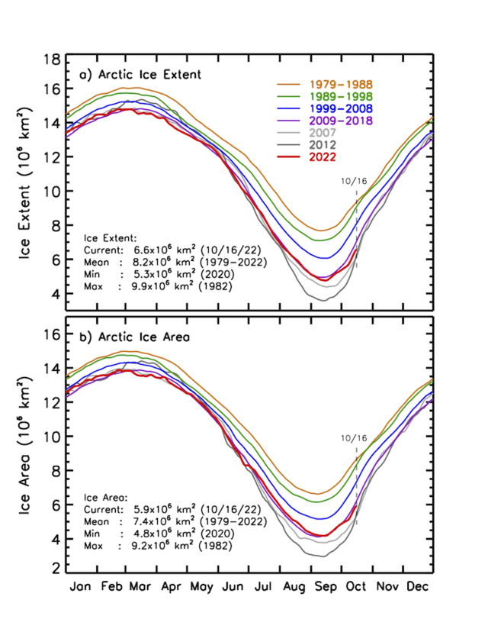

Source: NASA, Public domain

The natural environment has been significantly impacted. The loss of sea ice disrupts habitats for polar bears and seals, leading to declines in their populations. The melting ice also contributes to rising sea levels, threatening coastal communities worldwide. Economically, new shipping routes have opened, shortening travel times between continents. However, this also increases the risk of pollution and accidents in these fragile ecosystems.

Politically, the decline in Arctic ice has led to increased territorial claims and competition for resources among Arctic nations, including Russia, Canada, and the United States. The Arctic Council and other international bodies face challenges in managing these disputes and ensuring environmental protection. Socially, the indigenous peoples of the Arctic, who have lived in harmony with the ice for millennia, face unprecedented changes to their way of life.

Looking ahead, the future of the Arctic remains uncertain. Continued ice loss could lead to more extreme weather patterns globally, as the jet stream is disrupted. Nations must work together to mitigate climate change and protect this critical region. The Arctic's transformation is a stark reminder of the urgent need for climate action.

Read the above newspaper article and take notes: Do such reports worry you? Why (or why not)? Then discuss in class.

___________________________________________________________________

___________________________________________________________________

___________________________________________________________________

|  |  |  |
| --- | --- | --- |
| Arctic 1800    In 1800, the Arctic region, encompassing parts of Northern Canada, Greenland, Russia, and the Arctic Ocean, was a pristine, largely unexplored wilderness. The climate was characterized by extremely cold winters with average temperatures plunging to -40°C, and cool summers with temperatures barely rising above freezing. Precipitation was predominantly in the form of snow, with annual amounts less than 50 cm. The ice mass was immense, with glaciers and sea ice covering vast areas. Periods of drought were rare, and the environment was marked by a stable, frigid climate with minimal human impact.  An untouched Arctic landscape in 1800 with vast ice sheets, towering glaciers, and minimal human presence. | Arctic 1950    By 1950, the Arctic, including areas like Northern Canada, Greenland, and Russia, had begun to witness increased human activity, particularly with the establishment of research stations. The climate remained cold, with winter temperatures around -35°C and summer temperatures occasionally reaching just above freezing. Average annual precipitation was still around 50 cm, mainly as snow. The ice mass, though slightly reduced, continued to dominate the landscape, with glaciers and sea ice still prevalent. Coastal areas experienced slightly warmer temperatures due to oceanic influences. Periods of drought were still uncommon, but the early signs of climate change were becoming noticeable.  An Arctic landscape in 1950 with research stations, reduced ice cover, and signs of early environmental changes. | Arctic Today    Today, the Arctic region is experiencing profound environmental changes due to climate change. Winter temperatures now average around -30°C, while summer temperatures frequently exceed 0°C. Precipitation patterns have shifted, with more rainfall during the warmer months and annual precipitation increasing slightly. The ice mass has significantly diminished, with substantial ice melt and reduced glacier size. The Arctic sea ice extent has shrunk drastically, leading to more open water. Coastal areas are warmer, and periods of drought have become more common. Human activity has intensified, with increased shipping routes and modern research facilities altering the once-pristine landscape.  A contemporary Arctic landscape with significant ice melt, modern infrastructure, and visible impacts of climate change. |

# Changed Climate: A Region in Transition

Read through the reports above regarding the situation in the years 1800, 1950, and today. Then complete the tasks listed below.

Name the key environmental changes observed in the Arctic region from 1800 to today.

___________________________________________________________________

___________________________________________________________________

___________________________________________________________________

Describe how human activity has evolved in the Arctic region from 1800 to the present day.

___________________________________________________________________

___________________________________________________________________

___________________________________________________________________

Explain the impact of rising temperatures on the Arctic ice mass over the years.

___________________________________________________________________

___________________________________________________________________

___________________________________________________________________

# The future

Make predictions in class about how further developments might look. Will the effects of climate change continue to intensify? What could be done to counteract this?

