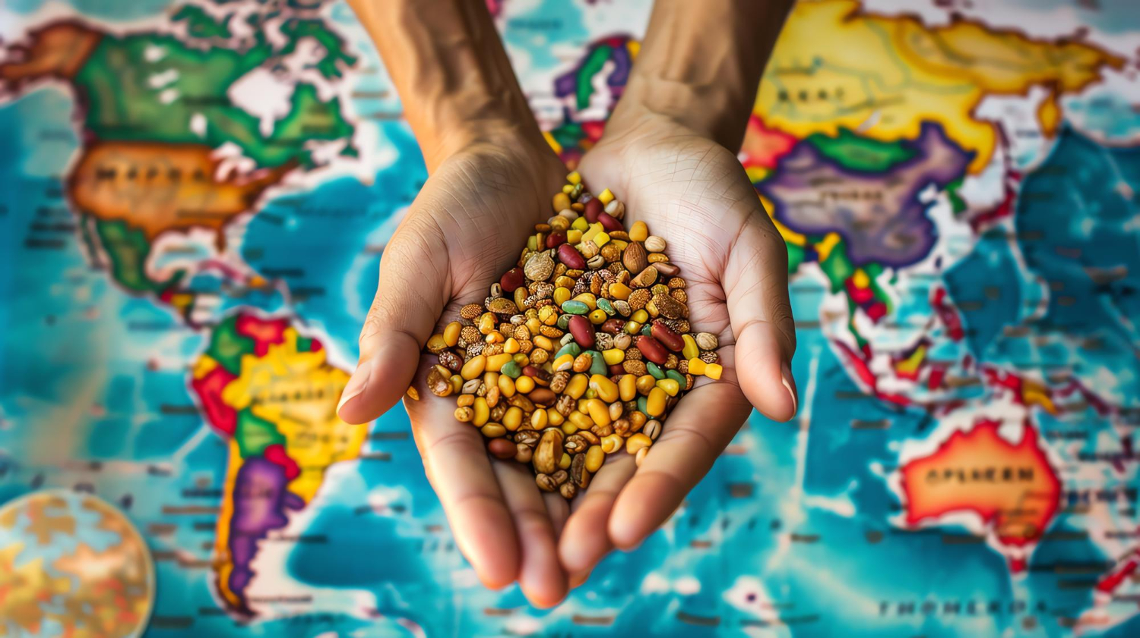

What do you already know about Fairtrade and Fairtrade products? Take notes. Then collect all the information together with your classmates in a mindmap.

___________________________________________________________________

___________________________________________________________________

___________________________________________________________________

## Additional information for teachers

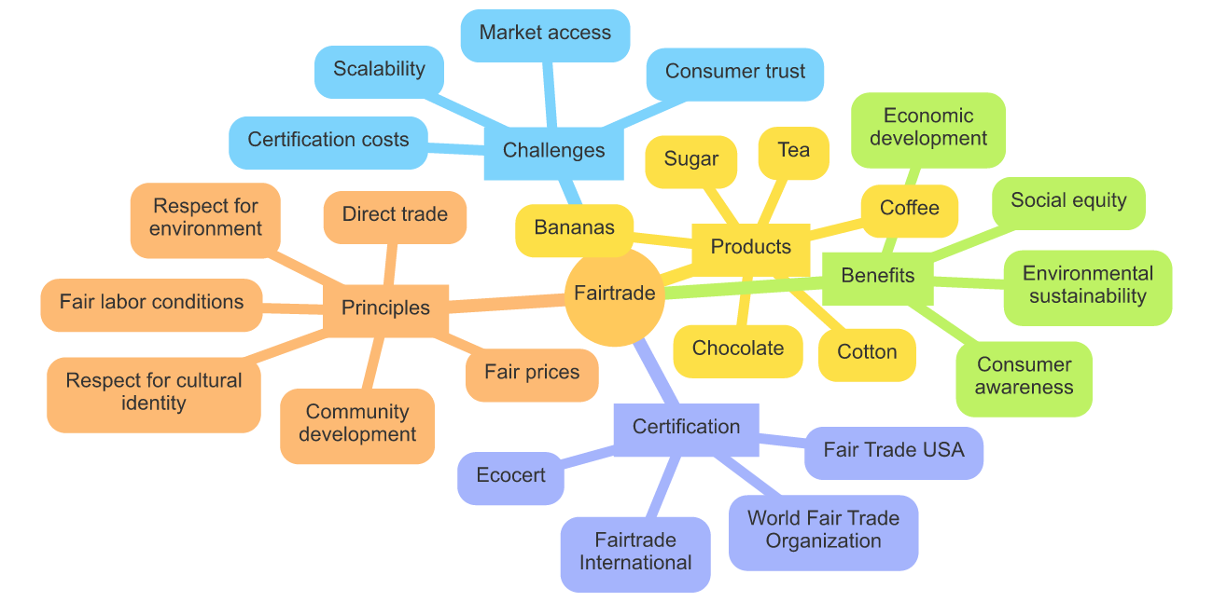

# What is Fairtrade?

Watch the video, then answer the questions below it.

|  |  |
| --- | --- |
|  | Youtube: What is Fairtrade?  To watch the youtube video just scan the QR code. |

Name three benefits that Fairtrade provides to coffee farmers.

___________________________________________________________________

___________________________________________________________________

___________________________________________________________________

Describe how the Fairtrade premium is used by producer organizations.

___________________________________________________________________

___________________________________________________________________

___________________________________________________________________

Explain how Fairtrade standards are developed and monitored.

___________________________________________________________________

___________________________________________________________________

___________________________________________________________________

# Fairtrade products in detail

Now learn more about a Fairtrade product and answer questions about it.

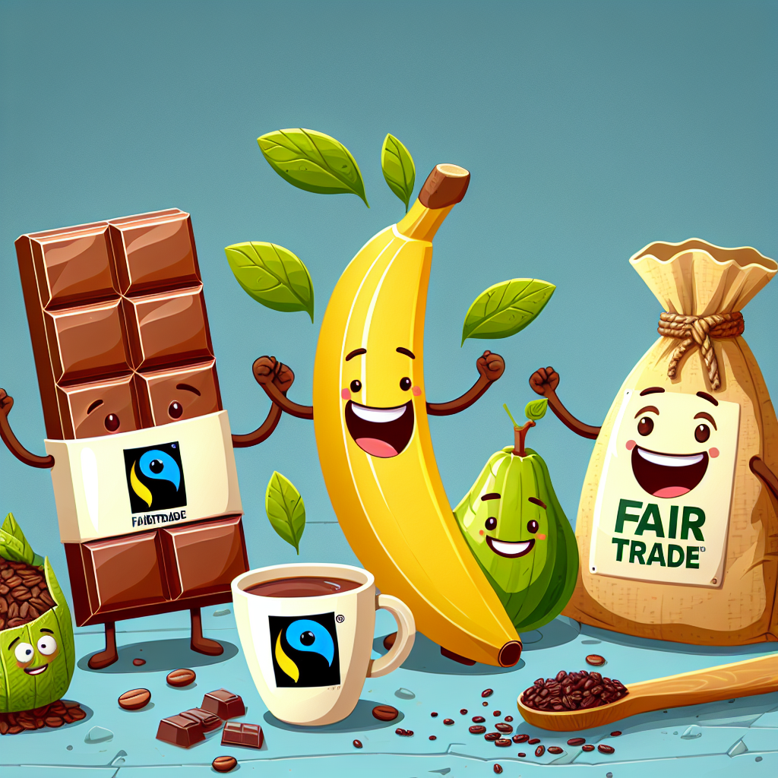

Fairtrade Chocolate

Hello there! I'm a piece of Fairtrade chocolate, and I'm so excited to share my journey with you. It all began in the beautiful country of Ghana, where cocoa farmers work hard to grow the beans that make me.

In Ghana, the farmers who grow my cocoa beans are part of a Fairtrade cooperative. This means they receive fair prices for their cocoa, which helps them support their families and improve their communities. These farmers use eco-friendly methods to take care of the cocoa trees and the environment. They avoid harmful chemicals and use natural ways to keep the plants healthy.

First, I started as a tiny cocoa bean inside a pod that grew on a cocoa tree. The farmers watched over me carefully, making sure I had enough sunlight and water. When I was ready, they harvested the cocoa pods by hand, treating each pod with care.

After harvesting, the farmers split open the pods and took out the cocoa beans. These beans were then fermented and dried under the warm sun. Fermentation is a special process that helps develop my rich chocolate flavor. The farmers turned the beans regularly to make sure they dried evenly.

Once the beans were dry, they were packed and sent to a Fairtrade-certified factory. Here, workers who are paid fairly and work in safe conditions roasted the beans to bring out their chocolatey goodness. The roasted beans were then ground into a smooth cocoa paste.

Next, I was mixed with other natural ingredients like sugar and milk to make me delicious and creamy. The mixture was carefully stirred and cooled until I became the chocolate bar you see now.

By choosing Fairtrade chocolate like me, you help support farmers and workers in Ghana. You also help protect the environment because Fairtrade standards ensure that farming practices are eco-friendly.

Isn't it amazing how your choice can make such a big difference? Enjoy your yummy and ethically made Fairtrade chocolate!

### Choose the correct answer for each question.

###### **What is one benefit for farmers in Ghana being part of a Fairtrade cooperative?**

They are exempt from paying taxes. They receive higher prices for their cocoa. They work fewer hours than non-Fairtrade farmers. They get free seeds and fertilizers.

###### **How do Fairtrade cocoa farmers in Ghana take care of the cocoa trees?**

By using eco-friendly methods and natural ways to keep the plants healthy. By harvesting them only during the rainy season. By planting them in artificial greenhouses. By using the latest chemical fertilizers and pesticides.

###### **What is the purpose of fermenting the cocoa beans after harvesting?**

To develop the rich chocolate flavor. To make the beans easier to grind. To remove the outer shell. To increase the size of the beans.

###### **What happens to the cocoa beans at the Fairtrade-certified factory?**

They are coated with sugar and milk. They are immediately packaged and shipped. They are soaked in water to remove impurities. They are roasted to bring out their chocolatey goodness.

###### **How does choosing Fairtrade chocolate help the environment?**

Fairtrade chocolate is made using solar energy only. Fairtrade chocolate uses no packaging materials. Fairtrade standards ensure that farming practices are eco-friendly. Fairtrade chocolate does not require any transportation.

Have another look at everything you have learned about Fairtrade and write down: What can you do to support Fairtrade?

___________________________________________________________________

___________________________________________________________________

___________________________________________________________________

# Bonus: Fairtrade recipe

Here is a recipe for you that you can easily bake/cook at home with your Fairtrade ingredient. Have fun!

Fairtrade Chocolate Brownies

Ingredients:

1/2 cup Fairtrade cocoa powder

1 cup Fairtrade sugar

1/2 cup butter, melted

2 large eggs

1 teaspoon vanilla extract

1/2 cup all-purpose flour

1/4 teaspoon baking powder

1/4 teaspoon salt

1/2 cup Fairtrade chocolate chips

Directions:

Preheat your oven to 350°F (175°C). Grease an 8x8-inch baking pan or line it with parchment paper.

In a large bowl, mix the melted butter and Fairtrade sugar until well combined.

Add the eggs and vanilla extract to the bowl. Beat the mixture until smooth and creamy.

In another bowl, whisk together the Fairtrade cocoa powder, all-purpose flour, baking powder, and salt.

Gradually add the dry mixture to the wet mixture, stirring until just combined.

Fold in the Fairtrade chocolate chips until they are evenly distributed in the batter.

Pour the batter into the prepared baking pan and spread it evenly.

Bake in the preheated oven for 20-25 minutes, or until a toothpick inserted into the center comes out clean.

Let the brownies cool in the pan before cutting them into squares.

Enjoy your delicious Fairtrade chocolate brownies!