Mia  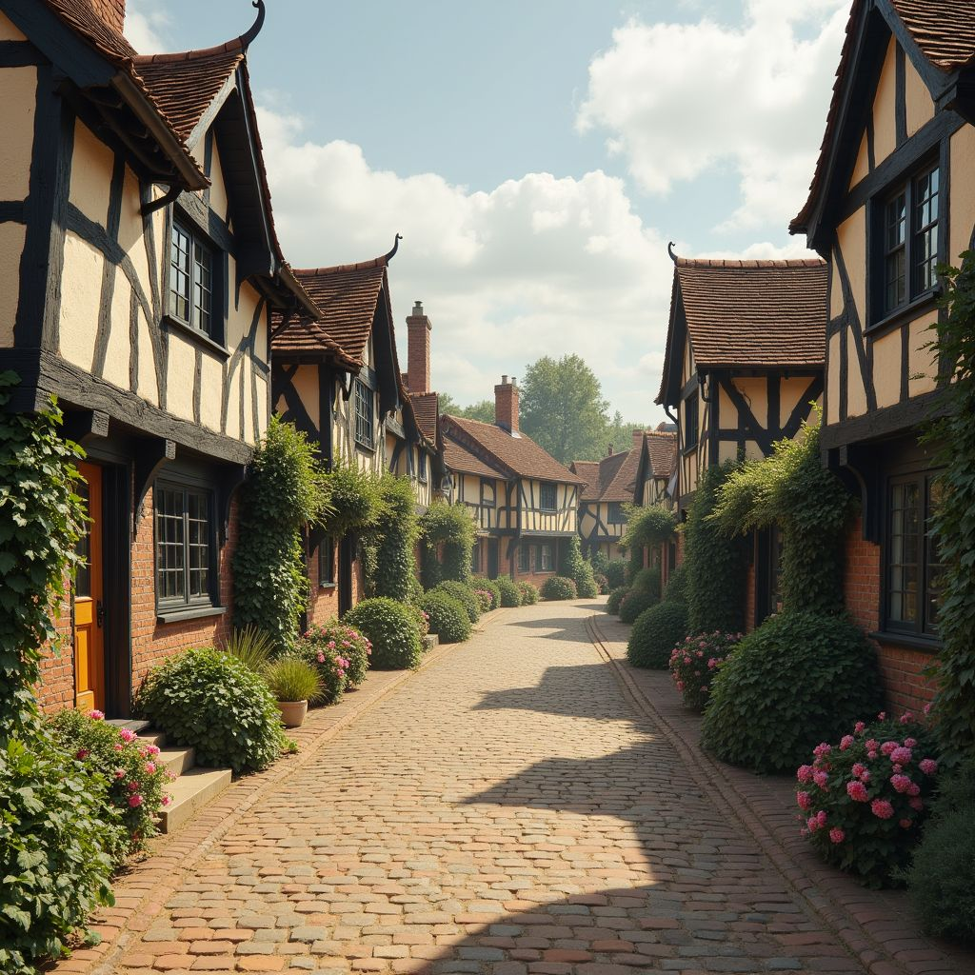  Mia lives in a small town called Stratford-upon-Avon. She is 13 years old and lives with her parents and younger sister. The way to school takes about 15 minutes by bike. Her hobbies include acting in the local theatre and painting. Mia likes the rich history and the picturesque scenery of her hometown. What she doesn't like is that it can get quite crowded with tourists, especially during the summer. | Harry  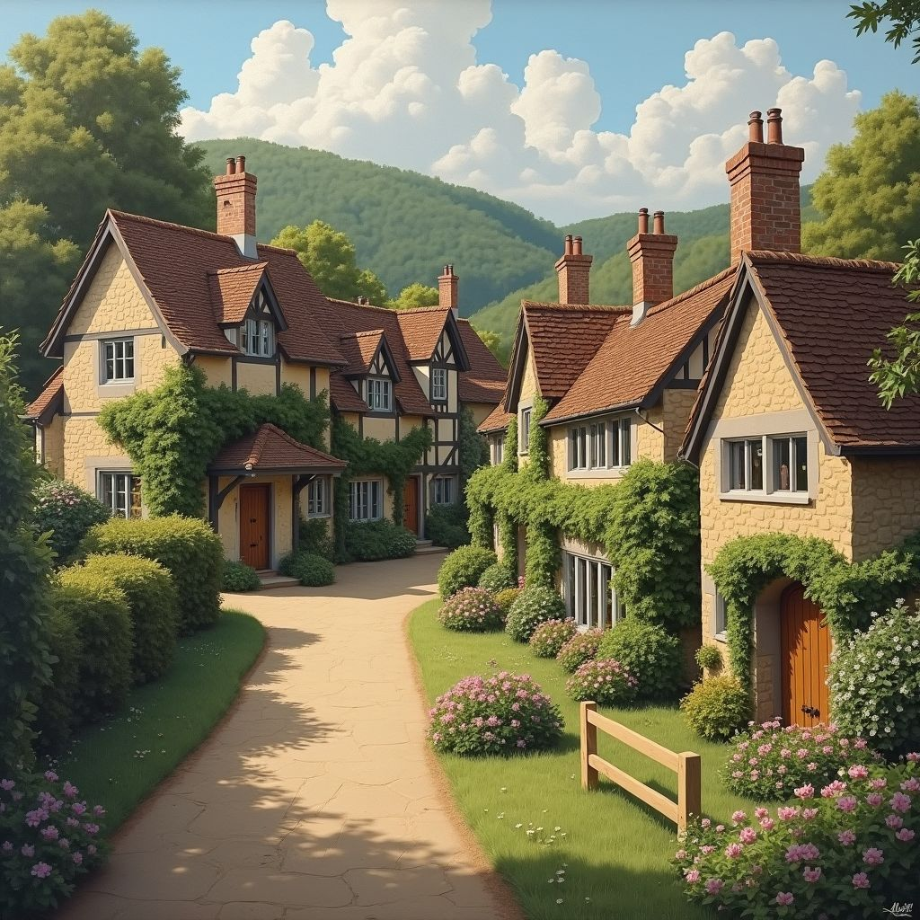  Harry lives in a village called Bibury. He is 11 years old and lives with his parents and a cat. The way to school takes about 20 minutes by bus. His hobbies include fishing in the river and helping out with the family garden. Harry likes the beautiful countryside and the quiet, friendly atmosphere of his village. What he doesn't like is that there are very few kids his age and not many places to hang out. | Sophia    Sophia lives in a big city called London. She is 15 years old and lives with her mother and two younger brothers. The way to school takes about 10 minutes by tube. Her hobbies include visiting museums and playing tennis. Sophia likes the endless possibilities for entertainment and the cultural diversity of her city. What she doesn't like is the constant noise and the pollution.

Collect the similarities and differences between the lifes of the three teenagers.
Similarities | Differences

Additional information for teachers

Collect the similarities and differences between the lifes of the three teenagers.
Similarities | Differences
All characters are school-aged children. | Mia lives in a small town, Harry in a village, and Sophia in a big city.
They all live with their families. | Mia and Harry live with their parents, but Sophia lives with her mother and two brothers.
Each has a unique set of hobbies. | Mia enjoys acting and painting, Harry likes fishing and gardening, and Sophia visits museums and plays tennis.
They all have aspects of their hometowns they like and dislike. | Their dislikes vary: Mia dislikes tourists, Harry dislikes the lack of kids his age, and Sophia dislikes noise and pollution.
Each has a different mode of transportation to school. | Mia bikes, Harry takes the bus, and Sophia takes the tube.

Stratford-upon-Avon

Stratford-upon-Avon is a small town in Warwickshire, England, known for its rich history and beautiful scenery. With a population of about 30,495 people, it feels like a cozy place. The town is famous as the birthplace of William Shakespeare. Stratford was first developed into a town in 1196 when it got a charter to hold a weekly market. The town is divided into different parts, like Old Town and Bridge Town, each with its own charm. There are many old buildings to see, like Shakespeare's Birthplace and the Royal Shakespeare Theatre. Traffic is usually light, and many people walk or bike. Mia takes about 15 minutes to bike to school. For fun, you can visit parks, go to the theater, or paint by the river. Nature is everywhere, making it a lovely place to live.

Bibury

Bibury is a small village in Gloucestershire, England, with a population of about 627 people. It's famous for its beautiful old cottages and peaceful countryside. The village dates back to the Saxon period and was even mentioned in the Domesday Book of 1086. Bibury doesn’t have distinct parts like a big city, but every corner feels special. Most people walk or bike around because it's so small. Harry takes about 20 minutes by bus to get to school. For fun, you can go fishing, help in the garden, or explore the lovely nature around you. There are not many kids around, but the quiet and friendly atmosphere makes Bibury a wonderful place to grow up.

London

London is the capital city of England and the United Kingdom, with a population of about 8.9 million people. It's a huge, bustling city with an endless array of things to do. London was founded by the Romans and has a history that goes back nearly 2,000 years. The city is divided into many different parts, like Westminster, Camden, and Southwark, each with its own vibe. Traffic can be heavy, but the Tube (subway) makes it easy to get around. Sophia takes about 10 minutes by Tube to get to school. For fun, you can visit museums, play tennis, or see a play in the West End. The city is full of parks like Hyde Park and Regent's Park, offering a bit of nature in the middle of the urban hustle. Despite the noise and pollution, London’s cultural diversity and endless activities make it a thrilling place to live.

For each question, choose the correct answer.

What significant historical event is associated with Bibury?
It was mentioned in the Domesday Book of 1086. It was the birthplace of William Shakespeare. It was developed into a town in 1196. It was founded by the Romans.

Why might someone prefer walking or biking in Stratford-upon-Avon?
The Tube makes it easy to get around. There are not many kids around. Traffic is usually light. It is a huge, bustling city.

What is a common activity for children in Bibury?
Exploring the lovely nature. Going to the theater. Visiting museums. Playing tennis in the parks.

How does the population size of Stratford-upon-Avon compare to London?
Stratford-upon-Avon is slightly smaller than London. Stratford-upon-Avon is slightly larger than London. Stratford-upon-Avon is much smaller than London. Both have similar population sizes.

Which town or city has a history that dates back nearly 2,000 years?
Stratford-upon-Avon None of the above Bibury London

Considering the historical relevance, which town or city is associated with William Shakespeare?
London Bibury Stratford-upon-Avon Westminster

Why might someone living in London choose to use the Tube?
Traffic can be heavy. It is a peaceful countryside. There are not many kids around. The town has many old buildings.

What mode of transportation does Mia use to get to school in Stratford-upon-Avon?
Bike Bus Car Tube

Why might someone choose to visit parks or paint by the river in Stratford-upon-Avon?
The city is full of cultural diversity and endless activities. It's a huge, bustling city. The town has a quiet and friendly atmosphere. Nature is everywhere, making it a lovely place to live.

What might make Bibury a wonderful place to grow up, despite having not many kids around?
The bustling city life. The presence of the Royal Shakespeare Theatre. The quiet and friendly atmosphere. The availability of the Tube.

Think about your hometown and compare it with the places where the three teenagers live. Which advantages and disadvantages can you find? Would you like to switch places with one of the teenagers?
___________________________________________________________________
___________________________________________________________________
___________________________________________________________________

