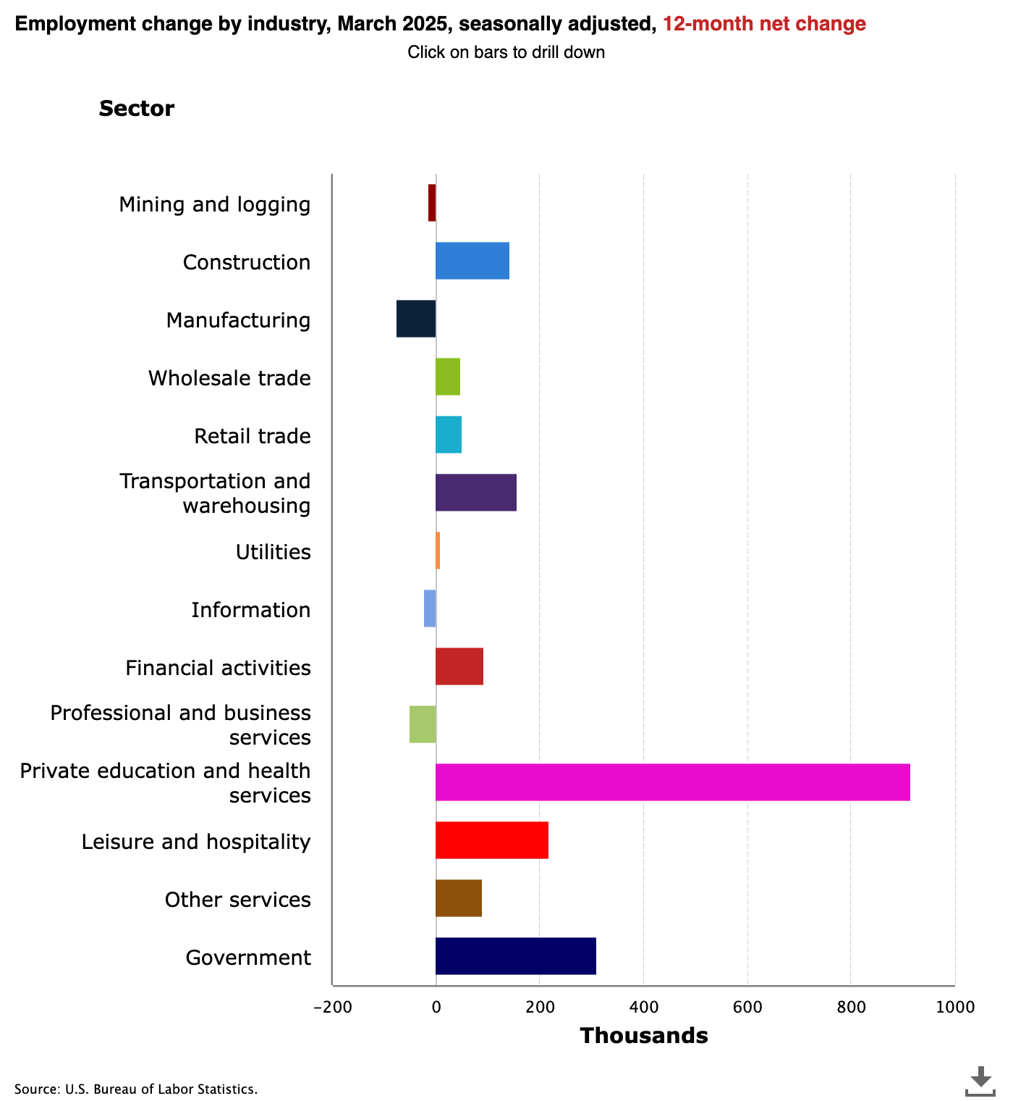

Employment change by industry, March 2025, seasonally adjusted, 12-month net change (source: https://www.bls.gov/charts/employment-situation/employment-by-industry-monthly-changes.htm)

### Determine whether the given statements are true or false.

###### **The diagram shows employment changes in the USA from March 2024 to March 2025.**

True False

###### **The sector with the largest decline in employment is 'Private education and health services'.**

True False

###### **Mining and logging experienced a decrease in employment numbers.**

True False

###### **The vertical axis of the diagram represents the number of employees in thousands.**

True False

###### **There is a significant employment growth in the sector 'Private education and health services'.**

True False

###### **The diagram provides a detailed timeline of employment changes throughout the year.**

True False

|  |
| --- |
| Method: Analyze diagrams & statistics subject being represented:  central theme  time period  event  development  For a detailed description of the diagram, it is important to first identify the What is the ? What is covered? Is it about a specific or a ?  source  Where  from  Who  for whom  used data  Next, it concerns the of the diagram and the data it is based on: does it originate ? created it ? Where do the come from?  individual elements  After that, it's about describing the of the diagram: chosen diagram type/format, axis, column, or row labels, chosen spacings, chosen subdivisions, years, assignments, the legend.  statement being made:  comparison  development  distribution  Finally, it involves describing the Is a being sought? Is a being shown? Is a being depicted? |

Describe the trends in employment changes across sectors as depicted in the horizontal stacked bar chart. Focus on the sectors that experienced the most significant growth and decline.

___________________________________________________________________

___________________________________________________________________

___________________________________________________________________

Explain the potential factors that could have influenced the employment changes in the 'Private education and health services' sector and the 'Mining and logging' sector.

___________________________________________________________________

___________________________________________________________________

___________________________________________________________________