|  |
| --- |
| Background information Use the following text as background information on the topic of your picture description. Carefully read the text and mark or write down any relevant information. |

# Martin Luther King

## Introduction

Martin Luther King Jr. was born on January 15, 1929, in Atlanta, Georgia. He was a Baptist minister and a civil rights activist. He is famous for his role in the American civil rights movement in the 1950s and 1960s. King fought for racial equality and justice using nonviolent protest.

## Early Years

Martin Luther King Jr. grew up in a middle-class family. His father and grandfather were Baptist preachers. His parents were well-educated, and his father was the pastor of the Ebenezer Baptist Church in Atlanta. King had a happy childhood, but he also experienced racism. When he was six, a white friend told him they could not play together anymore because they were going to segregated schools.

King was a bright student and started college at Morehouse College when he was just 15 years old. During a summer in Connecticut, he saw how black and white people lived peacefully together. This experience made him hate racial segregation even more.

## Education and Early Career

King decided to become a minister like his father. He studied at Crozer Theological Seminary in Pennsylvania. He learned about nonviolence from Mohandas Gandhi, an Indian leader who fought for independence without violence. King then went to Boston University and earned a doctorate in theology.

## Civil Rights Movement

In 1954, King became the pastor of a church in Montgomery, Alabama. In 1955, he led the Montgomery Bus Boycott. This protest started after Rosa Parks refused to give up her bus seat to a white person. The boycott lasted for over a year and ended when the Supreme Court ruled that bus segregation was illegal.

King founded the Southern Christian Leadership Conference (SCLC) in 1957. The SCLC promoted nonviolent protests to fight for civil rights. King organized many peaceful marches and protests. He believed in nonviolence and love for everyone.

## Famous Speeches and Achievements

One of King's most famous speeches is the "I Have a Dream" speech. He gave this speech during the March on Washington in 1963. In this speech, King talked about his dream of a world where people are not judged by their skin color but by their character.

King's work led to important changes in American laws. The Civil Rights Act of 1964 and the Voting Rights Act of 1965 were passed to end racial discrimination and protect voting rights for African Americans.

In 1964, King won the Nobel Peace Prize for his nonviolent fight for civil rights. He was the youngest person to receive the prize at that time.

## Later Years and Legacy

King continued to fight for civil rights until his death. He worked on the Poor People's Campaign to help poor people of all races. On April 4, 1968, King was assassinated in Memphis, Tennessee. His death was a great loss, but his work and ideas continue to inspire people around the world.

King's legacy is honored every year on Martin Luther King Jr. Day, a national holiday in the United States. His life and work remind us of the importance of fighting for equality and justice for everyone.

|  |
| --- |
| Guide to describing a picture Carefully read the following guide to describing a picture step-by-step. |

Guide to Describing a Picture in English Class

Introduction:

When describing a picture, include visible details and your background knowledge to show understanding of cultural, historical, and contextual elements.

Step-by-Step Guide:

1. Initial Observation:

General Overview:

Describe the setting, main subjects, and overall impression.

Example:

"The picture shows a busy city street during the day with many people walking and a few cars on the road."

2. Detailed Description:

Specific Elements:

Describe main parts in more detail, including people, objects, and actions.

Example:

"In the foreground, there is a woman pushing a stroller. To the left, a group of teenagers is gathered around a street performer who is playing the guitar."

3. Contextual and Background Knowledge:

Historical/Cultural Context:

Relate the picture to relevant historical or cultural knowledge.

Example:

"This scene could be set in a Western city, possibly during the early 21st century, given the modern clothing and vehicles."

4. Interpretation:

Analyze:

Interpret what is happening and its significance, using your background knowledge.

Example:

"The people seem to be in a hurry, which might indicate it is a weekday morning."

5. Personal Reaction and Reflection:

Express Views:

Share your reaction and thoughts about the picture.

Example:

"This picture reminds me of my visit to Berlin, where the streets were always bustling with activity."

6. Connecting to Broader Themes:

Relate to Issues:

Connect the picture to larger themes like social dynamics or environmental concerns.

Example:

"The image raises questions about urbanization and its impact on the environment."

Practice and Preparation:

Practice Descriptions:

Regularly practice describing different pictures.

Expand Knowledge:

Learn about cultural, historical, and social contexts of English-speaking countries.

Seek Feedback:

Share descriptions with teachers or peers for feedback.

Key Points to Remember:

Start with a general overview.

Provide detailed descriptions of specific elements.

Incorporate historical and cultural context.

Offer interpretations based on your background knowledge.

Share your personal reactions and reflections.

Connect the picture to broader themes and issues.

Good luck with your studies and exams!

|  |
| --- |
| Grammar present progressive  Remember that picture descriptions are done in . However, change the tense accordingly for talking about background information on the picture. |

|  |
| --- |
| Vocabulary Use the following list of vocabulary as a help for your picture description. |

### Vocabulary list for picture descriptions

above - über

below - unter

next to - neben

in front of - vor

behind - hinter

on the left - links

on the right - rechts

in the middle - in der Mitte

at the top - oben

at the bottom - unten

near - in der Nähe von

far - weit

between - zwischen

corner - Ecke

center - Zentrum

background - Hintergrund

foreground - Vordergrund

to the left of - links von

to the right of - rechts von

inside - drinnen

outside - draußen

around - um … herum

close to - nah an

|  |
| --- |
| Picture Now look at the following image in detail and take notes. You should write down anything that you notice about what's shown in the picture and what kind of background information will be important for your description. |

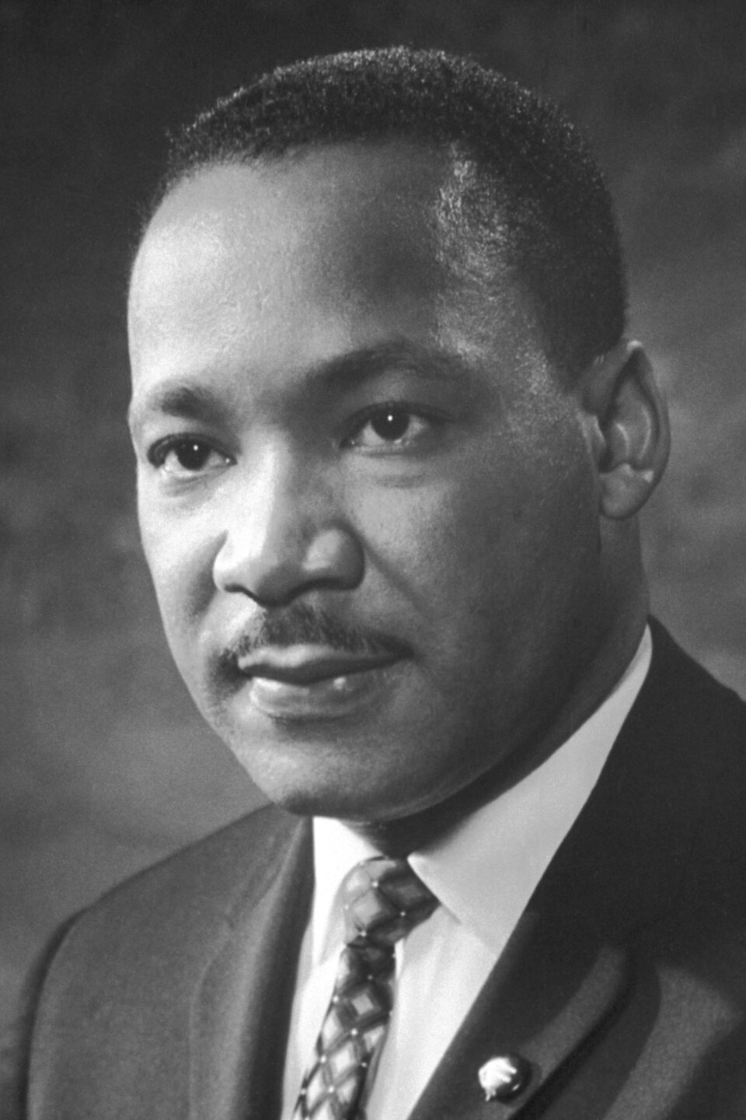

### Notes

Use this space to take notes.

___________________________________________________________________

___________________________________________________________________

___________________________________________________________________

___________________________________________________________________

|  |
| --- |
| Practising the picture description Use your notes as well as the vocabulary introduced at the beginning of the worksheet and start practising your picture description. Try talking for about 3-4 minutes.    Once you're quite confident with your talk, present your picture description to your partner. They will fill out the feedback sheet below and give you feedback on what you did well and what you can still improve upon. |

|  |  |  |
| --- | --- | --- |
| Aspect | Yes/No | Ideas for Improvement |
| Introduction |  |  |
| Detailed picture description  Present progressive  Vocabulary |  |  |
| Context  Detailed background information  Interpretation |  |  |
| Conclusion |  |  |