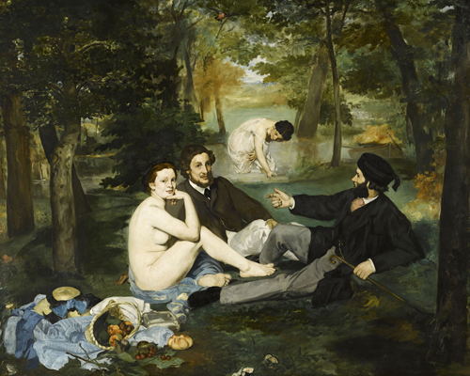

Edouard Manets- Frühstück im Grünen Quelle:https://de.wikipedia.org/wiki/Das_Fr%C3%BChst%C3%BCck_im_Gr%C3%BCnen_(Manet)#:~:text=Das%20Fr%C3%BChst%C3%BCck%20im%20Gr%C3%BCnen%20(franz%C3%B6sisch,Orsay%20in%20Paris%20zu%20besichtigen.

### 📝 Flash thoughts: Capture everything that strikes you about the picture within one minute.

___________________________________________________________________

___________________________________________________________________

___________________________________________________________________

___________________________________________________________________

### 📝 Fill in the table with the correct details of the painting. If necessary, do some research online.

|  |  |  |  |  |
| --- | --- | --- | --- | --- |
| Title of Painting | Artist Name | Year of Creation | Dimensions and Technique | Location |
|  |  |  |  |  |

📝 Describe the painting.

___________________________________________________________________

___________________________________________________________________

___________________________________________________________________

|  |
| --- |
| Memory box: formal image analysis 1. Composition and image structure  🎨    Arrangement of the image elements:  Symmetrical | Asymmetrical | Dynamic | Static    Eye tracking:  How is the viewer's gaze guided? (e.g. through lines, colors, light)    Division of space:  foreground | middle ground | background    Proportions &amp; Perspectives:    Central perspective | Bird's eye view | Frog's eye view | No spatial depth      2. Color and color effect  🌈    Color choice:  Colorful | Monochrome | Warm | Cold    Color contrasts:    Light-dark | Complementary contrasts | Quality and quantity contrasts    Color effect &amp; Symbolism:    Red: Passion, energy, danger    Blue: Calm, depth, cold    Yellow: Warmth, joy, warning    Green: Nature, harmony, poison    Black: Mourning, elegance, threat    White: Purity, innocence, emptiness      3. Light and shadow  💡    Light source(s):    Natural light (sun, moon)    Artificial light (candle, lamp)    Shadow representation:    Hard shadows: Clearly delineated    Soft shadows: Blurred    Plasticity &amp; three-dimensionality:  Created by light-dark contrasts      4. Perspective and spatial representation  🏞    Types of perspective:    Central perspective: Vanishing point in the center of the image    Bird's-eye view: View from above - figures appear smaller    Frog's-eye view: View from below - figures appear larger    Isometric: No vanishing points, parallel lines    Spatial representation through:    Size ratios: Foreground larger than background    Overlays: Objects partially obscure each other    Sharpness and blur: Spatial depth      5. Shape and lines  🔷    Shapes:    Geometric: circles, triangles, rectangles - order, stability    Organic: curved, irregular shapes - naturalness, dynamism    Lines:    Horizontal: calm, expanse (e.g. horizon)    Vertical: stability, strength    Diagonal: movement, dynamism    Curved: Liveliness, playfulness    Lines and effect:    Dominant or discreet    Movement and directing the eye      6. Structure and surface finish  🧩    Texture:  Smooth | Rough | Soft | Hard (e.g. for material illustrations)    Brushstroke:  Visible or invisible brushstrokes |

📝 Examine the composition of "Le Déjeuner sur l’herbe" by identifying and drawing the leading lines that guide the viewer's eye through the painting. Describe how these lines create interaction and focus within the scene.

___________________________________________________________________

___________________________________________________________________

___________________________________________________________________

📝 Analyze the significance of the nude woman gazing directly at the viewer. Discuss how this element challenges societal norms and what emotions or thoughts it evokes. Provide three specific details from the painting to support your interpretation.

___________________________________________________________________

___________________________________________________________________

___________________________________________________________________

📝 Analyze the significance of the nude woman gazing directly at the viewer. Discuss how this element challenges societal norms and what emotions or thoughts it evokes. Provide three specific details from the painting to support your interpretation.

___________________________________________________________________

___________________________________________________________________

___________________________________________________________________

📝 Examine the composition of 'Le Déjeuner sur l’herbe' by identifying and drawing the leading lines that guide the viewer's eye through the painting. Describe how these lines create interaction and focus within the scene.

___________________________________________________________________

___________________________________________________________________

___________________________________________________________________