# What do you know about the greenhouse effect?

What do you associate with the greenhouse effect, what do you already know about it? Make some notes. Then, gather your information together in a mind map.



|  |  |
| --- | --- |
|  | Youtube: What Is the Greenhouse Effect?  To watch the youtube video just scan the QR code.  https://www.youtube.com/watch?v=SN5-DnOHQmE |

### Watch the YouTube video, then fill in the blanks with the correct information.

The greenhouse effect is a natural process that warms the Earth's ______________. It occurs when the Sun's energy reaches the Earth and is absorbed, then radiated back as heat. Greenhouse gases in the atmosphere, such as carbon dioxide, water vapor, and ______________, trap some of this heat, preventing it from escaping into space. This trapped heat helps to maintain the Earth's temperature at a level suitable for life. Human activities, such as burning fossil ______________, have increased the concentration of greenhouse gases in the atmosphere. This increase has led to more heat being trapped, contributing to global ______________. NASA uses satellites to monitor the levels of these gases and to study their effects on the climate. Understanding the greenhouse effect is crucial for addressing issues related to climate ______________.

# Greenhouse gases in detail

Now have a look at one greenhouse gas and its contribution to the greenhouse effect. After reading the text, fill out the profile.

### Methane (CH₄)

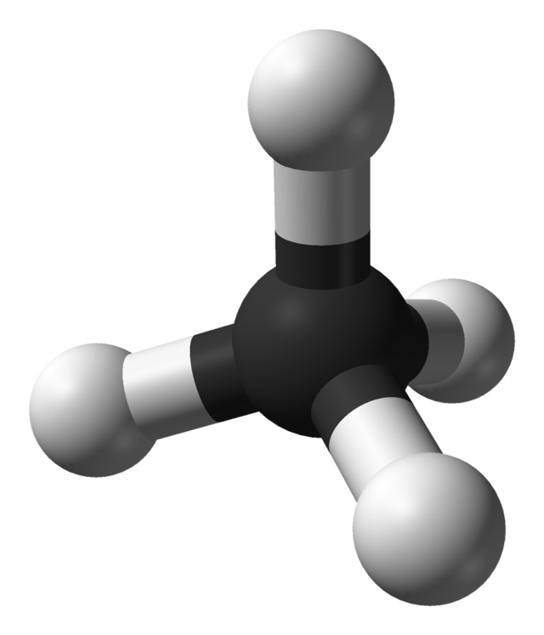

Source: Ben Mills (Public domain)

Methane, commonly known by its chemical formula CH₄, is a colorless and odorless gas composed of one carbon atom bonded to four hydrogen atoms. Though it constitutes a minuscule fraction of the Earth's atmosphere—about 0.00018%—methane is a potent greenhouse gas with properties that have significant implications for our climate.

Methane is primarily found in natural gas and is produced through both geological processes and biological activities, such as the digestion of food by ruminant animals and the decomposition of organic matter in wetlands. Methane clathrates, found beneath the seafloor, represent the largest reservoir of this gas.

One of the most critical aspects of methane is its contribution to the greenhouse effect and climate change. Methane is much more effective at trapping heat in the atmosphere than carbon dioxide, with a global warming potential 84 times greater over a 20-year period. Since the Industrial Revolution, methane levels have surged by about 160%, primarily due to human activities like agriculture, fossil fuel extraction, and waste management.

Methane's high potency as a greenhouse gas arises from its ability to absorb infrared radiation, which warms the Earth's atmosphere. Despite its shorter atmospheric lifetime compared to carbon dioxide, the immediate impact of methane on warming is substantial. This makes controlling methane emissions a priority in efforts to mitigate climate change.

Interestingly, methane has also been detected on other planets, such as Mars, which raises intriguing questions for astrobiology. On Earth, reducing methane emissions through improved agricultural practices, better waste management, and leak detection in fossil fuel industries could significantly slow the rate of global warming and improve air quality.

Understanding methane's properties, origins, and effects on the climate is essential for developing strategies to reduce its impact and protect our planet for future generations.

|  |  |
| --- | --- |
|  | Name |
| Chemical formula |
| Percentage in the Earth's atmosphere |
| Properties | |
| Origin | |
| Occurrence | |
| Contribution to the greenhouse effect | |

# Greenhouse gas crossword puzzle

Now solve the crossword puzzle with words related to the greenhouse gas presented above.

|  |  |  |  |  |  |  |  |  |  |  |  |  |
| --- | --- | --- | --- | --- | --- | --- | --- | --- | --- | --- | --- | --- |
|  |  | 2 |  |  |  |  |  |  |  |  |  |  |
|  |  |  |  |  |  |  |  |  |  |  |  |  |
|  |  |  |  |  |  |  |  |  |  |  |  |  |
|  |  |  |  |  |  |  |  |  |  |  |  |  |
|  |  |  |  |  |  |  |  |  |  |  |  |  |
|  |  |  |  | 4 |  |  |  |  |  |  |  |  |
|  |  |  |  |  |  |  |  |  |  |  |  |  |
| 3 |  |  |  |  |  |  |  |  |  |  |  |  |
|  |  |  |  |  |  |  |  |  |  |  |  |  |
|  |  |  |  |  |  |  |  | 5 |  |  |  |  |
|  | 6 |  |  |  |  |  |  |  |  |  |  |  |
|  |  |  |  |  |  |  |  |  |  |  |  |  |
|  |  | 1 |  |  |  |  |  |  |  |  |  |  |
|  |  |  |  |  |  |  |  |  |  |  |  |  |
|  |  |  |  |  |  |  |  |  |  |  |  |  |
|  |  |  |  |  |  |  |  |  |  |  |  |  |

Across

1 gas_composed_of_one_carbon_atom_bonded_to_four_hydrogen_atoms (7)

3 substance_in_natural_gas_and_wetlands_that_is_a_potent_greenhouse_gas (7)

6 scientific_field_that_studies_the_potential_of_life_on_other_planets (12)

Down

2 type_of_animals_that_produce_methane_through_digestion (8)

4 largest_reservoir_of_methane_found_beneath_the_seafloor (10)

5 term_for_methane's_ability_to_trap_heat_in_the_atmosphere (7)